**Data Analysis of Election Bonds**

**Total Donation of Each Party (in Crore) :-**

'ALL INDIA ANNA DRAVIDA MUNNETRA KAZHAGAM':- 6.05,

'BHARAT RASHTRA SAMITHI': -1214.7099,

'BHARATIYA JANATA PARTY':- 6060.5111,

'PRESIDENT, ALL INDIA CONGRESS COMMITTEE': -1421.8655,

'SHIVSENA': -159.3814,

'TELUGU DESAM PARTY':- 218.88,

'YSR': -334.0,

'DRAVIDA MUNNETRA KAZHAGAM (DMK)': -639.0,

'JANATA DAL ( SECULAR )':- 43.5,

'NATIONALIST CONGRESS PARTY MAHARASHTRA PRADESH':- 31.0,

'ALL INDIA TRINAMOOL CONGRESS': -1609.5314,

'BIHAR PRADESH JANTA DAL(UNITED)': -14.0,

'RASHTRIYA JANTA DAL': -73.5,

'AAM AADMI PARTY':- 65.45,

'ADYAKSHA SAMAJVADI PARTY':- 14.05,

'SHIROMANI AKALI DAL':- 7.26,

'JHARKHAND MUKTI MORCHA': 13.5,

'JAMMU AND KASHMIR NATIONAL CONFERENCE': - 0.5,

'BIJU JANATA DAL': - 775.5,

'GOA FORWARD PARTY':- 0.35,

'MAHARASHTRAWADI GOMNTAK PARTY':- 0.55,

'SIKKIM KRANTIKARI MORCHA': - 36.5,

'JANASENA PARTY': - 21.0,

'YSR CONGRESS PARTY':- 3.0,

'SIKKIM DEMOCRATIC FRONT':- 5.5

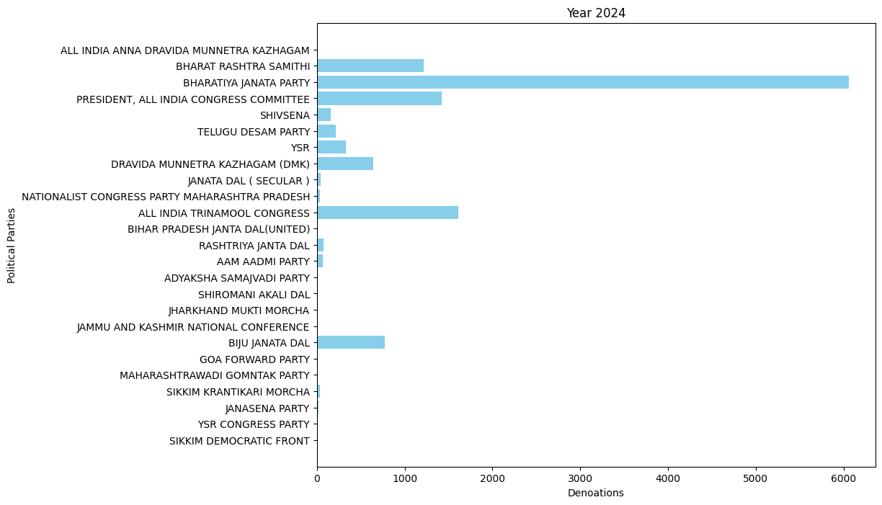

This data may not show proper information as the difference between each party's donations is high, so I break it down into yearly bases for more clarification.

**Classify on Yearly Bases (in Crore): -**

* 2019 Party Donation Data: -

'ALL INDIA ANNA DRAVIDA MUNNETRA KAZHAGAM': 6.05,

'BHARAT RASHTRA SAMITHI': 37.1529,

'BHARATIYA JANATA PARTY': 1971.7501,

'PRESIDENT, ALL INDIA CONGRESS COMMITTEE': 170.311,

'SHIVSENA': 33.38,

'TELUGU DESAM PARTY': 7.3,

'YSR': 8.25,

'DRAVIDA MUNNETRA KAZHAGAM (DMK)': 9.0,

'JANATA DAL ( SECULAR )': 2.5,

'NATIONALIST CONGRESS PARTY MAHARASHTRA PRADESH': 15.5,

'ALL INDIA TRINAMOOL CONGRESS': 87.0946,

'BIHAR PRADESH JANTA DAL(UNITED)': 3.0,

'RASHTRIYA JANTA DAL': 2.5,

'AAM AADMI PARTY': 2.2,

'ADYAKSHA SAMAJVADI PARTY': 10.84,

'SHIROMANI AKALI DAL': 6.76,

'JHARKHAND MUKTI MORCHA': 1.0,

'JAMMU AND KASHMIR NATIONAL CONFERENCE': 0.5,

'BIJU JANATA DAL': 10.0

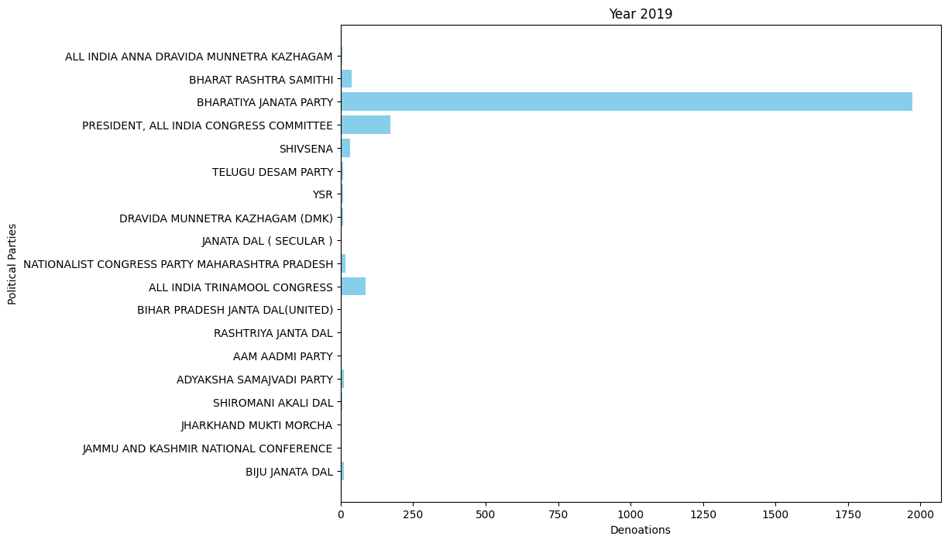

* 2020 Party Donation Data: -

'BIJU JANATA DAL': 77.0,

'BHARATIYA JANATA PARTY': 73.89,

'AAM AADMI PARTY': 3.3,

'ALL INDIA TRINAMOOL CONGRESS': 29.77,

'PRESIDENT, ALL INDIA CONGRESS COMMITTEE': 9.0,

'DRAVIDA MUNNETRA KAZHAGAM (DMK)': 80.0,

'RASHTRIYA JANTA DAL': 1.0,

'BIHAR PRADESH JANTA DAL(UNITED)': 1.0,

'YSR': 89.0

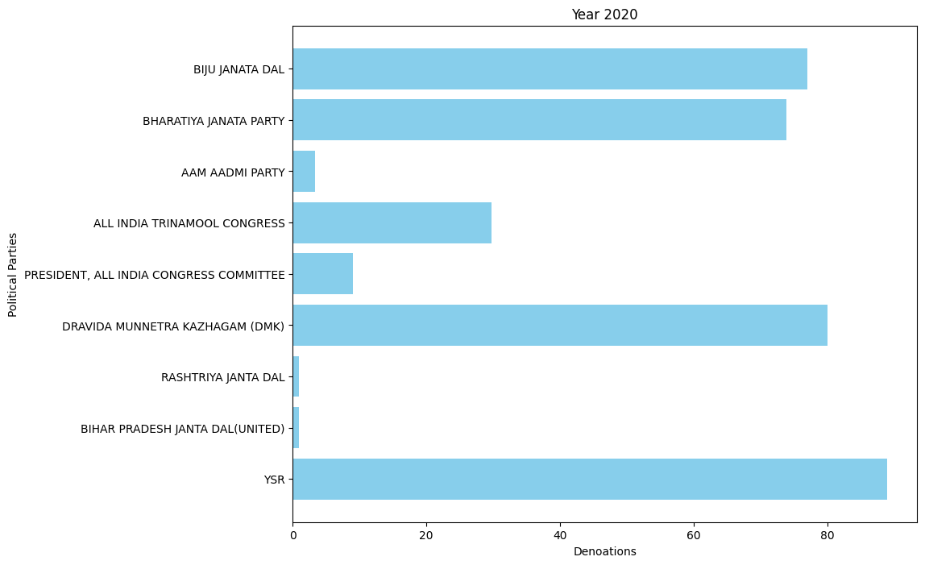

* 2021 Party Donation Data: -

'ALL INDIA TRINAMOOL CONGRESS': 330.943,

'AAM AADMI PARTY': 1.85,

'PRESIDENT, ALL INDIA CONGRESS COMMITTEE': 123.9245,

'YSR': 66.25,

'BHARATIYA JANATA PARTY': 372.995,

'BIJU JANATA DAL': 241.0,

'DRAVIDA MUNNETRA KAZHAGAM (DMK)': 205.0,

'TELUGU DESAM PARTY': 3.5,

'NATIONALIST CONGRESS PARTY MAHARASHTRA PRADESH': 3.8,

'BHARAT RASHTRA SAMITHI': 153.0

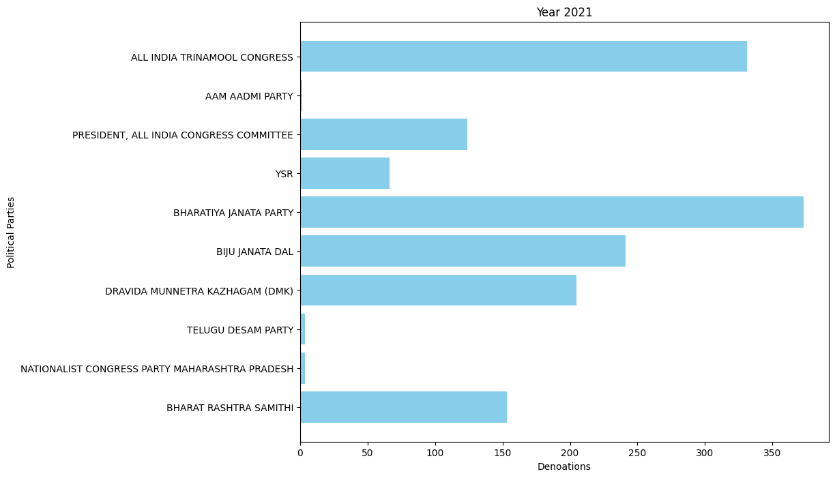

* 2022 Party Donation Data: -

'PRESIDENT, ALL INDIA CONGRESS COMMITTEE': 289.36,

'SHIVSENA': 29.0,

'AAM AADMI PARTY': 47.95,

'ADYAKSHA SAMAJVADI PARTY': 3.21,

'ALL INDIA TRINAMOOL CONGRESS': 468.8,

'BHARATIYA JANATA PARTY': 1763.5499,

'BIHAR PRADESH JANTA DAL(UNITED)': 10.0,

'BIJU JANATA DAL': 195.0,

'DRAVIDA MUNNETRA KAZHAGAM (DMK)': 285.0,

'NATIONALIST CONGRESS PARTY MAHARASHTRA PRADESH': 10.2,

'GOA FORWARD PARTY': 0.35,

'SHIROMANI AKALI DAL': 0.5,

'MAHARASHTRAWADI GOMNTAK PARTY': 0.55,

'BHARAT RASHTRA SAMITHI': 528.987,

'YSR': 51.0,

'TELUGU DESAM PARTY': 13.0,

'SIKKIM KRANTIKARI MORCHA': 2.0,

'JANASENA PARTY': 2.0,

'YSR CONGRESS PARTY': 1.0

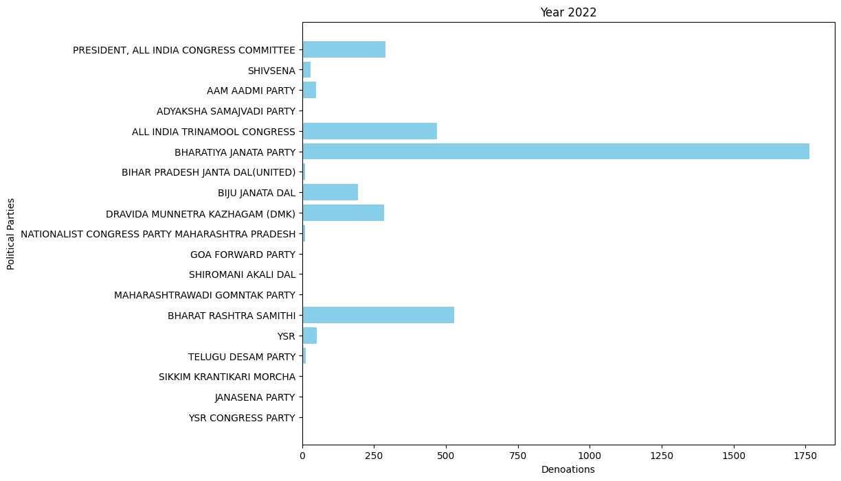

* 2023 Party Donation Data: -

'TELUGU DESAM PARTY': 76.88,

'ALL INDIA TRINAMOOL CONGRESS': 562.4738,

'PRESIDENT, ALL INDIA CONGRESS COMMITTEE': 793.37,

'BHARATIYA JANATA PARTY': 1676.3261,

'BHARAT RASHTRA SAMITHI': 495.57,

'BIJU JANATA DAL': 252.5,

'JHARKHAND MUKTI MORCHA': 12.5,

'SIKKIM KRANTIKARI MORCHA': 31.5,

'DRAVIDA MUNNETRA KAZHAGAM (DMK)': 40.0,

'YSR CONGRESS PARTY': 2.0,

'YSR': 116.5,

'NATIONALIST CONGRESS PARTY MAHARASHTRA PRADESH': 1.5,

'JANASENA PARTY': 2.0,

'JANATA DAL ( SECULAR )': 41.0,

'AAM AADMI PARTY': 10.15,

'RASHTRIYA JANTA DAL': 55.0,

'SHIVSENA': 72.0014,

'SIKKIM DEMOCRATIC FRONT': 5.0

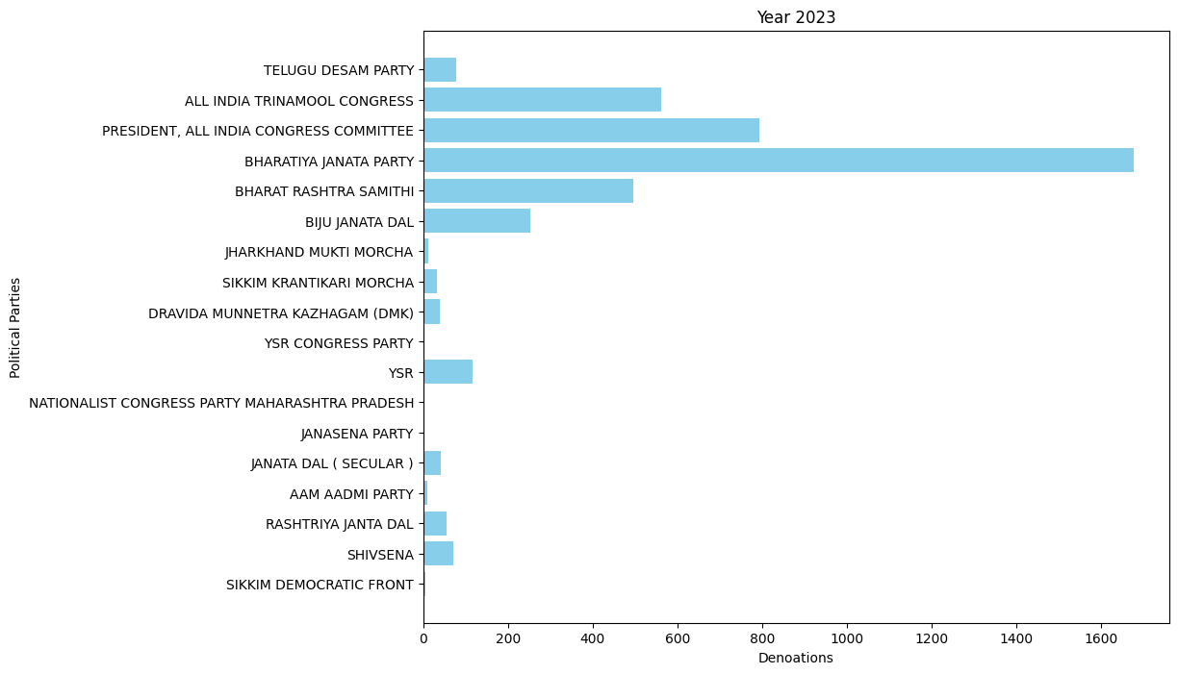

* 2024 Party Donation Data: -

'TELUGU DESAM PARTY': 118.2,

'ALL INDIA TRINAMOOL CONGRESS': 130.45,

'BHARATIYA JANATA PARTY': 202.0,

'PRESIDENT, ALL INDIA CONGRESS COMMITTEE': 35.9,

'SHIVSENA': 25.0,

'JANASENA PARTY': 17.0,

'SIKKIM DEMOCRATIC FRONT': 0.5,

'SIKKIM KRANTIKARI MORCHA': 3.0,

'YSR': 3.0,

'RASHTRIYA JANTA DAL': 15.0,

'DRAVIDA MUNNETRA KAZHAGAM (DMK)': 20.0

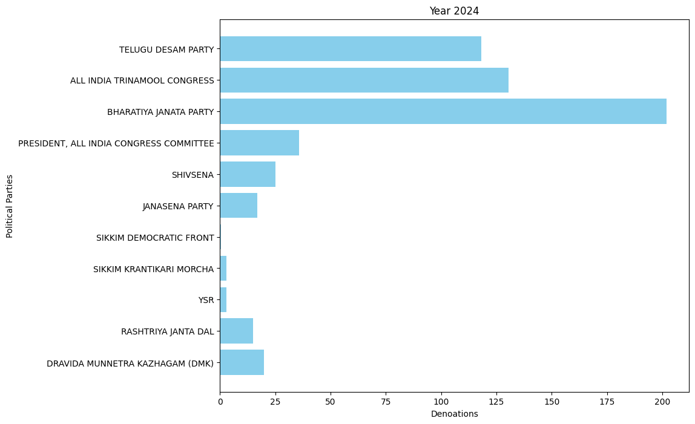

Now, gradually some clarification is shown, but in some years like:- 2019, 2022 there is more crowd and larger volume of transactions, so for more clarification I move forward based on months.

**Classify on Monthly Bases (in Crore): -**

* April 2019 :-

'ALL INDIA ANNA DRAVIDA MUNNETRA KAZHAGAM': 6.05,

'BHARAT RASHTRA SAMITHI': 23.55,

'BHARATIYA JANATA PARTY': 1056.8601,

'PRESIDENT, ALL INDIA CONGRESS COMMITTEE': 118.561,

'SHIVSENA': 14.63,

'TELUGU DESAM PARTY': 7.3,

'YSR': 8.25,

'DRAVIDA MUNNETRA KAZHAGAM (DMK)': 9.0,

'JANATA DAL ( SECULAR )': 2.5,

'NATIONALIST CONGRESS PARTY MAHARASHTRA PRADESH': 2.5,

'ALL INDIA TRINAMOOL CONGRESS': 17.76,

'BIHAR PRADESH JANTA DAL(UNITED)': 3.0,

'RASHTRIYA JANTA DAL': 2.5,

'AAM AADMI PARTY': 0.2,

'ADYAKSHA SAMAJVADI PARTY': 0.84,

'SHIROMANI AKALI DAL': 6.26,

'JHARKHAND MUKTI MORCHA': 1.0,

'JAMMU AND KASHMIR NATIONAL CONFERENCE': 0.5

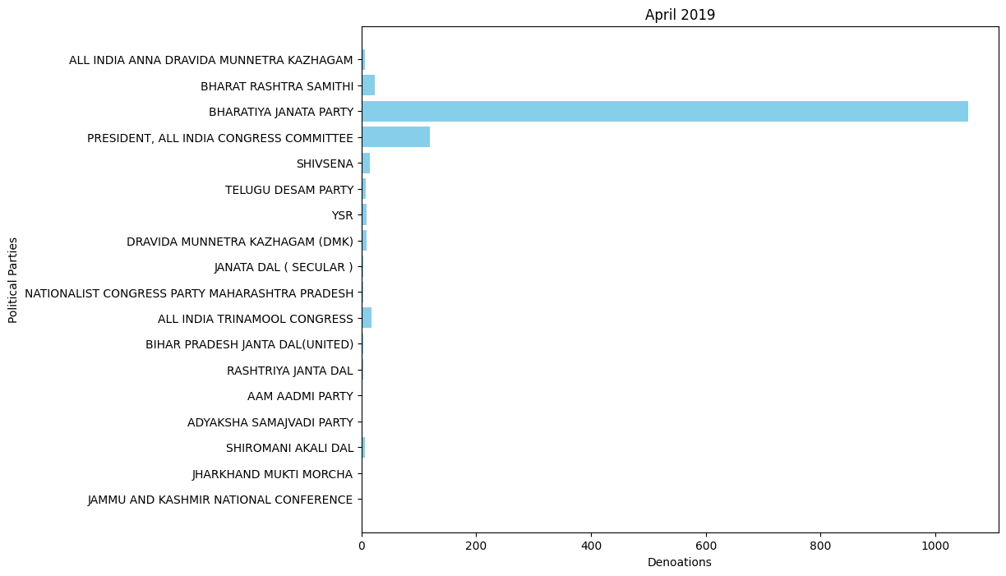

* May 2019: -

'BHARATIYA JANATA PARTY': 714.71,

'SHIVSENA': 0.75,

'ALL INDIA TRINAMOOL CONGRESS': 33.9546,

'BHARAT RASHTRA SAMITHI': 13.6029,

'PRESIDENT, ALL INDIA CONGRESS COMMITTEE': 50.0,

'NATIONALIST CONGRESS PARTY MAHARASHTRA PRADESH': 1.0,

'ADYAKSHA SAMAJVADI PARTY': 10.0,

'SHIROMANI AKALI DAL': 0.5,

'AAM AADMI PARTY': 2.0

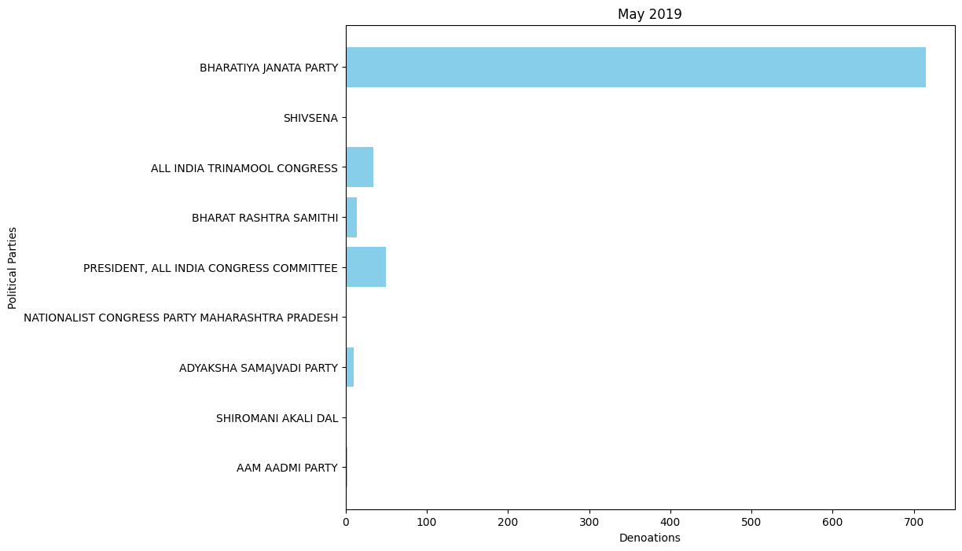

* July 2019: -

'SHIVSENA': 5.0,

'ALL INDIA TRINAMOOL CONGRESS': 15.38,

'BHARATIYA JANATA PARTY': 15.0,

'BIJU JANATA DAL': 10.0

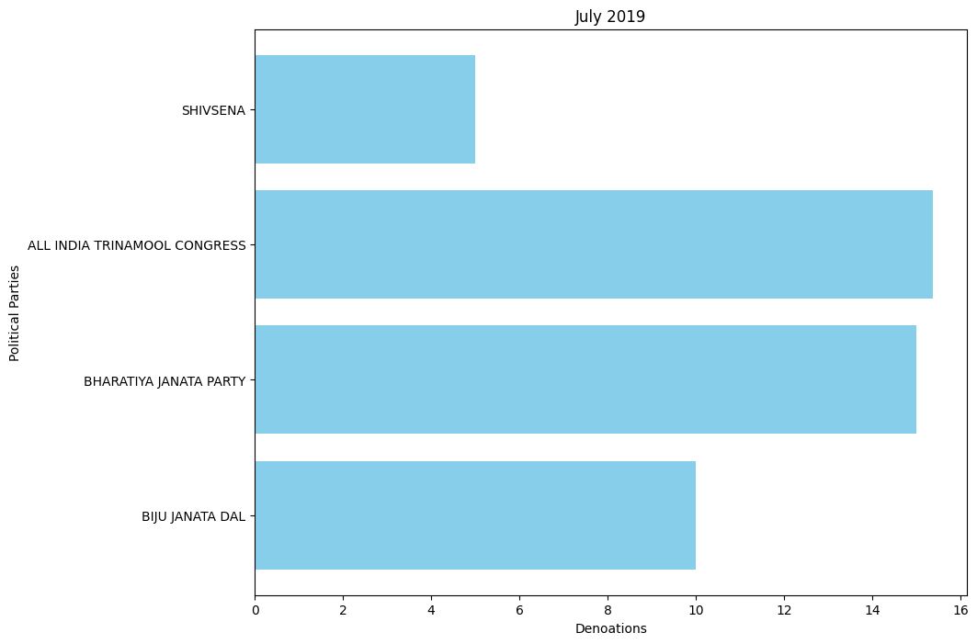

* Oct 2019: -

'ALL INDIA TRINAMOOL CONGRESS': 20.0,

'NATIONALIST CONGRESS PARTY MAHARASHTRA PRADESH': 12.0,

'SHIVSENA': 13.0,

'BHARATIYA JANATA PARTY': 185.18,

'PRESIDENT, ALL INDIA CONGRESS COMMITTEE': 1.75

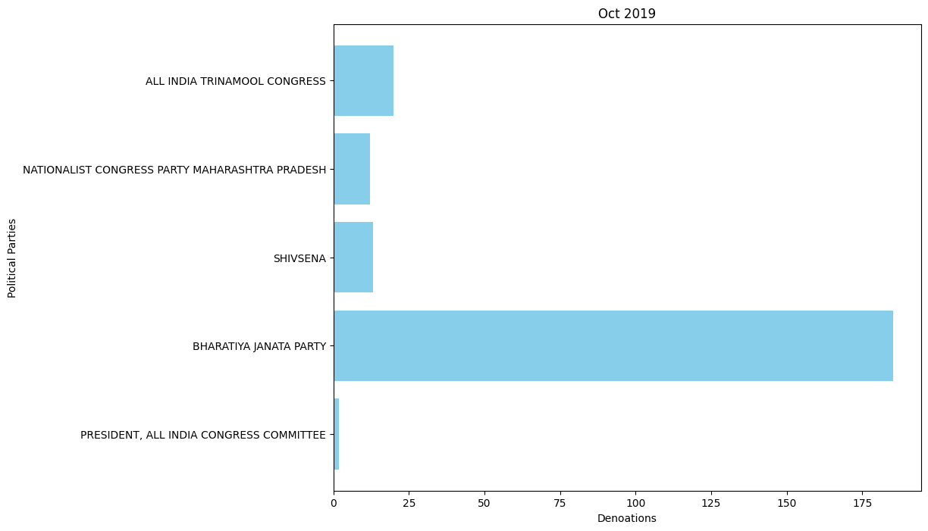

* Jan 2020: -

'BIJU JANATA DAL': 10.0,

'BHARATIYA JANATA PARTY': 50.0,

'AAM AADMI PARTY': 0.3,

'ALL INDIA TRINAMOOL CONGRESS': 12.37,

'PRESIDENT, ALL INDIA CONGRESS COMMITTEE': 6.0

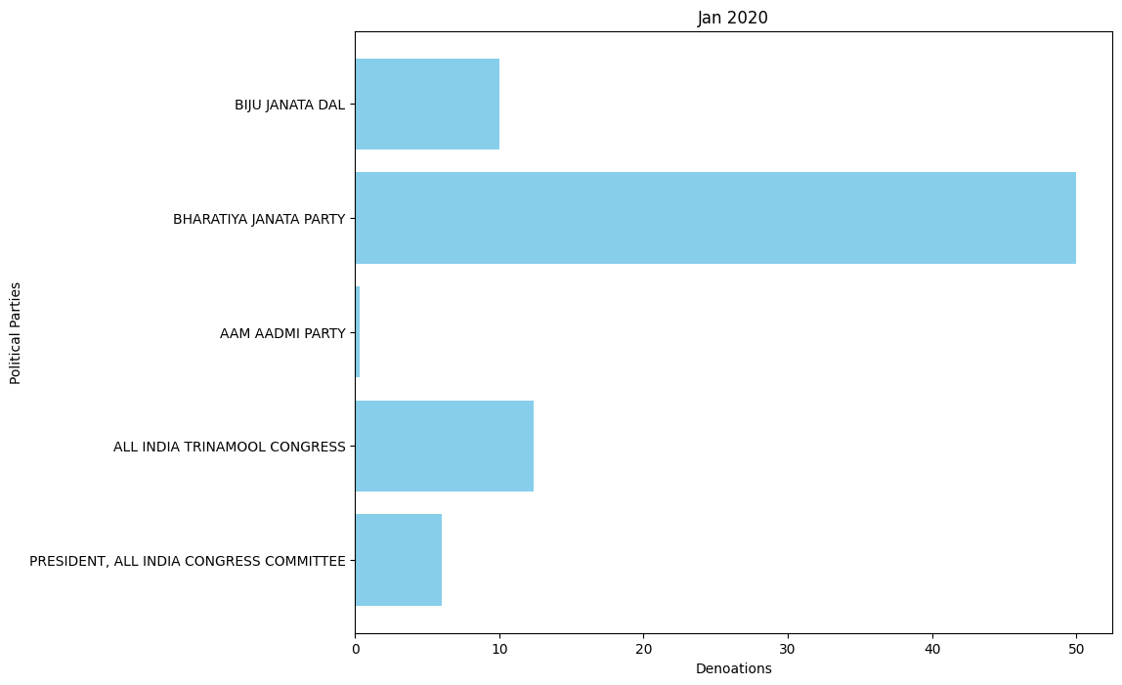

* Feb 2020: -

BHARATIYA JANATA PARTY': 3.0

* Oct 2020: -

'ALL INDIA TRINAMOOL CONGRESS': 16.4,

'BIJU JANATA DAL': 67.0,

'DRAVIDA MUNNETRA KAZHAGAM (DMK)': 80.0,

'PRESIDENT, ALL INDIA CONGRESS COMMITTEE': 3.0,

'RASHTRIYA JANTA DAL': 1.0,

'BIHAR PRADESH JANTA DAL(UNITED)': 1.0

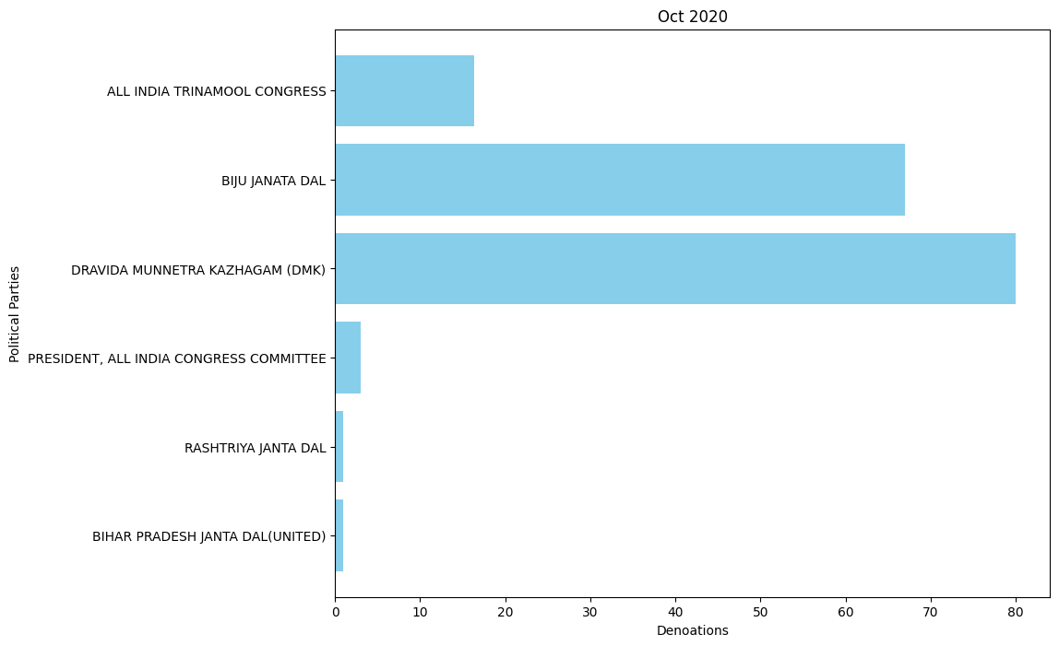

* Jan 2021: -

'ALL INDIA TRINAMOOL CONGRESS': 26.0,

'AAM AADMI PARTY': 1.25,

'PRESIDENT, ALL INDIA CONGRESS COMMITTEE': 7.075,

'YSR': 6.25,

'BHARATIYA JANATA PARTY': 1.495

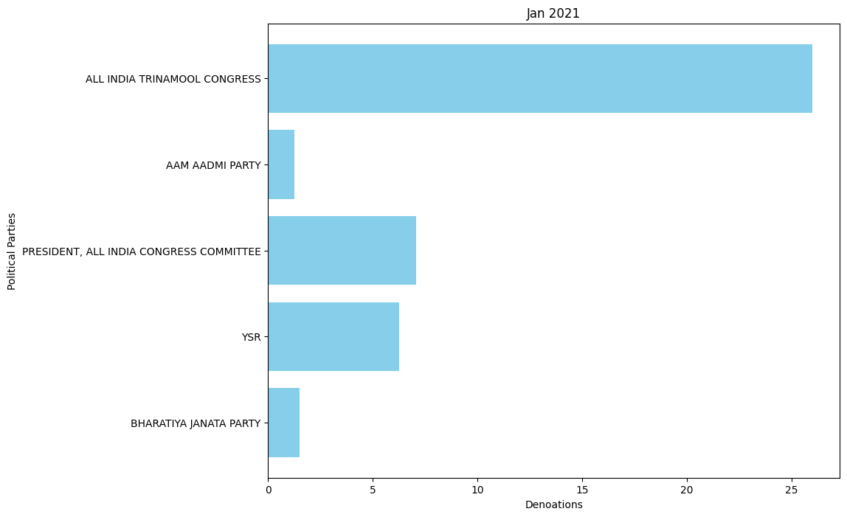

* April 2020: -

'BIJU JANATA DAL': 116.0,

'DRAVIDA MUNNETRA KAZHAGAM (DMK)': 106.0,

'TELUGU DESAM PARTY': 3.5,

'BHARATIYA JANATA PARTY': 291.5,

'PRESIDENT, ALL INDIA CONGRESS COMMITTEE': 58.75,

'NATIONALIST CONGRESS PARTY MAHARASHTRA PRADESH': 3.8,

'ALL INDIA TRINAMOOL CONGRESS': 55.44,

'AAM AADMI PARTY': 0.35,

'YSR': 60.0

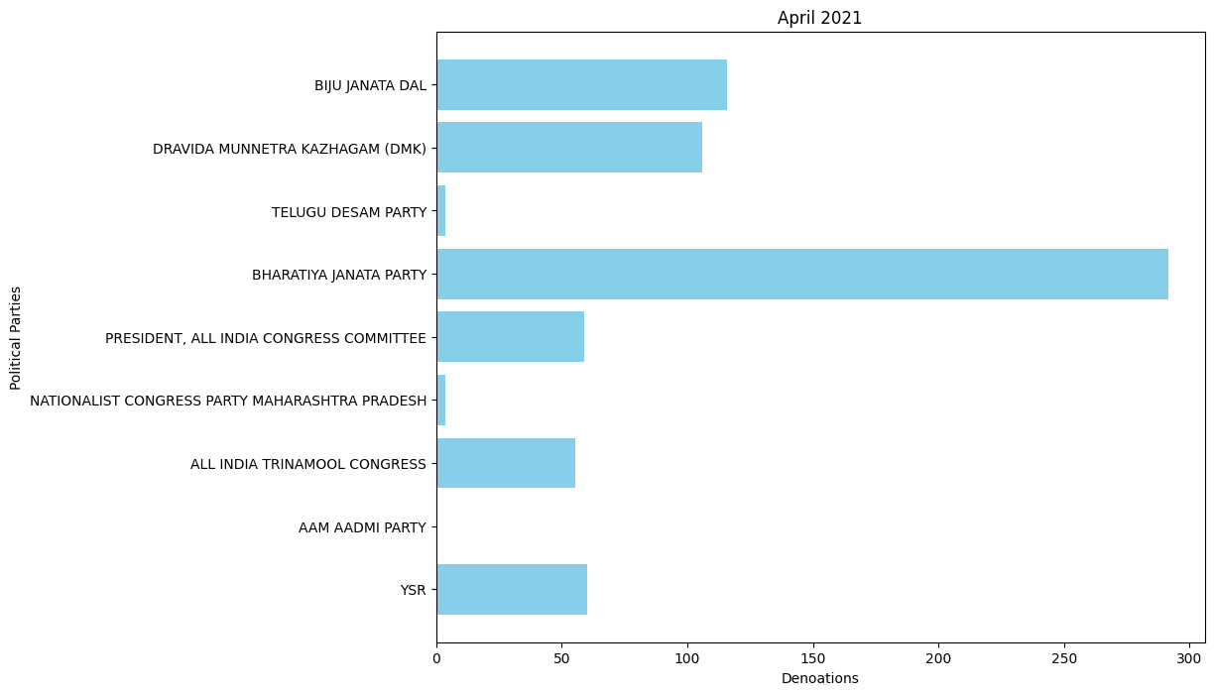

* July 2020: -

'ALL INDIA TRINAMOOL CONGRESS': 107.563,

'PRESIDENT, ALL INDIA CONGRESS COMMITTEE': 24.7,

'BHARATIYA JANATA PARTY': 18.0,

'AAM AADMI PARTY': 0.25

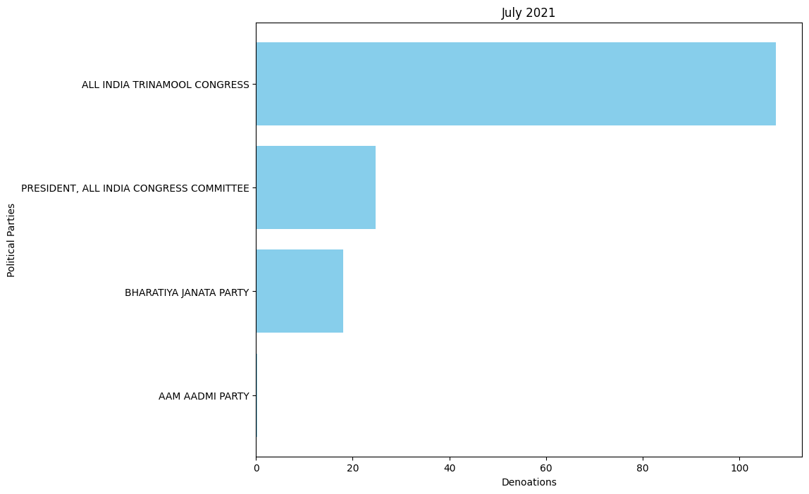

* Oct 2020: -

'PRESIDENT, ALL INDIA CONGRESS COMMITTEE': 33.3995,

'BIJU JANATA DAL': 125.0,

'ALL INDIA TRINAMOOL CONGRESS': 141.94,

'BHARAT RASHTRA SAMITHI': 153.0,

'BHARATIYA JANATA PARTY': 62.0,

'DRAVIDA MUNNETRA KAZHAGAM (DMK)': 99.0

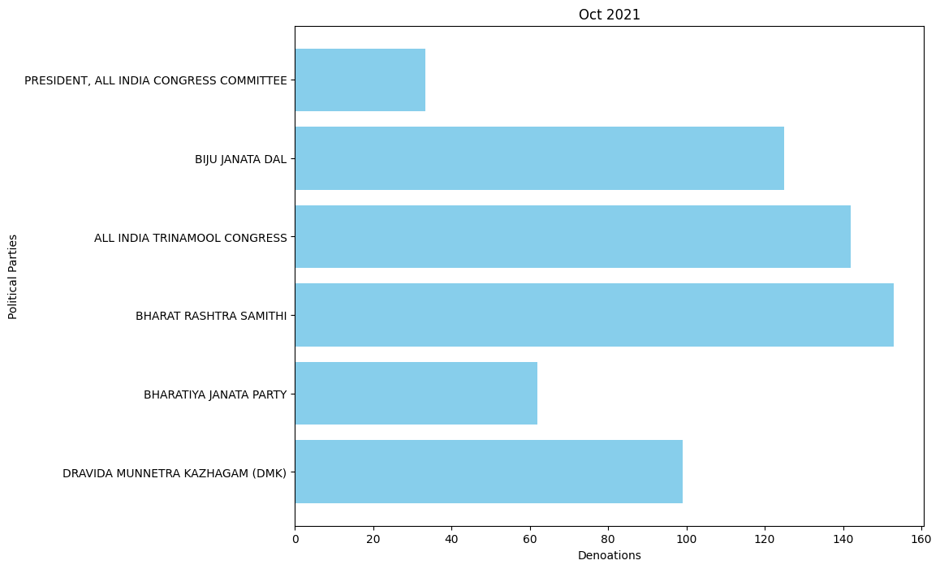

* Jan 2022: -

'PRESIDENT, ALL INDIA CONGRESS COMMITTEE': 119.25,

'SHIVSENA': 29.0,

'AAM AADMI PARTY': 3.4,

'ADYAKSHA SAMAJVADI PARTY': 3.21,

'ALL INDIA TRINAMOOL CONGRESS': 224.2,

'BHARATIYA JANATA PARTY': 662.2,

'BIHAR PRADESH JANTA DAL(UNITED)': 10.0,

'BIJU JANATA DAL': 50.0,

'DRAVIDA MUNNETRA KAZHAGAM (DMK)': 100.0,

'NATIONALIST CONGRESS PARTY MAHARASHTRA PRADESH': 10.2,

'GOA FORWARD PARTY': 0.35,

'SHIROMANI AKALI DAL': 0.5,

'MAHARASHTRAWADI GOMNTAK PARTY': 0.55

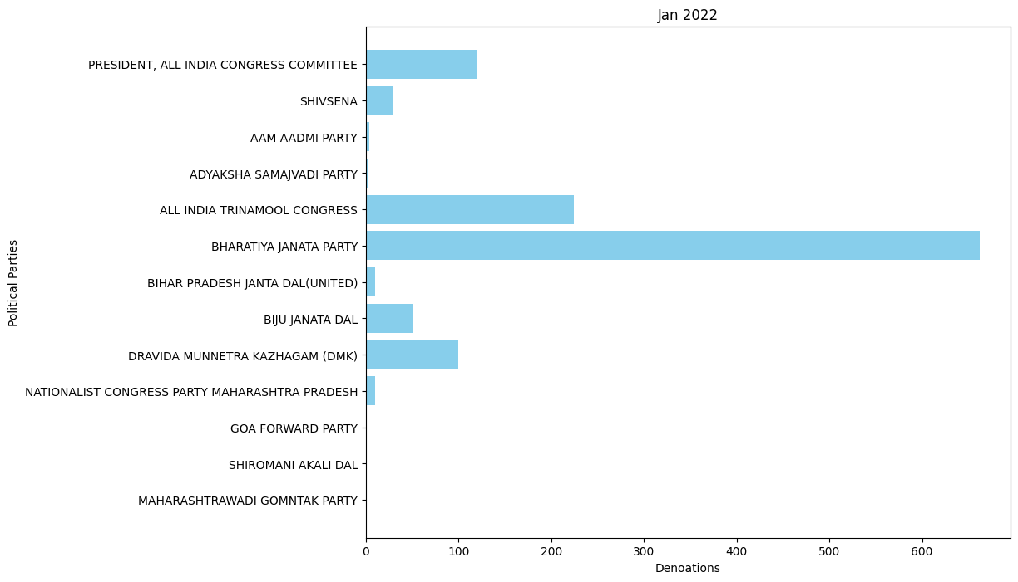

* April 2022: -

'BHARAT RASHTRA SAMITHI': 410.987,

'ALL INDIA TRINAMOOL CONGRESS': 18.0,

'BIJU JANATA DAL': 3.0,

'DRAVIDA MUNNETRA KAZHAGAM (DMK)': 100.0,

'BHARATIYA JANATA PARTY': 98.5,

'PRESIDENT, ALL INDIA CONGRESS COMMITTEE': 8.0,

'YSR': 10.0

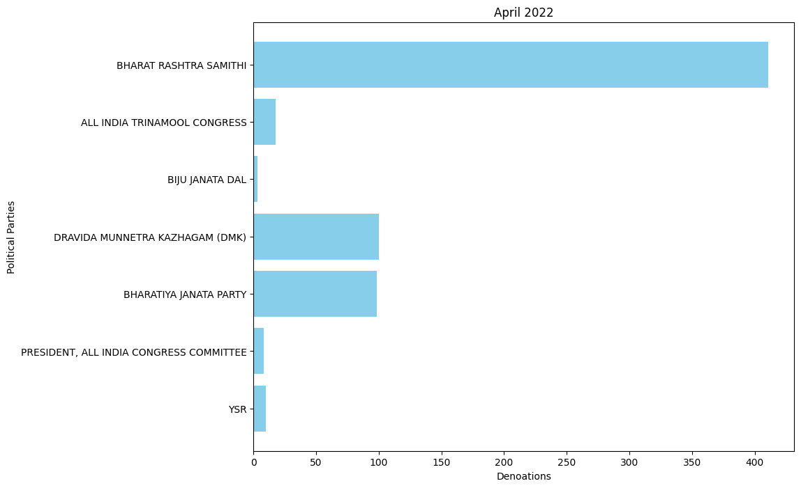

* Oct 2022: -

'AAM AADMI PARTY': 25.45,

'BHARAT RASHTRA SAMITHI': 55.0,

'PRESIDENT, ALL INDIA CONGRESS COMMITTEE': 37.2,

'ALL INDIA TRINAMOOL CONGRESS': 143.1,

'BHARATIYA JANATA PARTY': 222.5,

'BIJU JANATA DAL': 35.0,

'DRAVIDA MUNNETRA KAZHAGAM (DMK)': 10.0,

'SIKKIM KRANTIKARI MORCHA': 2.0,

'TELUGU DESAM PARTY': 5.0,

'YSR': 5.0,

'JANASENA PARTY': 2.0

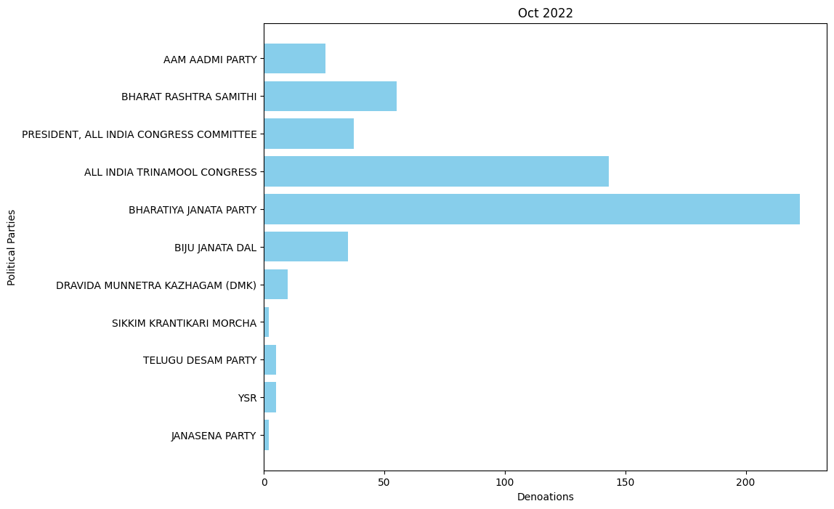

* Nov 2022: -

'AAM AADMI PARTY': 8.0,

'BHARATIYA JANATA PARTY': 602.8499,

'PRESIDENT, ALL INDIA CONGRESS COMMITTEE': 49.41,

'YSR': 16.0

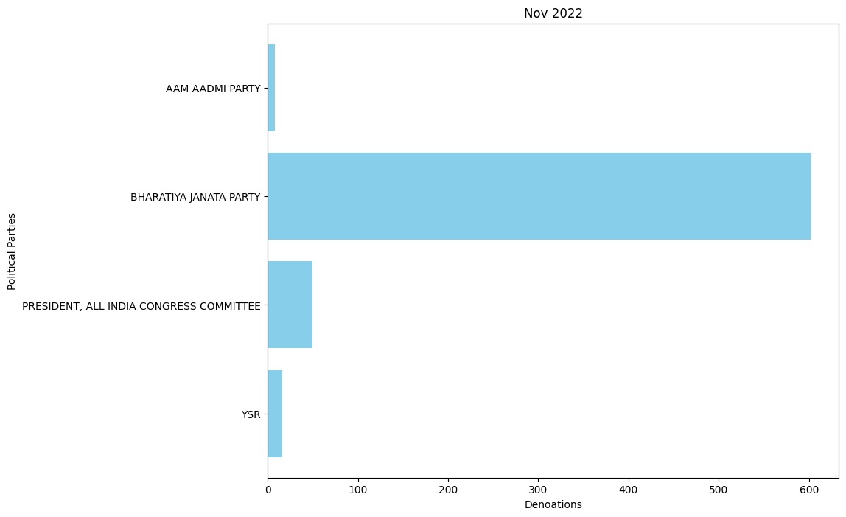

* Dec 2022: -

'AAM AADMI PARTY': 11.1,

'YSR': 20.0,

'PRESIDENT, ALL INDIA CONGRESS COMMITTEE': 18.0,

'ALL INDIA TRINAMOOL CONGRESS': 17.0,

'BHARATIYA JANATA PARTY': 165.0,

'YSR CONGRESS PARTY': 1.0

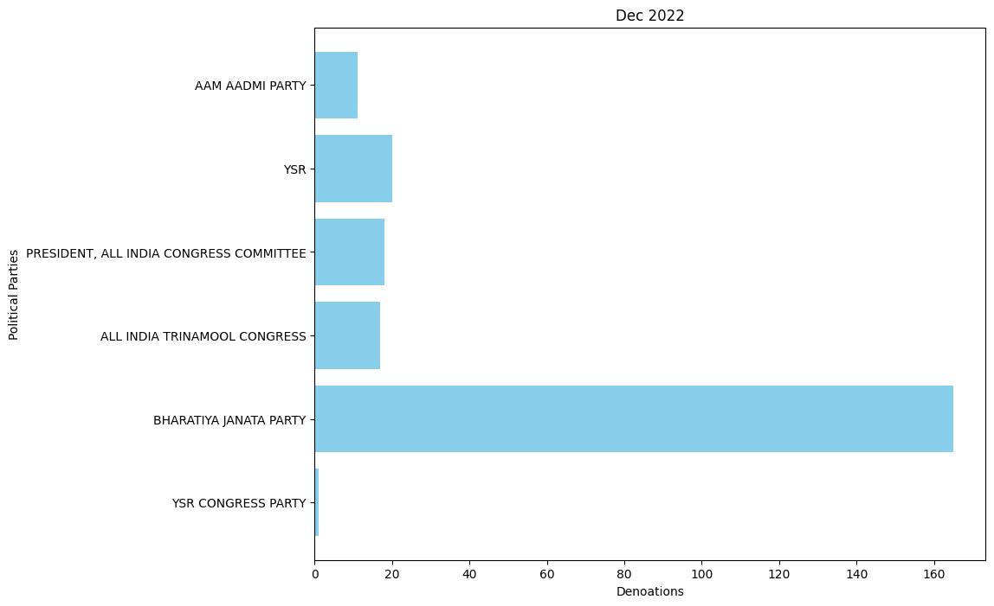

* Jan 2023: -

'TELUGU DESAM PARTY': 19.0,

'ALL INDIA TRINAMOOL CONGRESS': 60.5,

'PRESIDENT, ALL INDIA CONGRESS COMMITTEE': 0.91,

'BHARATIYA JANATA PARTY': 100.0,

'BHARAT RASHTRA SAMITHI': 0.05

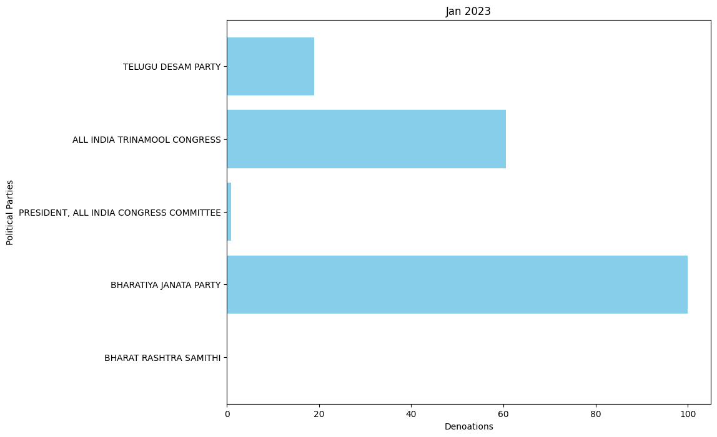

* Feb 2023: -

ALL INDIA TRINAMOOL CONGRESS': 20.0,

'BHARATIYA JANATA PARTY': 92.8,

'BIJU JANATA DAL': 7.0,

'JHARKHAND MUKTI MORCHA': 1.0,

'TELUGU DESAM PARTY': 2.0,

'SIKKIM KRANTIKARI MORCHA': 5.5

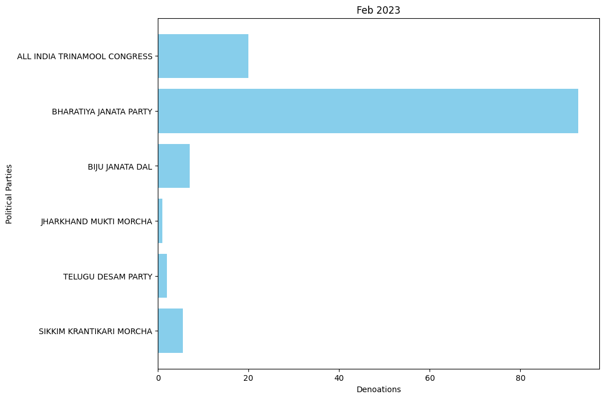

* April 2023: -

'BHARAT RASHTRA SAMITHI': 91.1,

'PRESIDENT, ALL INDIA CONGRESS COMMITTEE': 190.55,

'DRAVIDA MUNNETRA KAZHAGAM (DMK)': 40.0,

'TELUGU DESAM PARTY': 32.0,

'YSR CONGRESS PARTY': 2.0,

'YSR': 33.0,

'BHARATIYA JANATA PARTY': 334.245,

'ALL INDIA TRINAMOOL CONGRESS': 186.955,

'JHARKHAND MUKTI MORCHA': 1.0,

'NATIONALIST CONGRESS PARTY MAHARASHTRA PRADESH': 1.5,

'BIJU JANATA DAL': 15.0,

'JANASENA PARTY': 2.0,

'JANATA DAL ( SECULAR )': 41.0

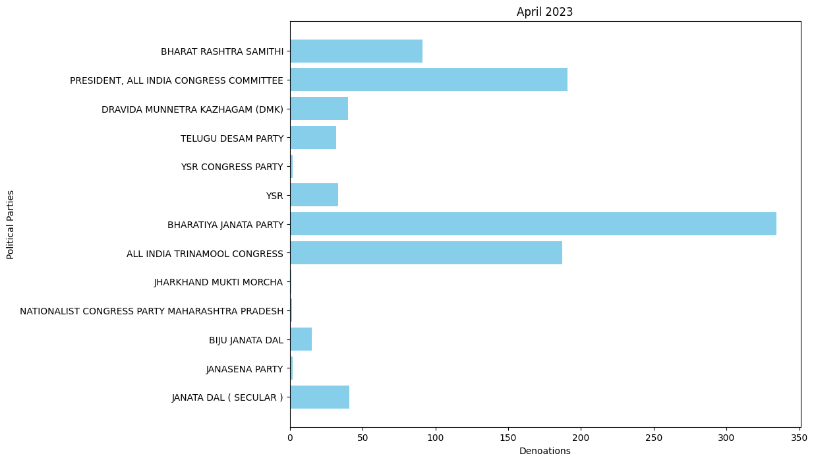

* July 2023: -

'BIJU JANATA DAL': 155.5,

'BHARATIYA JANATA PARTY': 86.9301,

'PRESIDENT, ALL INDIA CONGRESS COMMITTEE': 20.5,

'TELUGU DESAM PARTY': 2.75,

'AAM AADMI PARTY': 10.15,

'ALL INDIA TRINAMOOL CONGRESS': 117.0,

'YSR': 25.5,

'BHARAT RASHTRA SAMITHI': 318.42,

'RASHTRIYA JANTA DAL': 30.0,

'SIKKIM KRANTIKARI MORCHA': 8.0,

'JHARKHAND MUKTI MORCHA': 5.0,

'SHIVSENA': 33.0

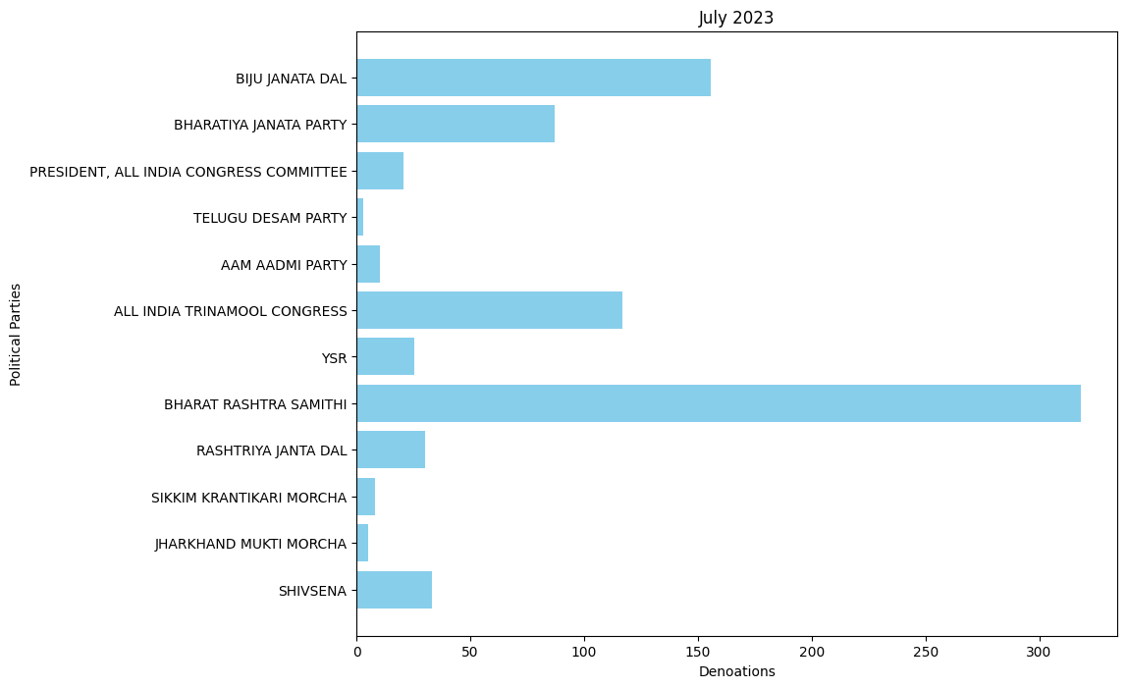

* Oct 2023: -

'PRESIDENT, ALL INDIA CONGRESS COMMITTEE': 401.91,

'BHARAT RASHTRA SAMITHI': 72.5,

'ALL INDIA TRINAMOOL CONGRESS': 171.2888,

'BHARATIYA JANATA PARTY': 359.05,

'TELUGU DESAM PARTY': 11.13,

'SIKKIM KRANTIKARI MORCHA': 18.0,

'JHARKHAND MUKTI MORCHA': 5.5,

'BIJU JANATA DAL': 45.0,

'SHIVSENA': 39.0014,

'RASHTRIYA JANTA DAL': 25.0

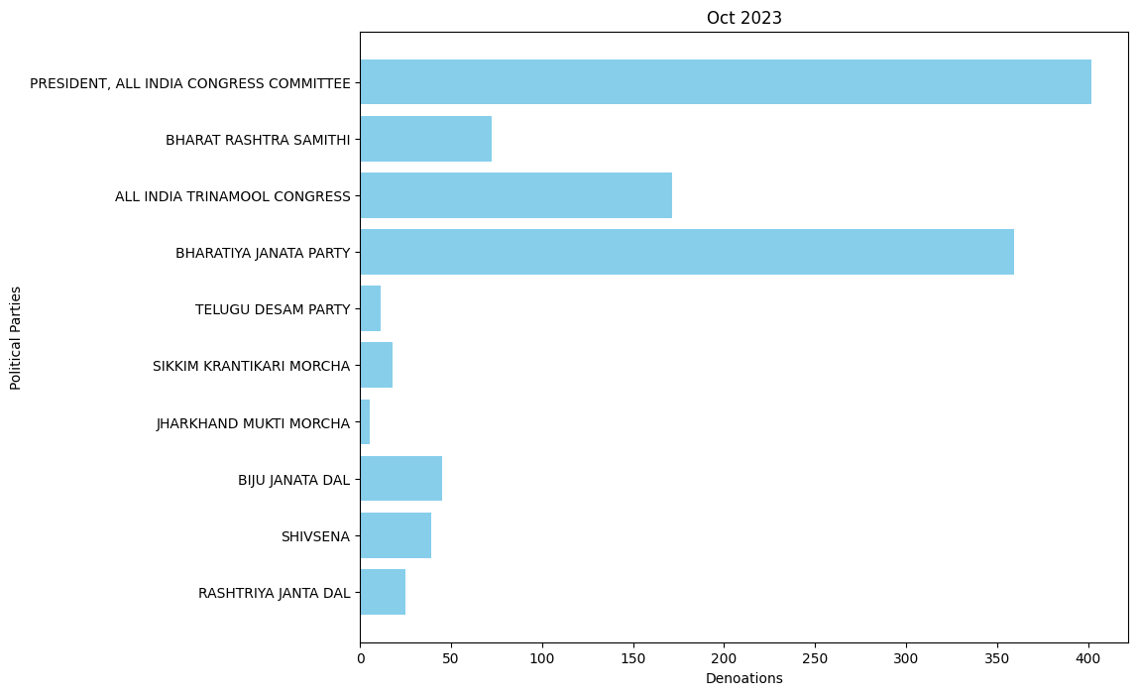

* Nov 2023: -

'PRESIDENT, ALL INDIA CONGRESS COMMITTEE': 179.5,

'SIKKIM DEMOCRATIC FRONT': 5.0,

'BHARATIYA JANATA PARTY': 702.001,

'BHARAT RASHTRA SAMITHI': 13.5,

'YSR': 24.0,

'BIJU JANATA DAL': 30.0,

'TELUGU DESAM PARTY': 10.0,

'ALL INDIA TRINAMOOL CONGRESS': 6.73

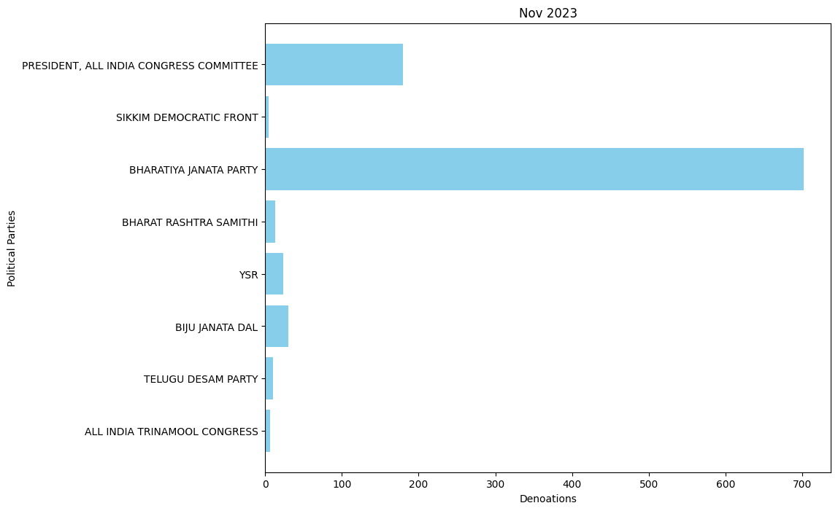

* Dec 2023: -

'BHARATIYA JANATA PARTY': 1.3, 'YSR': 34.0

* Jan 2024: -

'TELUGU DESAM PARTY': 118.2,

'ALL INDIA TRINAMOOL CONGRESS': 130.45,

'BHARATIYA JANATA PARTY': 202.0,

'PRESIDENT, ALL INDIA CONGRESS COMMITTEE': 35.9,

'SHIVSENA': 25.0,

'JANASENA PARTY': 17.0,

'SIKKIM DEMOCRATIC FRONT': 0.5,

'SIKKIM KRANTIKARI MORCHA': 3.0,

'YSR': 3.0,

'RASHTRIYA JANTA DAL': 15.0,

'DRAVIDA MUNNETRA KAZHAGAM (DMK)': 20.0

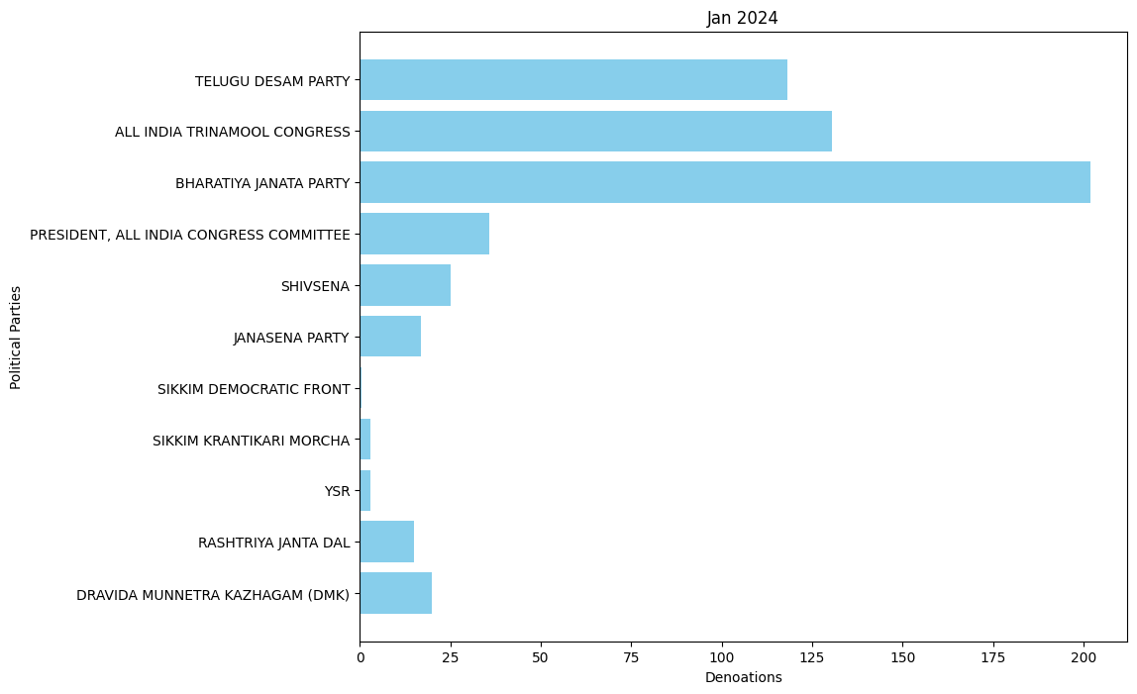

**Name of the Purchase (in Rs.): -**

A B C INDIA LIMITED : - 4000000

ACROPOLIS MAINTENANCE SERVICES PRIVATE LIMITED :- 2500000

ARIHANT ENTERPRISES :- 4000000

CHOUDHARY GARMENTS :- 2000000

ESSEL MINING AND INDS LTD :- 2245000000

GRASIM INDUSTRIES LTD :- 330000000

HIGHSTREET CRUISES AND ENTERTAINMENT PVT LTD :- 3000000

INNOCENT MERCHANDISE PVT LTD :- 2500000

KAMLANG SAW & VENEER MILLS PVT LTD :- 2000000

MEGHA ENGINEERING AND INFRASTRUCTURES LI MITED :- 8210000000

MERLIN RECREATION PVT LTD :- 2500000

MSPL LTD :- 40000000

MYRIAD DEVELOPERS :- 1500000

OMKAR VENTURES PVT LTD :- 40000000

PATEL HIGHWAY MANAGEMENT PVT LTD :- 10000000

PHL FINIVEST PVT LTD :- 400000000

PIRAMAL CAPITAL AND HOUSING FINANCE LTD :- 100000000

PIRAMAL ENTERPRISES LTD :- 100000000

PONUGOTI HEMENDAR RAO :- 300000

RENUKA INVESTMENTS AND FINANCE LTD :- 50000000

RENUKESHWAR INVESTMENTS PVT LTD :- 50000000

SHIVAM TRANSCON PRIVATE LIMITED :- 5000000

SKYWORLD DEVELOPERS LLP :- 1500000

TEXPORT CREATION :- 9000000

ALOK NARAYAN PANDEY :- 34000000

BELLWEY INTERNATIONAL CO :- 10000000

CHHATTISGARH DISTILLERIES LIMITED :- 30000000

DEMPO INDUSTRIES PVT LTD :- 500000

GUJARAT FLUORO CHEMICALS LIMITED :- 120000000

KOTESWAR RAO GULLAPALLY :- 500000

MANDADI RAMULU :- 400000

MOHINDER :- 2500000

MR RAJ DEEPAK VARSHNEY :- 500000

MS PEARL GLOBAL INDUSTRIES LTD FORM :- 16000000

OCEAN SPARKLE LTD :- 1000000

PAPPI REDDY :- 500000

PEDDIREDDY RAMANJANEYA REDDY :- 500000

PREMCHAND GODHA :- 2200000

PRL DEVELOPERS PRIVATE LIMITED :- 200000000

RAVINDER AGARWAL :- 800000

SANGIREDDY THIRUPATHI REDDY :- 500000

SHAHAB RIZVI :- 1000000

SHANKARANARAYANA CONSTRUCTIONS PVT :- 50000000

SRI KRISHNA INFRAASTRUCTURES :- 20000000

SUN PHARMA LABORATORIES LIMTED :- 200000000

SUN PHARMA LABORATORIES LTD :- 115000000

SWAPNA CHENNAVARAM :- 500000

UTKAL ALUMINA INTERNATIONAL LIMITED :- 1353000000

VARDHMAN TEXTILES LTD :- 182500000

VASSUDEVA DEMPO FAMILY PRIVATE TRUST :- 500000

VINAY AGARWAL :- 2100000

CAVALIER TRANSPORTERS PRIVATE LIMITED :- 8500000

IDEAL REAL ESTATES PRIVATE LIMITED :- 10000000

JAI SUSPENSION SYSTEMS LLP :- 5000000

JUBILANT LIFE SCIENCES LIMITED :- 10000000

KEVENTER FOODPARK INFRA LIMITED :- 1950000000

KEYSTONE REALTORS PVT LTD :- 50000000

MODERN ROAD MAKERS PVT LTD :- 130000000

MUTHOOT FINANCE LTD :- 30000000

OMKAR REALTORS PROJECTS PVT LTD :- 45000000

P SHIVA SHANKAR REDDY :- 400000

PEGASUS PROPERTIES PVT LTD :- 100000000

POLINA GANESWARARAO :- 400000

PRIME SALES CORPORATION :- 12500000

QUALITY MAINTENANCE VENTURE LTD :- 20000000

RAIPUR BOTLING COMPANY :- 10001000

S R C CHEMICALS PVT LTD :- 10000000

SANJAY JAIN :- 1000000

SDS LOGISTICS PRIVATE LIMITED :- 3500000

SHAURYAVIR CARRIERS PRIVATE LIMITED :- 10000000

SK INFRA :- 400000

SNS CLOTHING PVT LTD :- 20000000

SREE KRUTHI :- 800000

ST PATRICKS REALTY PVT LTD :- 30000000

SWETA ESTATES PVT LTD :- 20000000

THE SUPREME INDUSTRIES LTD :- 27500000

UM CABLES LIMITED :- 45000000

VEDANTA LIMITED :- 3756500000

ACE COMERCIAL COMPANY PRIVATE LIMITED :- 2500000

DEVEN CHAND JAIN :- 7000000

JUPITER MERCANTILES PVT LTD :- 2500000

RAJEEV KUMAR JAIN :- 2000000

AISHWARYA BUSINESS CORPORATION PVT, LTD :- 50000000

ANJANI ROADLINES :- 5000000

APOLLO TYRES LIMITED :- 30000000

B2C CONSULTING LLP :- 10000000

BAJAJ AUTO LTD :- 180000000

BAJAJ FINANCE LTD :- 200000000

BAJAJ HOLDINGS & INVESTMENT LIMITED :- 100000000

BHARTI AIRTEL LIMITEDAIRTEL CURRE NT AC-GCO :- 150000000

BHARTI INFRATEL LIMITED :- 120000000

FASTWAY TRANSMISSIONS PVT LTD :- 50000000

FINOLEX CABLES LTD :- 200000000

GRAUER AMP :- 100000

HUB POWER COMPANY :- 9500000

INOX AIR PRODUCTS LTD :- 40000000

INOX LEISURE LTD :- 10000000

LAKSHMI NIWAS MITTAL :- 350000000

LALIT GULATI :- 5000000

M/SGAURAV INTERNATIONAL :- 5000000

MEHERFOUNDATIONSANDCIVILENGPVT :- 5000000

MOTOWN TRADING PVT LTD :- 3000000

MR. VIJAY KUMAR GOYAL :- 1000000

NAVAYUGA ENGINEERING COMPANY LIMITED :- 450000000

ORIENT FASHION EXP (I) PVT LTD :- 6000000

RICHA & CO :- 5000000

RICHA GLOBAL EXPORTS PRIVATE LIMITED :- 10000000

SAMMAN LAL SHER SINGH PAPERS PVT LT :- 2500000

SANDEEP KHANNA AND ASSOCIATES :- 40000

SARD INDIA PRIVATE L :- 6000000

SARITA HANDA EXPORTS PVT LTD :- 3000000

SAURABH GUPTA :- 100000000

SHAHIEXP :- 30000000

VIKAS KUMAR GARG :- 30000

VM SALGAOCAR CORPORATION PVT LTD :- 3000000

WELSPUN ENTERPRISES LTD :- 130000000

ADIT BUILD WELL PVT LTD :- 10000000

C MACKERTICH PVT LTD :- 4000000

CH UDAYA SANKAR :- 200000

CV SRINIVASA :- 200000

DERIVE TRADING AND RESORTS PRIVATE LIMIT :- 65000000

DERIVE TRADING AND RESORTS PRIVATE LIMITED :- 10000000

GANNON DUNKERLEY AND CO LIMITED :- 15000000

GOURAV KUMAR :- 30000

K RAHEJA CORP PVT LTD :- 210000000

KAYPEE ENTERPRISES :- 270000000

LOTUS TEXPARK LIMITED FORMERLY LOTUS INT EGRATED TEXPARK LTD :- 45000000

M/SKJS AHLUWALIA :- 140000000

MEENU CREATION LLP :- 6000000

MR SAURABH BAKLIWAL :- 11000000

OM METALS DEVELOPERS (P) LTD. :- 90000000

R SURYA NARAYNARAJU :- 200000

RADICO KHAITAN LIMITED :- 50000000

S D CORPORATION PVT LTD :- 170000000

SHIVALIK PRINTS LIMITED :- 13500000

SPPL PROPERTY MANAGEMENT PVT LTD :- 30000000

STAR CEMENT MEGHALAYA LIMITED :- 50000000

SUDHA COMMERCIAL COMPANY LTD :- 3000000

SULA VINEYARDS PVT LTD :- 2500000

T SIRISH BABU :- 200000

UNNIKRISHNAN K :- 11000000

VAMONA DEVELOPERS PRIVATE LIMITED :- 2500000

AIS DISTRIBUTION :- 25000000

ECL FINANCE LTD :- 20000000

EDELWEISS HOUSING FINANCE LTD. :- 10000000

EDELWEISS RURAL CORPORATE SERVICE :- 10000000

FORCE MOTORS LTD :- 63500000

INDUSTRIAL TECHNO MAN POWER SUPPLY AND SERVICES PVT LTD :- 90000000

ISHAN TECHNICAL PLANT SERVICES PVT LTD :- 160000000

JAI BHARAT TECHNICAL SERVICES PVT LTD :- 105000000

JAI SUSPENSION SYSTEMS L L P :- 4000000

MADHYA PRADESH WASTE MANAGEMENT PR :- 2500000

PVR LTD :- 20000000

REAL TECHNICAL SOLUTIONS PVT LTD :- 110000000

ROSHINI DEVELOPERS PRIVATE LTD :- 5000000

TALENTO TECHNICAL PLANT SERVICES PVT LTD :- 120000000

AMBUJA HOUSING AND URBAN INFRASTRUCTURE CO. LTD. :- 10000000

AMBUJA REALTY EVENTS MANAGMENT LTD :- 15000000

COMFORT TRIMS PRIVATE LIMITED :- 25000000

GHCL LTD :- 5000000

GUWAHATI CARBON LIMITED :- 20000000

HALDIA ENERGY LIMITED :- 3770000000

HITECH SYSTEMS & SERVICES LTD :- 10000000

INDIA GLYCOLS LTD :- 39900000

JINDAL POLY FILMS LIMITED :- 35000000

PHILIPS CARBON BLACK LTD :- 50000000

REGENT ELECTRO MECH PRIVATE LIMITED :- 10000000

TORRENT POWER LIMITED :- 865000000

TORRENT PHARMACEUTICALS LIMITED :- 350000000

ZENSAR TECHNOLOGIES LTD :- 30000000

BISHAN M AGARWAL :- 1000000

BRIGHT STAR INVESTMENTS PVT.LTD :- 100000000

CEAT LTD :- 60000000

DERIVE INVESTMENTS :- 50000000

DR.REDDY'S LABORATORIES LTD :- 800000000

ITC LIMITED :- 65575000

IVL DHUNSERI PETROCHEM INDUSTRIES PRIVAT E LIMITED :- 10000000

KISHAN M AGARWAL :- 1000000

M R F LIMITED :- 1500000

MADANLAL LTD. :- 1855000000

SARITA MIRANIA AGARWAL :- 3000000

SEEMA MIRANIA AGARWAL :- 3000000

SHANKARRESOURCESPVTLTD :- 50000000

SHREE CEMENT LIMITED :- 15000000

SITARA DIAMOND PRIVATE LIMITED :- 5000000

SWAL CORPORATION LIMITED :- 350000000

HIND TERMINALS PVT LTD :- 10000000

INFOTELACCESSENTERPRISESPL00108 :- 50000000

INFOTELBUSINESSSOLUTIONSLTDBR :- 150000000

INFOTELTECHNOLOGIESPRIVATELIMITE :- 100000000

KEC INTERNATIONAL LIMITED :- 110000000

LUMAX INDUSTRIES LIMITED :- 20000000

NEXG DEVICES PVT LTD :- 350000000

S.S.EARTHMOVERS AND LOGISTICS :- 100000000

WELSPUN CORP LTD :- 140000000

ASHUTOSH JYOTIPRASAD TAPARIA :- 5000000

ATHENA INFRASTRUCTURE LIMITED :- 100000000

BAGDOGRA REALTORS PVT LTD :- 10000000

BG SHIRKE CONSTRUCTION TECHNOLOGY PVT LTD :- 15000000

ENAM HOLDINGS PRIVATE LIMITED :- 100000000

ESTEE TRANSWAYS PRIVATE LIMITE :- 5000000

FAMY ENERGY PRIVATE LIMITED :- 50000000

FAMY STERI PVT LIMITED :- 5000000

INDRANI PATNAIK :- 50000000

INTERGLOBE AIR TRANSPORT LIMITED :- 110000000

INTERGLOBE REAL ESTATE VENTURES PVT LTD :- 200000000

JBM INDUSTRIES LIMITED :- 12500000

JMC PROJECTS :- 40000000

JMC PROJECTS INDIA LTD :- 10000000

K K RESOURCES PRIVATE LIMITED :- 25000000

LUCINA LAND DEVELOPMENT LIMITED :- 200000000

M/S VISION SECURITY SERVICES, PROP-MAJOR DEVENDRA NATH DAS :- 20000000

MAKARAND PLANTATIONS PVT LIMITED :- 5000000

MR. ABHIJEET SOLOMAN KAMBLE :- 4000

MYTRAH ENERGY(INDIA) PRIVATE LIMITED :- 50000000

NARBHERAM VISHRAM :- 40000000

OM CREDIT PVT LTD :- 40000000

S.P. SINGLA CONSTRUCTIONS PRIVATE LTD. :- 7500000

SAROSH ALIZAH MINING :- 25000000

SELENE CONSTRUCTIONS LIMITED :- 100000000

SMR AUTOMOTIVE SYSTEMS INDIA LTD :- 30000000

SYLVANUS PROPERTIES LIMITED :- 100000000

THAKUR PRASAD SAO & SONS PVT LT :- 50000000

URMILA DEVI TAPARIA :- 5000000

ALMIGHTY FINANCE AND INVESTMENT P :- 3000000

G M HOLDINGS PVT LTD :- 4000000

SUNSHINE FINTRADE PVT LTD :- 4000000

FAIRPLAN VINTRADE PRIVATE LIMITED :- 7000000

CHAKRADHARI TRADELINK PRIVATE LIMIT :- 12000000

CHITRAKUT HOLDINGS LTD :- 10000000

DAFFODIL GOODS PRIVATE LIMITED :- 2000000

LILAC MERCHANDISE PRIVATE LIMITED :- 2000000

MAHAVIRA VINCOM PRIVATE LIMITED :- 3000000

ALLANA COLD STORAGE :- 10000000

ALLANASONS PRIVATE L :- 30000000

AVEES TRADING & FINANCE PVT LTD :- 240000000

FRIGORIFICO ALLANA P :- 20000000

NIRMALDEEP RESOURCES LTD :- 4000000

TAQUITO LEASE OPERATORS PVT. LTD :- 40000000

CIPLA LTD :- 70000000

CONFIDENT FINANCIAL CONSULTANCY PRI :- 2500000

PERFECT INVESTMENT CONSULTANCY PRIV :- 1800000

SIDHANT INVESTMENT ADVISORY PRIVATE :- 2500000

SKP MERCHANTS LLP :- 80000000

CIPLA LIMITED :- 322000000

PUSHKARA COMMOSALES PRIVATE LIMITED :- 7500000

ROOPREKHA VYAPAAR PRIVATE LIMITED :- 5000000

CENTURY TEXTILES AND INDUSTRIES LTD :- 10000000

MANKIND TRACOM PRIVATE LIMITED :- 6000000

MKJ ENTERPRISES LTD :- 640700000

NATRAJ GOODS PRIVATE LIMITED :- 5000000

ULTRA TECH CEMENT LIMITED :- 150000000

NATCO PHARMA LTD :- 572500000

PRESTIGE HABITAT VENTURES :- 50000000

PRESTIGE NOTTING HILL INVESTMENTS :- 50000000

PRESTIGE SOUTHCITY HOLDINGS :- 50000000

JNS INSTRUMENTS LTD :- 10000000

ABHISHEK RATHI :- 400000

AMRITA AGARWAL :- 400000

ANIL CHANDAK :- 900000

ANSHUL GADIA :- 300000

ANUBHAV CHANDAK :- 800000

BAPPADITYA ROY :- 200000

BHAWNA AGARWAL :- 500000

BHAWNA KASAT :- 50000

CHANDA INVESTMENT TRADING CO. PVT :- 5000000

CYZACHEM PVT LTD :- 7500000

DLF COMMERCIAL DEVELOPERS LIMITED :- 1300000000

DLF LUXURY HOMES LIMITED :- 250000000

HARI PRASAD AGARWAL :- 500000

HIMANSHU RAJNIKANT SHAH :- 200000

JASWANT KUMAR SETHIA :- 500000

JAY USHIN LTD :- 3300000

JAYANTA KUMAR DAS :- 100000

JOSYULA VENKATESH :- 700000

MAGARPATTA TOWNSHIP DEV AND CONST C :- 30000000

MANISH AGARWAL :- 200000

MINDA KYORAKU LTD :- 5000000

MINDARIKA PRIVATE LTD :- 10000000

NANDED CITY DEVELOPMENT AND CONSTRU :- 20000000

NAVARUN SEN :- 200000

NCC LIMITED :- 600000000

NEERAJ GANDHI :- 850000

PANKAJ PERIWAL :- 900000

PRAHLAD SHARMA :- 200000

PRAMOD BAJORIA :- 1800000

RAHUL TULSIAN :- 400000

RAJESH JAIN :- 100000

RAJESH KUMAR AGARWAL :- 3500000

RAJESH SHARMA :- 1700000

RAJIV KUMAR JHA :- 100000

RAMAWATAR SHARMA :- 200000

RAMESH TAPARIA :- 200000

RAVI KUMAR SHARMA :- 300000

ROHIT AGARWAL :- 150000

SEZ BIOTECH SERVICES PVT LTD :- 7500000

SHIRISH BAJAJ :- 100000

SOHAN SARAF :- 100000

SUBHASH CHANDRA GUPTA :- 100000

SUKHBIR SINGH :- 300000

SUMITRA DEVI AGARWAL :- 500000

SUNDEEP JHUNJHUNWALA :- 500000

UPL LIMITED :- 100000000

VAIBHAV BHUTANI :- 200000

VIKASH JHUNJHUNWALA :- 500000

VIKRAM KUMAR KHAITAN :- 500000

VINAY KUMAR GANERIWAL :- 200000

YOGESH GARODIA :- 100000

GENEXT HARDWARE PARKS PVT. LTD :- 50000000

INFINA FINANCE PRIVATE LIMITED :- 600000000

KANHA VINCOM PRIVATE LIMITED :- 10000000

MAHALAXMI VIDYUT PVT.LTD. :- 60000000

ORIENTAL SOUTH DELHI HOTELS PVT LTD :- 50000000

PURI CONSTRUCTION PVT LTD :- 10000000

RAJIV S SOMANI :- 1000000

RAJU KUMAR SHARMA :- 100000000

APCO INFRATECH PVT LTD FORMERLY AP :- 100000000

KEJRIWAL MIINIING PRIVATE LIMITED :- 40000000

JINDAL SAW LIMITED :- 290000000

MS S N MOHANTY :- 450000000

BHARAT AJMERA :- 600000

CRESCENT POWER LTD :- 340000000

KIRTAN AJMERA :- 1100000

LEPTON SOFTWARE EXPORT AND RESEARCH PRIVATE LTD :- 1000000

MUKESH AJMERA :- 600000

POORVI DUGAR AJMERA :- 500000

RONAK AJMERA :- 2500000

TILAK AJMERA :- 600000

CASTAMET WORKS PRIVATE LIMITED :- 6500000

RATNAMANI METALS AND TUBES LTD :- 25000000

BANGUR SHREE :- 4000000

JANAM ENTERPRISES :- 3500000

KRBL LTD :- 2000000

PENGUIN TRADING & AGENCIES LIMITED :- 275000000

SHREE CEMENT LTD :- 60000000

TANUSHREE LOGISTICS PRIVATE LIMITED :- 56000000

FRIGERIO CONSERVA AL :- 10000000

GENUS POWER INFRASTRUCTURES LTD :- 30000000

POONAM AGARWAL :- 1000

ULTRATECHCEMENTSLTD :- 200000000

FUTURE GAMING AND HOTEL SERVICES PR :- 12080000000

UTKAL ALUMINA INTERNATIONAL LTD :- 100000000

HARINAGAR SUGAR MILLS LTD :- 8000000

ARDENT STEEL LIMITED :- 40000000

G R INFRAPROJECTS L :- 50000000

UTKARSH SFATIK LIMITED :- 10000000

PRAKASH DISTILLERY & CHEMICAL CO (P) LT D :- 13080000

RAMESH AGARWAL C S BOTTLING PLANT :- 7500000

S E BUILDERS AND REALTORS LTD :- 5000000

SAROJIT KUMAR DEY :- 34100000

TECH MAHINDRA LTD :- 10000000

CASTAMET WORKS :- 20000000

GEOJIT INVESTMENT SERVICES LTD :- 1000000

HIMALAYAN ENDEAVOUR PVT LTD :- 129000000

L S DAVAR AND CO :- 10000000

LAXMI INDUSTRIAL BOTTLING PLAN :- 35550000

MONALISA BOTTLING INDUSTRIES PVT LTD :- 101500000

SENGUPTA AND SENGUPTA PRIVATE LIMIT :- 92000000

SPICEJET LIMITED :- 6500000

TRANSWAYS EXIM PRIVATE LTD :- 25000000

VARAS INTERNATIONAL PRIVATE LIMITED :- 6500000

AUROBINDO PHARMA LIMITED :- 490000000

BHARTI AIRTEL LIMITED :- 1830000000

BHARTI TELEMEDIA LIMITED :- 370000000

HH IRON AND STEEL PRIVATE LIMITED :- 200000000

KAL RADIO LIMITED :- 35000000

MKK METAL SECTIONS P LTD :- 100000000

PHILLIPS CARBON BLACK LIMITED :- 300000000

SHYAM STEEL MANUFACTURING LTD. (FLY SOVA ISPAT LTD.) :- 30000000

SOUTH ASIA FM LIMITED :- 35000000

SUN DISTRIBUTION SERVICES PVT LTD :- 30000000

THE INDIA CEMENTS LTD :- 40000000

BALU CEMENT CORPORATION :- 60000000

BALU IRON AND STEEL COMPANY :- 160000000

RUNGTA SONS P LTD :- 1000000000

JINDAL HOUSE :- 100000000

MISRILALL MINES PVT LTD :- 150000000

MOHAN STEEL CORPORATION :- 160000000

SILVERTOSS SECURITIES PVT LTD :- 25000000

AJAY GUPTA :- 40000000

CRYSTAL TEA INDIA PVT LTD :- 12500000

K AMISH KUMAR TRADING PVT LTD :- 50000000

N RAMAMOORTHY :- 1000

NANGALIA ASSOCIATES :- 15000000

PURSHOTTAM LAL GUPTA :- 50000000

RAHUL BHATIA :- 200000000

RAVLON PROPERTIES PVT LTD. :- 1000000

SILVER LINE INVESTMENT COMPANY :- 4000000

AUSTIN PLYWOOD PRIVATE LIMITED FORMERLY B S PROGRESSIVE PVT :- 17000000

CHANDER COMMERCIALS PVT LTD :- 200000000

CHANDRAJYOTI ESTATE DEVELOPERS PVT. :- 100000000

D R INTERNATIONAL PRIVATE LIMITED :- 30000000

D R POLYMERS PVT LTD :- 30000000

GENUS POWER :- 50000000

HARDESH ORES PVT LTD :- 90000000

HONEYWELL PROPERTIES PVT LTD :- 300000000

ISHANI BHAVIK AJMERA :- 500000

JMS MINING PRIVATE LIMITED :- 25000000

PARESH AJMERA :- 200000

RAY CONSTRUCTIONS LTD :- 175001000

UTSAV ENCLAVE LLP :- 1000000

ABHIJIT INTERNATIONAL :- 30000000

ABHINANDANSTOCKBROKINGPVTLTD :- 147000000

AGARWAL M BISHAN :- 3000000

BESSEGGEN INFOTECH LLP :- 40000000

BM DEALERS LLP :- 2000000

D S ENGINEERING WORKSHOP LLP :- 50000000

DESCENT BUILDWELL LLP :- 25000000

DR. MANDEEP SHARMA :- 5500000

FRESHBYTE BUILDTECH PVT LTD :- 2000000

GOLDSTONE CEMENTS LTD :- 20000000

GOODLUCK INDIA LTD :- 50000000

INDIAN VALVE :- 2000000

JK LAKSHMI CEMENT LIMITED :- 140000000

K B DEALERS PRIVATE LIMITED :- 2000000

K M A COMMODITIES LLP :- 4000000

K M DEALERS LLP :- 2000000

KB DEALERS LLP :- 2000000

KISHAN MIRANIA AGARWAL :- 3000000

KM DEALERS LLP :- 2000000

LEVOC FINANCE PVT LTD :- 4000000

NORTH EAST INFRA NET WORK :- 16500000

RAMAN SHARMA :- 2000000

SHRI JAGANNATH STEELS & POWER LTD :- 145000000

SURENDRA STEELS PRIVATE LIMITED :- 10000000

THRIVENI EARTH MOVERS PVT LTD :- 30000000

BHUDUTT JANGID :- 500000

SHIV SHANKAR SECURITIES PVT LTD :- 8500000

VIKRAM SINGH :- 500000

PURULIA BOTTLING PVT LTD :- 50000000

ABHAY SHUKLA :- 2000000

M/S. K.D. LIQUOR FERTILIZER PRIVATE L :- 35000000

M/S. RAMESH AGARWAL C S BOTTLING PL :- 75000000

MYTRAH ENERGY INDIA PRIVATE LIMITED :- 140000000

NAMIT PURI :- 3000000

PLUTO FINANCE PRIVATE LTD :- 2400000

RITESH PROJECTS PVT LTD :- 53500000

RITESH REAL ESTATES PVT LTD :- 3400000

RITESH VANIJYA PRIVATE LIMITED :- 3000000

SANJAY KUMAR :- 4500000

VPL OIL MARKETING PVT LTD :- 4000000

DEEPAK KUMAR AGARWAL :- 600000

DHARIWAL INFRASTRUCTURE LIMITED :- 1150000000

HIMADRI KHAN COUNTRY SPIRIT BOTTLING PLA NT CUM WARE HOUSE :- 7000000

PRARAMBH SECURITIES PVT LTDOWN A/C :- 7500000

RAJESH M AGRAWAL :- 20000000

RITESH NIRMAN PVT LTD :- 4000000

SHREE SALASAR PROPERTIES & FINANCE PVT LTD :- 10000000

SPEED BUSINESS PVT LTD :- 4000000

SREENATH FINVEST PRIVATE LIMITED :- 3000000

SSALASAR FINANCIAL ADVISORY SERVICE PVT LTD :- 10000000

SUMAN AGARWAL :- 400000

SWARNAPUSHPA VANIJYA PRIVATE LIMITE :- 12500000

J.K.CEMENT LTD. :- 100000000

MIRANIA BUILDERS LLP :- 4500000

RIPLEY & CO STEVDORING & HANDLING PVT LT D :- 85000000

SUDSAR BUILDSPACE LLP :- 2000000

B M A MERCHANDISE LLP :- 1000000

COALSALE COMPANY LTD :- 9500000

GLOWING FERN HIGHRISE LLP :- 1000000

KISHAN M AGARWAL HUF :- 2000000

OM VINCOM PVT LTD :- 6000000

TIVOLI PARK APARTMENTS PVT LTD :- 70000000

ARCHANA PROPERTIES P LTD :- 9000000

CHAITANYA ESTATES PRIVATE LIMITED :- 6000000

DHARMENDRA JAYANTILAL VORA :- 1620000

GOURAB ROY :- 5000000

SPML OM METALS JV :- 50000000

YASHODA SUPER SPECIALITY HOSPITAL :- 1620000000

AVEES TRADING FINANCE PVT LTD :- 855000000

CHARISMA COMBINES PVTLTD :- 2000000

M S VARAS INTERNATIONAL PVT LTD :- 38000000

OM ENCLAVE PVT LTD :- 3000000

PRB SECURITIES PVT LTD :- 40000000

RAJEEV KUMAR SHARMA :- 1000000

RANISATI MERCANTILES PVT LTD :- 3000000

RITESH ENCLAVE PVT LTD :- 5000000

RUPA H SHAH :- 2600000

SALASAR SAREES PVT LTD :- 1500000

SALASAR STOCK BROKING LTD-PROPRIETARY :- 50000000

TRANSWAYS EXIM PRIVATE LIMITED :- 415000000

VENUS FINANCIAL CONSULTANTS PVT LTD :- 7000000

ANAND PIMPARKAR :- 800000

DEEPAK KUMAR GADDHYAN :- 5000000

RAKESH KUMAR SHARMA :- 2500000

ACHINT MAHESHWARI :- 500000

ANBEE CONSTRUCTIONS LLP :- 45000000

ANIL KUMAR KEDIA :- 500000

ANUJ KUMAR JAIN :- 600000

ARUN KUMAR GANERIWALA :- 200000

ASHOK DALMIA :- 300000

ASISH RAHA :- 300000

ATUL KUMAR SINGH :- 700000

CAPE TRADING LLP :- 45000000

CAPSTAN TRADING LLP :- 52500000

CASA MARIA PROPERTIES LLP :- 50000000

DEEPAK GURUM :- 100000

GALAXY C.S. BOTTLING PLANT :- 36000000

HITESH D SHAH :- 7500000

LAURELSECURITIESPVTLTD :- 45000000

LIFELINE MARKETING PRIVATE LIMITED :- 20000000

MONIKA :- 500000

NARAYAN PODDAR :- 500000

NITIN BANSAL :- 500000

PALM SHELTER ESTATE DEVELOPMENT LL :- 20000000

RAGHUKOOL ESTATE DEVELOPMENT LLP :- 45000000

RAHUL GUPTA :- 400000

SAGUN TULSYAN :- 3000000

SANJAY KUMAR SINHA :- 400000

TAVINDER SINGH KOHLI :- 50000000

VIKASH GUPTA :- 1000000

VIKASH NAHATA :- 700000

VINEET GUPTA :- 400000

VIVEK AGARWAL :- 1200000

YOGESH MANPURIA :- 1700000

AMIT AGARWAL :- 100000

ANAND AGARWAL :- 75000

ANIL KUMAR MALAWAT :- 1300000

ANKIT AGARWAL :- 100000

ARUN KUMAR JOSHI :- 700000

BIGC MOBILES PVT LTD :- 25000000

BIMALA PRASANNA SINGH ROY :- 400000

BINOD KUMAR AGARWAL :- 1000000

CROCHET TRADE AND INVESTMENT PVT L :- 20000000

IFB AGRO INDUSTRIES LIMITED :- 923000000

MANISH KUMAR KHAKHOLIA :- 400000

MANOJ KUMAR AGARWAL :- 450000

MIRANIA COMPLEX LLP :- 1000000

NARESH HIRALAL BHANSALI :- 5500000

NATURAL RESIDENCY LLP :- 2000000

NITESH KUMAR GUPTA :- 2500000

NLB SERVICES PRIVATE LIMITED :- 3200000

ORISSA METALIKS PVT LIMITED :- 100000000

PAYEL AGARWAL :- 300000

PRADIP KUMAR DAS :- 150000

PROCURE ADVISORY SERVICES PRIVATE LTD :- 80000000

R.S.BROTHERS RETAIL INDIA PRIVATE LIMITE D :- 25000000

RAHUL AGARWAL :- 100000

RAHUL BHUWANIA :- 300000

RAJENDRA AGARWAL :- 2000000

RASHMI CEMENT LTD :- 635000000

RASHMI METALIKS LTD :- 270000000

RIGHT AID CONSULTANTS PVT LTD :- 30000000

ROSHNI DEALMARK PRIVATE LTD :- 50000000

SANDEEP JHUNJHUNWALA :- 1250000

SANDHYA CONSTRUCTIONS & ESTATES PRIVATE LIMITED :- 130000000

SANJAY JHUNJHUNWALA :- 300000

SILVERTONE SECURITIES PVT LTD :- 20000000

SUMAN ESTATES PRIVATE LIMITED :- 13500000

SURBHI AGARWAL :- 1000000

SUSHIL KUMAR KOTHARI :- 850000

TULIP RESIDENCY LLP :- 1000000

UTTAM KUMAR GHOSH :- 250000

BANSAL BUSINESS PRIVATE LIMITED :- 5000000

BANSHIDHAR VYAPAAR PVT LTD :- 7200000

BENGAL COKE COMPANY LIMITED :- 113210000

BMW INFOTECH PRIVATE LIMITED :- 900000

BMW INFRASTRUCTURE LLP :- 26000000

CLIX SECURITIES PRIVATE LIMITED :- 3500000

DALMIA BHARAT SUGAR AND INDUSTRIES LTD :- 20000000

DEEP IRON AND STEEL PVT LTD :- 3000000

GANDHI SECURITIES INVESTMENT :- 5000000

JIT INDUSTRIAL PARK LLP :- 9990000

PRATIKSHA DOSHI :- 7500000

RAJESH MANNALAL AGRAWAL :- 130000000

RAMOLI DEALERS PVT LTD :- 2500000

TORRENT POWER LTD :- 200000000

VAIBHAW TIE UP PRIVATE LIMITED :- 8500000

KAMNA CREDITS AND PROMOTORS PVT LTD :- 305000000

LALITPUR POWER GENERATION COMPANY LIMITED :- 50000000

PRARAMBH SECURITIES PVT LTDPROPRIET :- 780000000

AUROBINDO PHARMA LTD :- 30000000

CHENNAI GREEN WOODS PRIVATE LIMITED :- 1050000000

CHOWGLE AND COMPANY PVT LTD :- 15000000

KVR BASELINE RESOURCES PRIVATE LIMI :- 40000000

MADHYA PRADESH WASTE MANAGEMENT PRI :- 60000000

MODERN ROAD MAKERS PVT. LTD. :- 400000000

QWIKSUPPLYCHAINPRIVATELIMITED :- 4100000000

SCAFFOLD PROPERTIES PVT LTD :- 70000000

VARAS INTERNATIONAL PVT LTD :- 5000000

ALOK KUMAR SOMANI :- 1500000

AMIT SOMANI :- 1500000

DEEPAK KHEMKA :- 300000

FUTURE GAMING AND HOTEL SERVICES PRIVATE LIMITED :- 950000000

M S JUGENDRA SINGH AND COMPANY :- 2100000

MANJU SHREE SOMANI :- 2000000

NIDHI SOMANI :- 500000

PARIKSHIT SOMANI :- 1500000

RISHABH KHEMKA / ISHWAR CHAND KHEMK :- 1300000

TANUSHREE SOMANI :- 500000

V M SALGAOCAR BROTHER PVT LTD :- 15000000

V M SALGAOCAR CORPORATION PVT LTD :- 41500000

VEDANTA LTD :- 250000000

APOLLO VINTRADE PVT LTD :- 10000000

BALRAMPUR CHINI MILLS LTD :- 20000000

BKC PROPERTIES PVT LTD :- 200000000

BLUEBERRY TRADING COMPANY PRIVATE L :- 50000000

DIWAKAR NIGAM :- 2500000

HEENA STEEL LLP :- 50000000

HINDUSTAN TEXTILES :- 50000000

KAMAL TRADING CORPORATION :- 35000000

KAMNA COMMERCIAL PRIVATE LIMITED :- 500000

LOUISIANA INVESTMENT FINANCE PVT :- 30000000

MEGA EQUITAS PRIVATE LIMITED :- 18000000

MEGHA ENGINEERING AND INFRASTRUCTURES LTD :- 700000000

MKK METAL SECTIONS PVT LTD :- 25000000

NIRMAL KUMAR BATHWAL :- 20000000

ORRISA METALIKS PVT LTD :- 80000000

PALM SHELTER ESTATE DEVELOPMENT LLP :- 32500000

PENGUIN TRADING AND AGENCIES LTD :- 30000000

R B DEALERS PVT LTD :- 12500000

SATISHCHANDRA SHANTILAL DOSHI HUF :- 7500000

TARGET VINCOM PVT LTD :- 10000000

TORRENT PHARMACEUTICALS LTD :- 425000000

VACMETINDIALIMITED :- 90000000

YOGA BUILDERS PVT LTD :- 85000000

AAKANKSHA BAHETY :- 1000000

ABHISHEK TIBREWAL :- 1000000

ADITYA KUMAR GARG :- 17500000

ADWITA FINVEST PRIVATE LIMITED :- 1000

AJAY METALLOYS PVT LTD :- 75000000

ANANT UDYOG LLP :- 20000000

ANKIT BAHETY :- 1000000

APCO INFRATECH PRIVATE LIMITED :- 100000000

AVIGHNA MEDITECH SOLUTIONS PVT LTD :- 1000000

AVIGHNA SOLUTIONS :- 1000000

BALU IRON & STEEL COMPANY :- 40000000

BIJAY RATAN BAHETY :- 1000000

BIRLAESTATESPRIVATELIMITED :- 20000000

BRIJESH BINANI :- 2000000

CAMELIA GRIHA NIRMAN PRIVATE LIMITED :- 65000000

DEMPO IND PVT LTD NAVHIND PAPERSAND PUB :- 1500000

DEVASHRI NIRMAN LLP :- 3500000

DR HEALTHTECH :- 8000000

GAURAV BAHETY :- 1000000

GOA CARBON LTD :- 5000000

HARMESH RAHUL JOSHI :- 100000000

HEALTHTECH SOLUTION :- 2000000

INFRASTRUCTURE LOGISTICS PVT LTD :- 40000000

JYOTI LADHA :- 1500000

KRISHNA SHEET PROCESSORS PVT LTD :- 30000000

LULU INDIA SHOPPING MALL PRIVATE LI :- 20000000

MUKUND BINANI :- 1500000

NAVAL KISHORE AGARWAL :- 40000000

NEHA BAHETY :- 1000000

NETINCON MARKETING PVT LTD :- 30000000

PRAVEEN BAHETY :- 1000000

PREETI BINANI :- 1500000

PREM RATAN BAHETY :- 1000000

RAHUL JAGANNATH JOSHI :- 100000000

REENA GARG :- 17500000

SHADOWFAX TRADERS :- 15000000

SHREE RATAN BAHETY :- 1000000

SHRINIVAS VASUDEVA DEMPO :- 12500000

SHYAM SUNDAR BAHETY :- 2000000

SRINIVASH BINANI :- 2000000

SUKRITI GUPTA BAHETY :- 500000

SRABANI ROY :- 500000

GORUKANTI DEVENDER RAO :- 10000000

GORUKANTI SURENDER RAO :- 10000000

LAKSHMI MEDICALS :- 50000000

RAJAPUSHPA ASSET MANAGEMENT LLP :- 50000000

RAJAPUSHPA PROPERTIES PVT LTD :- 200000000

RAVENDER RAO GORUKANTI :- 10000000

AUTHUM INVESTMENT AND INFRASTRUCTURE LTD :- 250000000

AVEES TRADING AND FINANCE PVT LTD :- 30000000

BORAVELLI BHUPAL REDDY :- 10000000

BORAVELLI RAMULAMMA :- 10000000

DHEERAJ MEDICALS :- 170000000

HETERO DRUGS LIMITED :- 300000000

HETERO LABS LIMITED :- 250000000

HONOUR LAB LTD :- 200000000

KOYA AND COMPANY CONSTRUCTION LTD :- 200000000

MEGHA ENGINEERING & INFRASTRUCTURES LIMITED :- 750000000

PIRAMAL ENTERPRISES LIMITED :- 250000000

WELSPUN CORP LIMITED :- 130000000

14 REELS PLUS LLP :- 10000000

AASHMAN ENERGY PVT LTD :- 20000000

ACHINTYA SOLAR POWER PVT LTD :- 10000000

ANANTPURA WIND ENERGIES PVT LTD :- 10000000

AXIS CLINICALS LIMITED :- 50000000

BRICKS INFRATECH LLP :- 50000000

CHOWGULE AND COMPANY PVT LTD :- 5000000

DIVYESH POWER PVT LTD :- 20000000

ELENA RENEWABLE ENERGY PVT LTD :- 20000000

ELITE DEVELOPERS :- 20000000

EVEY TRANS PVT LTD :- 60000000

GANGDARI HYDRO POWER PVT LTD :- 10000000

GREENKO ASTHA PROJECTS (INDIA) PVT LTD :- 10000000

GREENKO HIM KAILASH HYDRO POWER PVT LTD :- 10000000

GREENKO SOLAR POWER (DHARAMAVARAM) LTD :- 10000000

GREENKO SRI SAI KRISHNA HYDRO ENERGIES PVT LTD :- 10000000

GREENKO SUMEZ HYDRO ENERGIES PVT LTD :- 20000000

HES INFRA PVT LTD :- 220000000

INDUS INDUSTRIAL TEC :- 1950000

INDUS ORGANICS :- 1950000

IRA BLOSSOM FIELDS :- 30000000

KONERU RAVITEJA :- 1990000

LOKESH KUMAR :- 1990000

MKJ ENTERPRISES LIMITED :- 1283500000

MSN PHARMACHEM PVT LTD :- 260000000

P TEJAVARDHAN REDDY :- 5000000

PAVANKUMAR REDDY KUNDURU :- 5000000

PPR M SAND LLP :- 100000000

PRATYASH RENEWABLE PRIVATE LIMITED :- 20000000

R.S.BROTHERS RETIAL INDIA PVT LTD :- 10000000

RAVINDRANATHA REDDY BANDI :- 5000000

RAYALA SEEMA WIND ENERGY PVT LTD :- 10000000

RIPLEY AND CO. STEVEDORING & HANDLING PVT LTD :- 30000000

RT RENEWABLE ENERGY PVT LTD :- 20000000

SAROJA RENEWABLES PRIVATE LIMITED :- 20000000

SEI BASKARA POWER PVT LTD :- 20000000

SEI ENERSTAR RENEWABLE ENRGY PVT LTD :- 20000000

SEI MIHIR ENERGY PVT LTD :- 20000000

SHREYAS RENEWABLE ENERGY PVT LTD :- 20000000

SRI YANTRA ASSOCIATES :- 1990000

SRICHAITANYA STUDENTS FACILITY MANAGEMENT PVT LTD :- 100000000

TRIREME INFRASTRUCTURRE PVT LTD :- 10000000

VARSITY EDUCATION MANAGEMENT PVT LIMITED :- 20000000

VEERA RAVEENDRA :- 5000000

ZUVAN ENERGY PVT LTD :- 20000000

GREENKO BUDHIL HYDRO POWER PVT LTD :- 30000000

GREENKO RAYALA WIND POWER PVT LTD :- 30000000

SANOLA WIND PROJECT PVT LTD :- 20000000

SEI DIAMOND PVT LTD :- 20000000

SEI VENUS PVT LTD :- 20000000

SUNBORNE ENERGY ANDHRA PVT LTD :- 20000000

TANOT WIND POWER VENTURES PVT LTD :- 40000000

DR REDDYS LABORATORIES LIMITED :- 40000000

JINDAL STAINLESS LTD :- 300000000

NATCO PHARMA LIMITED :- 120000000

TRANSWAYS EXIM PVT LTD :- 30000000

GREENKO ENERGY PROJECTS PRIVATE LTD :- 80000000

RITESH AGARWAL :- 5000

PCBL LIMITED :- 450000000

DASAMI LAB PRIVATE LTD :- 25000000

HAZELO LAB PRIVATE LTD :- 125000000

HINDYS LAB PRIVATE LTD :- 125000000

TRIDENTCHEMPHARLIMITED :- 50000000

DANIKA TRADERS PRIVATE LTD :- 25000000

DIVIT SECURITY :- 12000000

INORBIT MALLS :- 150000000

MR. DEEPAK :- 500000

NUVOCO VISTAS CORPORATION LTD :- 70000000

SELMAR LAB PRIVATE LTD :- 100000000

WESTWELL GASES PRIVATE LIMITED :- 285000000

AQ SQUARE REALTORS PRIVATE LIMITED :- 80000000

GREAT EASTERN STORES PVT LTD :- 20000000

PROCURE ADVISORY SERVICES PRIVATE L :- 10000000

ROSHNI DEALMARK PRIVATE LIMITED :- 10000000

ANAND SAKHARAM PIMPARKAR :- 2000000

ASHOK PATNI :- 20000000

FERTILELAND FOODS PRIVATE LIMITED :- 50000000

MR ANUJ GOENKA :- 1000000

MR. BAL KISHAN GOENKA :- 1000000

MRS. SUSHILA GOENKA :- 1000000

MS. SHIPRA GOENKA :- 1000000

S K SUPPLY CHAIN SOLUTIONS :- 1000000

S K TRADERS :- 1000000

S K TRADING CO. :- 1000000

SAN BEVERAGES PVT LTD :- 3000000

SAN LOGISTICS :- 7000000

SURESH PATNI :- 20000000

SUSHILA PATNI :- 10000000

VINAY KUMAR BHATT :- 3000000

VINEET PATNI :- 20000000

AAYTEE LOGISTICS PRIVATE LIMITED :- 3000000

ABHISHEK KAUSHIK :- 1000000

ARUNANGSHU MUKHERJEE :- 11000000

ASHISH AGARWAL :- 1000000

ASHOK KUMAR :- 2000000

ASIAN TRADING CORPORATION LIMITED :- 50000000

BENGAL VIPANAPAN PRIVATE LIMITED :- 60000000

GPC FOODS PRIVATE LIMITED :- 1000000

HERO MOTOCORP LIMITED :- 200000000

JINDAL STEEL AND POWER LIMITED :- 1230000000

KANWAR :- 20000000

MOHIT MINERALS LIMITED :- 70000000

PRATIBHA AGARWAL :- 1000000

RISHABH PATNI :- 20000000

SANTOSH GOYAL :- 1000000

SUNKURU SURESH SUBUDHI :- 2300000

SUNKURU SURESH SUBUDHI JT :- 200000

SWAMI FUELS PRIVATE LIMITED :- 50000000

VIKAS PATNI :- 20000000

VIVEK PATNI :- 20000000

ACHINTYA SOLAR POWER PRIVATE LIMITED :- 40000000

AJANTA PHARMA LTD :- 40000000

ARCEDGES BUILDING INDIA LLP :- 5000000

ARROW PROJECTS PVT LTD :- 45000000

AVON CYCLES LTD :- 14000000

BESSEGGENINFOTECHLLP :- 75000000

FORTUNE METALIKS LIMITED :- 5000000

GANDHAR COALS AND MINES PVT LTD :- 60000000

GANDHI BROTHERS :- 4000000

GENUS POWER INFRASTRUCTURES LIMITED :- 305000000

GRINIBHRIT SOLAR POWER PVT LTD :- 10000000

INTAS PHARMACEUTICALS LIMITED :- 200000000

J K CEMENT LTD. :- 50000000

MICHIGAN ENGINEERS PVT LTD :- 90000000

MICRO LABS LTD :- 90000000

NAVAYUGA ENGINEERING CO LTD :- 100000000

NIRMA LIMITED :- 160000000

NSL SEZ(HYDERABAD) PRIVATE LIMITED :- 195000000

PENNAR RENEWABLES PVT LTD( NEW ERA :- 10000000

PRABHAKARA RAO MANDAVA :- 5000000

PREMIER PHOTOVOLTAIC MEDAK (P)LTD :- 10000000

SUVARCHAS SOLAR POWER PRIVATE LIMITED :- 10000000

THE RAMCO CEMENTS LIMITED :- 540000000

VISHVARUPA SOLAR POWER PRIVATE LIMITED :- 20000000

ZYDUS HEALTHCARE LIMITED :- 290000000

MARUTI SUZUKI INDIA LTD :- 200000000

ARVIND LIMITED :- 90000000

ARVINDBEAUTYBRANDSRETAILPVTLTD :- 30000000

ARVINDINFRACONLLP :- 40000000

IPCA LABORATORIES LIMITED :- 135000000

MAATHA PROJECTS LLP :- 250000000

SOMASILA SOLAR POWER LIMITED :- 70000000

SRI SIDDHARTH INFRATECH AND SERVICES I P :- 601000000

THE ANUP ENGINEERING :- 20000000

ARAVALI TECHNICAL SERVICES PVT LTD :- 30000000

ARIZONAGLOBALSERVICESPVTLTDBR :- 50000000

GLENMARK PHARMACEUTICALS LTD :- 97500000

MANKIND PHARMA LIMITED :- 240000000

MNMEDIAVENTURESPVTL108 :- 50000000

ABHINAV JAIN :- 200000

ALEMBICPHARMACEUTICALSLINCLRTGS :- 102000000

ALKEM LABORATORIES LIMITED :- 150000000

AMIT GUPTA :- 200000

FIOTEX COTSPIN PRIVATE LIMITED :- 3800000

HARSHIT CHHABRA :- 200000

KULWANT SINGH :- 3000000

MANJIT KAUR :- 5000000

NAHAR BUILDERS AND DEVELOPERS LTD :- 5000000

PANACEA BIOTEC PHARMA LTD PHARMACEU :- 10000000

PARAMJIT SINGH S O JAGJIT SINGH :- 2000000

PIRAMAL PHARMA LIMITED :- 30000000

RMC SWITCHGEARS LTD :- 5000000

SAURABH JAIN :- 500000

WELSPUN INDIA LIMITED :- 100000000

ANGEL FIBERS LIMITED :- 2900000

ASHOK CHOUDHARY :- 1000000

BEST AGROLIFE LIMITED :- 100000000

BIRD WORLDWIDE FLIGHT SERVICES INDI :- 20000000

DHRUV COTTON PROCESSING PVT LTD :- 1915000

DLF GARDEN CITY INDORE PVT LTD :- 150000000

J S K HOTELS P LTD :- 7500000

JYOTSNA AGGARWAL :- 2500000

KHUSHBU AGGARWAL :- 2500000

M M YARNS PVT LTD :- 3830000

PAWAN AGARWAL :- 1000

PREM AGGARWAL :- 2500000

PREM AGGARWAL AND SONS HUF :- 2500000

RAGHAV COTSPIN PRIVATE LIMITED :- 1504000

RAMKRISHNA COTSPIN PVT LTD :- 1915000

S G AGARWAL & CO :- 1000000

SANDEEP AGGARWAL :- 2500000

SANDEEP AGGARWAL AND SONS HUF :- 2500000

SANVI SPINNING MILLS PVT LTD :- 2833000

SERVEALL LAND DEVELOPERS PVT LTD :- 22500000

SHINE COTSPIN PVT LTD :- 1368000

SNB MINERALS PRIVATE LIMITED :- 10000000

SUN OILNATURAL GAS DIV SUN PETRO P. :- 80000000

SUSTAINABLE SPINNING AND COMMODITIES PVT LTD :- 1450000

TRIBHUVAN SPINTEX PRIVATE LIMITED :- 2484000

UNITED PHOSPHORUS INDIA LLP :- 500000000

USHA AGGARWAL :- 2500000

USV PRIVATE LTD ( FORMERLY USV LTD) :- 100000000

VEDANTA ELECTRICALS PRIVATE LIMITED :- 17500000

VIPIN AGGARWAL :- 2500000

VIPIN AGGARWAL AND SONS HUF :- 2500000

DCM SHRIRAM LTD :- 50000000

EVERSHINE INTERIORS CHENNAI PVT LTD :- 50000000

INORBIT MALLS INDIA PRIVATE LIMITED :- 100000000

PATEL ENGINEERING LTD. :- 60000000

ABNLINVESTMENTLIMITED :- 100000000

BIRLACARBONINDIAPRIVATELIMITED :- 1050000000

RAJDHANI DEALERS PRIVATE LIMITED :- 30000000

VINEET NANDA :- 1000000

AMARAVATI TEKSYSTEMS PRIVATE LIMITE :- 20000000

DINESH KUMAR AGARWALLA :- 300000

MR. DEEPAK KHEMKA :- 400000

TEKREANT INDIA PRIVATE LIMITED :- 20000000

ANAND AGRAWAL :- 25000

KAMAL MANOHAR :- 3000000

SHREE CHAND SARAOGI :- 15000000

SLICK SOFTWARE SOLUTIONS PRIVATE LI :- 10000000

SREE RAYALASEEMA HI STRENGTH HYPO LTD :- 10000000

DAMINI NATH :- 1000

MAHESH NARAYAN KHADE :- 5000000

MR. KAUKUNTLA VENU GOPAL :- 1000000

MANU VYAPAR (P) LTD. :- 50000000

RANJIT BUILDCON LIMITED :- 90000000

RANJIT PROJECTS PRIVATE LIMITED :- 25000000

RANJIT TOLL ROAD PRIVATE LIMITED :- 35000000

B G SHIRKE CONSTRUCTION TECHNOLOGY PVT L TD :- 1170000000

BUILDOX DEVELOPERS LLP :- 9500000

LUPIN LIMITED :- 180000000

RAKESH PRAVINCHANDRA SHAH :- 18700000

BIOXGREEN TECHNOLOGY PRIVATE LIMITE :- 100000000

EFICENS SOFTWARE SERVICES PVT LTD :- 20000000

MAHINDRA & MAHINDRA LTD :- 250000000

MOHIT MINERALS LTD :- 50000000

MR KONARK RAJENDRA SHAH :- 20000000

PRAGATI ENTERPRISES :- 35000000

RITHWIK PROJECTS PRIVATE LIMITED :- 450000000

SOPANRAO BALKRISHNA DHASAL AGRO PRODUCTS LIMITED :- 2000000

BINOD KUMAR MAROTI :- 2500000

KIRITI VENTURES PRIVATE LIMITED :- 20000000

KONARK RAJENDRA SHAH :- 45000000

MARAL OVERSEAS LTD. :- 30000000

SMRITI AGRAWAL :- 20000000

TARLA RAJENDRA SHAH :- 15000000

CAPACITE INFRAPROJECTS LTD :- 70000000

DIPAN :- 14800000

FUTURISTIC HANDLING SERVICES PVT LTD :- 50000000

INDER :- 140000000

JAINENDRA :- 15200000

JAINENDRA P SHAH :- 100000

LAXMI CIVIL ENGINEERING SERVICES PR :- 400000000

MAHABIR BANKA :- 50000000

RAUNAK GUPTA :- 50000000

SALASAR FINANCIAL ADVISORY SERVICES :- 5000000

SPECO INFRASTRUCTURES :- 25000000

UNIPRO TECHNO INFRASTRUCTURE PVT LTD :- 80000000

VIKAS PARASRAMPURIA :- 50000000

WPIL LIMITED :- 220000000

ANTIQUE INDIA PRIVATE LIMITED :- 10000000

KALPATARU PROJECTS INTERNATIONAL LIMITED :- 255000000

ARS COATED STEEL :- 10000000

ASIAN AGRI GENETICS LIMITED :- 45000000

BANSAL UDYOG PRIVATE :- 5000000

BISHOPS WEED FOOD CRAFTS PRIVATE LI :- 10000000

CANDY SPIRITS PVT LTD :- 10000000

CHAYA REAL ESTATE PVT LIMITED :- 10000000

CHENNAMANAGATHIHALLI SOLAR POWER PROJECT :- 750000

CHIKKAHALLI SOLAR POWER PROJECT LLP :- 2000000

COMFORT TRIMS PRIVATE LIMITED DIVIS :- 80000000

CURATED LIVING SOLUTIONS PRIVATE LI :- 10000000

DINESH KUMAR LAKHANPAL :- 500000

DIVYASREE HOLDINGS PVT LTD :- 10000000

DIVYASREE NSL INFRASTRUCTURE PRIVATE LIM ITED :- 10000000

DIVYASREE SOFTTECH REALTORS PVT LTD :- 10000000

GOODLUCK INDIA LIMITED :- 100000000

GORJA STEEL PROCESSORS :- 30000000

GREENKO MP01 IREP PRIVATE LIMITED :- 50000000

GUPTA VARUN :- 500000

HANSVAHINI AUTO INTERIOR PVT LTD :- 40000000

HIMADRI KHAN :- 13000000

HIREHALLI SOLAR POWER PROJECT LLP :- 2000000

HUNSANKODILLI SOLAR POWER PROJECT LLP :- 2000000

ILABS HYD TECHNOLOGY CENTRE PVT LTD :- 50000000

KCR ENTERPRISE LLP :- 50000000

KIRAN MAZUMDAR SHAW :- 60000000

M/S KAMAL ISPAT :- 5000000

MADAMAGERI SOLAR POWER PROJECT LLP :- 2000000

MARDI GRAS LIQUOR DIV OF MARDI GRAS :- 23000000

MIDAS PROJECTS PRIVATE LIMITED :- 10000000

MTC ISPAT PVT LTD :- 25000000

NSL RENEWABLE POWER PRIVATE LIMITED :- 50000000

PRABHAKAR RAO ASHA PRIYA PROPERTIES :- 30000000

PRABHAT HOMES PRIVATE LIMITED :- 20000000

RSLH AUTO SEAT TRIMS PVT LTD :- 30000000

TOPNOTCH PROJECTS PRIVATE LIMITED :- 5000000

VIJAY KUMAR GOYAL :- 1000000

AARISH SOLAR POWER PRIVATE LIMITED :- 20000000

AASHMAN ENERGY PRIVATE LIMITED :- 10000000

ANIMALA WIND POWER PRIVATE LIMITED :- 20000000

AUGMONT ENTERPRISES PRIVATE LIMITED :- 50000000

AXIS WIND FARMS (MPR DAM) PRIVATE L :- 30000000

BAPUNA ALCOBREW PRIVATE LIMITED :- 2500000

BRINDABAN NASKAR :- 500000

DIVYESH POWER PRIVATE LIMITED :- 10000000

ELENA RENEWABLE ENERGY PRIVATE LIMITED :- 10000000

FORTUNE ESTATE DEVELOPERS PVT LTD :- 10000000

GREENKO ANANTAPUR WIND POWER PRIVATE LIMITED :- 50000000

GREENKO URAVAKONDA WIND POWER PRIVA :- 30000000

HERALD BEVERAGES PRIVATE LIMITED :- 115000000

JWIL INFRA LTD. (FORM. JITF WATER :- 105000000

K D LIQUOR AND FERTILIZER PVT LTD :- 5000000

LCCPROJECTSPRIVATELIMITED :- 315000000

PRESTIGE ESTATES PROJECTS LTD PREST :- 50000000

PRESTIGE GARDEN ESTATES PRIVATE LIM :- 100000000

PRESTIGE PROJECTS PVT LTD :- 100000000

PRESTIGE PROPERTY MANAGEMENT AND SE :- 50000000

R R KABEL LIMITED :- 200000

SATEC ENVIR ENGINEERING (I) PVT LTD :- 120000000

SEI ARUSHI PVT LTD :- 10000000

SHREYAS RENEWABLE ENERGY PRIVATE LTD :- 10000000

SKEIRON RENEWABLE ENERGY AMIDYALA PRIVATE LIMITED :- 50000000

SOHINI DEVELOPERS LLP :- 30000000

TADAS WIND ENERGY PVT LTD :- 10000000

VAMSIRAM BUILDERS LLP :- 30000000

VAMSIRAM DEVELOPERS LLP :- 30000000

VAMSIRAMS JYOTHI LORVEN :- 10000000

VILLAGE DE NANDI PVT LTD RERA DESIG :- 50000000

VIPIN GUPTA :- 5000000

ZUVAN ENERGY PRIVATE LIMITED :- 10000000

AKSENTT TECH SERVICES LIMITED (UNITY TEL ECOM INFRASTRUCTURE) :- 150000000

ASKUS LOGISTICS PRIV :- 60000000

BALAJI REAL ESTATE VENTURES PVT LT :- 10000000

BHAGYANAGAR INFRA PROJECTS :- 10000000

BHAGYASREE REALTORS PRIVATE LIMITED :- 10000000

C R ASSOCIATES :- 50000000

CASTLE LIQUORS PRIVATE LIMITED :- 75000000

CHANDAN AGARWAL :- 150000

D S ENGINEERING WORKS LLP :- 50000000

DILIP RAMANLAL THACKER :- 30000000

DINESHCHANDRA R AGRAWAL INFRACON PVT LTD :- 185000000

HONOUR LAB LIMITED :- 50000000

MADHUMITA SAH :- 200000

MR SACHIN BAKLIWAL :- 3000000

N A R INFRA PRIVATE LIMITED :- 50000000

NARA CONSTRUCTIONS :- 100000000

NIMBHA BIOTECH PRIVATE LIMITED :- 20000000

NSL SEZ HYDERABAD PRIVATE LIMITED :- 50000000

PRAKASH DISTILLERY & CHEMICAL CO (P) LT :- 13000000

RAMGAD MINERALS AND MINING LTD :- 20000000

RUMA GHATAK :- 100000

SANDEEP AUTO LINES :- 100000000

SANJIB CHAKRABORTY :- 100000

SIGMA ADVANCED SYSTEMS PRIVATE LIMI :- 30000000

SUDHAKAR KANCHARLA :- 50000000

TEJAS :- 8700000

SUPER CYBERTECH PARK PRIVATE LIMITE :- 100000000

IRB MP EXPRESSWAY PRIVATE LIMITED :- 250000000

VENKAT PRANEETH DEVELOPRS (P) LTD :- 10000000

DIVI S LABORATORIES LIMITED :- 550000000

KITEX CHILDRENSWEAR LTD :- 90000000

KITEX GARMENTS LIMITED :- 160000000

MANOTOSH DAS :- 12000000

RAMESH AGARWAL C S BOTTLING PL :- 15000000

AALAYA CONSTRUCTIONS :- 10000000

BHASWINI DEVELOPERS :- 10000000

MY HOME INFRASTRUCTURES PRIVATE LI :- 150000000

SRI DEVELOPERS :- 10000000

SRI KARTHIKEYA DEVELOPERS :- 10000000

VASUDHA DEVELOPERS :- 10000000

AQUA SPACE DEVELOPERS PRIVATE LIMIT :- 150000000

ASKUS LOGISTICS PRIVATE LIMITED :- 90000000

CHANDAKA SANYASI RAO :- 500000

CROCHET TRADE AND INVESTMENT PVT LT :- 15000000

DINESH PROJECTS :- 5500000

ELLISBRIDGE ESTATES PVT LTD :- 5000000

FOR M/S SRI NIDHI CONSTRUCTIONS :- 10000000

G CHANDRASHEKHAR :- 500000

GAJA ENGINEERING PVT LTD :- 50000000

MB POWER (MADHYA PRADESH) LTD :- 50000000

PUNIT DEVENDRABHAI BHANDERI :- 1000

SAGAR CEMENTS LIMITED :- 25000000

SIDDHARTH DEVELOPERS :- 10000000

SWARNARETH MINERAL INDUSTRIES :- 10000000

VERTEX VEGA DEVELOPERS LLP :- 40000000

AMAR KRISHNA SAJJA :- 500000

ARAVIND S :- 1000

CREATIVE LLP :- 9600000

KAUSTUBH VERMA :- 5000000

KNR CONSTRUCTIONS LTD :- 100000000

LAXMI INDUSTRIAL BOTTLING PLANT :- 36500000

LPF SYSTEMS PRIVATE LIMITED :- 10000000

MUPPANA VENKATA RAO :- 9000000

NVNR POWER INFRA PRIVATE LIMITED :- 20000000

PARESH CHAMPAKLAL SHAH :- 10000000

PRUDHVI CONSTRUCTIONS PRIVATE LIMIT :- 25000000

R :- 25000000

REPALLY ASHOK :- 500000

SAGI VENKATA RAMAKRISHNA RAJU :- 10000000

SILVERTONE SECURITIES PRIVATE LIMIT :- 15000000

TELLAPUR TECHNOCITY PRIVATE LIMI :- 200000000

V BALAVEERIAH SONS :- 2500000

VIDITVA CONSTRUCTIONS :- 4800000

VIPUL CHAMPAKLAL SHAH :- 10000000

ASHOKA MUDHOL NIPANI ROADS LIMITED :- 50000000

BSCPL INFRASTRUCTURE LIMITED :- 15000000

GURRAM MOUNIKA :- 2000000

GURRAM RAVI :- 2000000

INDIA EXPOSITION MART LTD :- 1000000

MANITHEJ ENTERPRISES :- 1000000

PASURA AGRI SCIENCES LLP :- 2500000

PASURA CROP CARE PVT LTD :- 5000000

PRIMUSGLOBALTECHNOLOGIESPVTLTD :- 7000000

RPSG VENTURES LIMITED :- 30000000

THE PUNJAB BUSINESS SUPPLY COMPANY :- 78000000

VIVA HIGHWAYS LTD :- 50000000

ALA RAMANJANEYULU :- 500000

AMD ENGINEERING CONSULTANTS :- 7500000

BIOLOGICAL E LIMITED :- 50000000

BOSE CONSTRUCTIONS :- 5000000

BUTTA HOSPITALITIES PVT LTD :- 2500000

BYRAPANENI SHIVARJUN RAO :- 2500000

CYBER HOMES :- 10000000

DOYEN ENGINEERING SERVICES PRIVATE :- 10000000

EAGLE INFRA INDIA LTD :- 40000000

EVEREST ENTERPRISE :- 2000000

GANGADASU BASIVI REDDY :- 800000

GANGES JUTE PRIVATE LTD :- 10000000

GOWREDDY HARIPRASAD REDDY :- 500000

HINDYS LAB PVT. LTD. (PREVIOUSLY HIND LI FE SCIENCES PVT LTD) :- 50000000

ICONICA PROJECTS :- 10000000

ISTAMSETTY SONY :- 1200000

KARTHIKEYA CONSTRUCTIONS :- 10000000

KARTIKEYA INFRA :- 900000

KMK DEVELOPERS PVT LTD ASHISH BHAS :- 10000000

MOUNT EVEREST BREWERIES LIMITED :- 19900000

NIRANJAN LAL AND SONS HUF :- 7500000

NIRAV MAROTI :- 3500000

NVSUBBA RAO :- 15000000

PRADEEP AGGARWAL :- 10000000

PREMIER PLASTIC INDUSTRIES :- 900000

R K V FABTECH INDIA PRIVATE LIMITED :- 4000000

R N CONSTRUCTIONS :- 20000000

R V SUBRAHAMANYAM ISTAMSETTY :- 1300000

RAMESH KRISHNA ENGINEERS PRIVATE LIMITED :- 2000000

SHRI SHAMLAJI SALES PRIVATE LIMITED :- 100000000

SIAN INFRA AND REALCON LLP :- 2500000

SLRV HOMES LLP :- 20000000

SOM DISTILERIES PRIVATE LTD :- 10000000

SR DEVELOPERS :- 10000000

SRI SAI BIO ORGANICS( OPR BY R V SUBRAHM ANYAM I) :- 35500000

SRI SIDDARTHA CONSTRUCTIONS :- 10000000

SRI VIGNEWARA CONSTRUCTIONS :- 900000

SRIVAY INDUSTRIES LIMITED :- 14900000

SRIVILAS HYDROTECH PVT LTD :- 10000000

SUNIL ENGINEERING AND SYSTEMS :- 15000000

THE ANGUS COMPANY LIMITED :- 20000000

THE GANGES MANUFACTURING CO LTD :- 10000000

TSHARKS INFRA DEVELOPERS PRIVATE LI :- 35000000

TSHARKS OVERSEAS EDUCATION CONSULTA :- 40000000

VASAVI AVENUES LLP :- 50000000

VENKATESH NARAYAN REDDY :- 2000000

VIKAS AGGARWAL :- 10000000

ANKUR SINGHAL S O SH ANIL SIN :- 1000

IDEAL ROAD BUILDERS PVT.LTD. :- 60000000

INTERGLOBE AVIATION LIMITED :- 50000000

SIDDHI TRADING :- 220000000

BASANT GAJANAND LAKHOTIYA :- 2000000

DHARMENDRA VORA :- 1500000

FUTURE GAMING AND HOTEL SERVICES PVT LTD :- 650000000

GOURAV RAJESH MUNDHRA :- 500000

HEMANT LAKHOTIA :- 700000

HITESH D SHAH HUF :- 2500000

NIKHIL SUNIL MUNDHRA :- 500000

RACHIT KAILASH MUNDHRA :- 500000

SRI KUMARASWAMY MINERAL EXPORTS PR :- 83300000

TRIDENT LIMITED {FORMERLY ABHISHEK INDUS TRIES LIMITED} :- 20000000

VEERABHADRAPPA SANGAPPA AND CO :- 55000000

ASHISH KHANDELWAL :- 600000

THE SANDUR MANGANESE &AMP;AMP; IRON ORES LI :- 56000000

TRIDENT LIMITED :- 50000000

VIVEK BANSAL :- 700000

WESTERN UP POWER TRANSMISSION COMPANY LI MITED :- 2200000000

ABHRAJIT MITRA :- 42500000

AJAY SARAF :- 5000000

GVPR ENGINEERS LTD :- 100000000

HIMANGA MERCANTILES PVT LTD :- 1500000

MR. SAMEER BHATIA :- 1000

RAUNAK PROPERTIES PVT. LTD :- 3000000

B.DAS AND ASSOCIATES PVT. LTD. :- 10000000

BAIN GLOBAL RESOURCES LLP :- 50000000

INDURU SUDHAKARA REDDY :- 50000000

J B ENTERPRISE :- 10000000

MICRO LABS LIMITED :- 70000000

R K INFRACORP PRIVATE LIMITED :- 8800000

STOCKPATHADVISORSLLP :- 52000000

ASHISH JAIN :- 2000000

ASHOKA BAGEWADI SAUNDATTI ROAD LIMITED :- 40000000

ASSOCIATED ALCOHOLS :- 20000000

DEEPAK :- 2000000

INTERNATIONAL TRADING CORPORATION :- 15000000

KAUSHALENDER AGGARWAL :- 1500000

L7 HITECH PRIVATE LIMITED :- 220000000

NANDI ENTERPRISES :- 61800000

NORTHERN SPIRITS LTD :- 12000000

RAHUL CHOUDHARY :- 500000

SOM DISTILLERIES BREWERIES LIMITED :- 10000000

SOM DISTILLERIES PVT LTD :- 10000000

VARDHMAN TEXTILES LIMITED :- 40000000

AKSHAT GREENTECH PRIVATE LIMITED :- 50000000

ASHOKA HUNGUND TALIKOT ROAD LTD :- 45000000

BHACHIBEN KHAMUBHAI MANVAR :- 10768000

DEVAL KHAMUBHAI MANVAR :- 11268000

H S ARAVINDA :- 2500000

HARIJAN HIRIBAI :- 10768000

MANVAR DEVABHAI :- 11436000

MANVAR SAVABHAI :- 55006000

MR. ISHANT GUPTA :- 500000

MR. NISHANT K YADAV :- 1000000

NUVOCO VISTAS CORP. LTD :- 30000000

PRASHANT KUMAR JAISWAL :- 43000000

PUJA COAL PRIVATE LIMITED :- 20000000

RATHOD LAKHIBEN :- 10768000

SENGUPTA AND SENGUPTA PVT LTD :- 15000000

SI AIR SPRINGS PRIVATE LTD :- 15000000

THE ASSOCIATED AUTO PARTS PRIVATE LIMITED :- 10000000

TVS MOBILITY PRIVATE LIMITED :- 160000000

VIJAYKUMARMISHRACONSTRUCTIONPVT :- 60000000

ANITA HEMANT SHAH :- 82000000

APARNA FARMS AND ESTATES LLP :- 300000000

APCO INFRATECH PRIVATE LTD :- 100000000

BLUESTONE COMMODITIES LLP :- 20000000

DASAMI LAB PRIVATE LIMITED (FORMERLY HEL IUS LAB PVT LTD) :- 50000000

HETERO BIOPHARMA LIMITED :- 50000000

HORIZON MEDICAL SUPPLIES :- 40000000

KISHAN F.L. BOND HOUSE :- 25000000

NISHANT SARAFF :- 250000

SANDEEP KUMAR SULTANIA (JT1) :- 1000000

SELMAR LAB :- 50000000

SOURABH :- 2688000

SUNDRAM INDUSTRIES PVT LTD :- 5000000

THRIVENI SAINIK MINING PRIVATE LIMI :- 30000000

UTKARSH JAIN :- 500000

VISHAL KOTHARI :- 100000

VS TOWERS :- 5000000

YOGESH MANNALAL AGRAWAL :- 5000000

YUVAN TRADING CONSULTANCY LLP :- 50000000

AJIT KUMAR JAIN :- 200000

AYUSH JAIN :- 300000

BASUDEV AGARWAL :- 150000

DYNAMIC CS BOTTLING PVT LTD :- 5000000

HARSHIT KOTHARI :- 100000

J K CEMENT LIMITED :- 50000000

MR GIRIDARAN MANIVANNAN :- 3000

MRS LILA DEVI SULTANIA :- 500000

PARIBARTAN ELECTORAL TRUST :- 10000000

SANJAY AGARWAL :- 1000000

TEGA INDUSTRIES LIMI :- 10000000

THRIVENI EARTHMOVERS PVT LTD :- 50000000

UNILIGHT REINSURANCE BROKERS PVT LTD :- 5000000

VINIT GUPTA :- 600000

WONDER CEMENT LTD :- 200000000

ASHOK :- 30000000

AVINASH MODI :- 30000000

CYIENT LIMITED :- 100000000

APL HEALTHCARE LIMITED :- 100000000

EUGIA PHARMA SPECIALITIES LIMITED :- 150000000

SASMAL INFRASTRUCTURE PRIVATE LIMITED :- 440000000

MR. MAYANK SINGHAL :- 7500000

PRAKASH BALWANT MENGANE :- 30000000

PRATHMESH CONSTRUCTION :- 250000000

SARDA ENERGY AND MINERALS LTD :- 50000000

SECURE METERS LTD :- 2500000

WOLKEM INDIA LTD :- 2500000

DAAWAT FOODS LTD :- 10000000

MAHENDRA SPONGE AND POWER LIMITED :- 2500000

WONDER MINERALS PVT LTD. :- 30000000

WONDER MARMOSTONES PVT LTD :- 20000000

DEVARAHIPPARIGI WIND POWER PVT LTD :- 20000000

GREENKO RAYALA WIND POWER PRIVATE LIMITE D :- 20000000

HAPPYTAT VILLAS PRIVATE LIMITED :- 10000000

JK PAPER LIMITED :- 5000000

KHANDKE WIND ENERGY PRIVATE LIMITED :- 20000000

SKEIRON RENEWABLE ENERGY AMIDYALA P :- 20000000

SNEHA KINETIC POWER PROJECTS PVT LTD :- 100000000

WARORA CHANDRAPUR BALLARPUR TOLLRO :- 10000

CYGNUS POWER INFRA SERVICES PRIVATE :- 55000000

DESAI TRADING CONSULTANTS PVT LTD :- 10000000

MAITHRI LABORATORIES (PVT) LTD :- 20000000

MSN LABORATORIES PVT LTD :- 100000000

MSN ORGANICS PVT LTD :- 20000000

MY HOME INFRASTRUCTURES PVT LTD MY :- 95000000

SAFAL GOYAL REALTY LLP :- 350000000

TERACON BUILDTECH LLP :- 150000000

ACE URBAN DEVELOPERS PVT LTD :- 100000000

DCM SHRIRAM LIMITED :- 50000000

K R RAJA JT :- 250000000

LAXMIDAS VALLABHDAS ASMITA MERCHA :- 250000000

PRASAD AND COMPANY PRIVATE LIMITED :- 30000000

SEPC POWER PVT LTD OPERATION RETEN :- 400000000

SUNDARAM INDUSTRIES PVT LIMITED :- 10000000

WELSPUN LIVING LIMITED :- 50000000

ABIS AGROTECH PVT LTD :- 5000000

G S ISPAT :- 40000000

SRI SIDDHARTH INFRATECH & SERVICES(I) PVT LTD :- 9000000

VAIBHAV LAXMI CAPITAL MARKET PRIVATE LIM :- 10000000

AIC VMR PROJECTS PVT LTD :- 20000000

JAI GANESH ISPAT AND FERRO ALLOYS PVT LTD :- 40000000

M/S T S WIND POWER DEVELOPERS :- 23000000

OSTRO JAISALMER PRIVATE LIMITED :- 170000000

OSTRO MADHYA WIND PRIVATE LIMITED :- 170000000

WARORA CHANDRAPUR BALLARPUR TOLLROA :- 70000000

KALPTARU INVESTMENTS PVT.LTD. PROP :- 25000000

KUSUM MAROTI :- 1500000

PREETI MAROTI :- 1500000

ASISH FINANCE PRIVATE LIMITED :- 70000000

PLUTO FINANCE PRIVATE LTD. :- 7500000

AMAR SECURITIES PVT LTD :- 25000000

BHARAT BIOTECH INTERNATIONAL LIMITED :- 100000000

CHIRON BEHRING VACCINES PVT LTD :- 50000000

MVM SECURITIES PVT LTD-SELF A/C :- 30000000

RAJ KAMAL DRUGS :- 500000

RANISATI MERCANTILES PVT. LTD. :- 7500000

SPECO INFRASTRUCTURE :- 15000000

ENVIRO CONTROL PRIVATE LIMITED FORM :- 100000000

TPK PARTNERS :- 10000000

BIOVET PVT LTD :- 50000000

MR. BISWAJIT GHOSH :- 2000

RCC NUTRA FILL PRIVATE LIMITED :- 50000000

AMAN JAISWAL :- 1000000

ASKUS LOGISTICS PVT LTD :- 70000000

GK ENERGY MARKETERS PRIVATE LIMITED :- 60000000

KUNAL GUPTA :- 1000

MRPANKAJKUMARGUPTA :- 1000000

SYNERGY DEALCOM PVT LTD-SELF A/C :- 30000000

TVS MOTOR COMPANY LIMITED :- 100000000

VALLURUPALLI PRABHU KISHORE :- 10000000

ASHOKA DEVELOPERS :- 10000000

DYNERE ENGINEERING PRIVATE LIMITED :- 10000000

GRANULES INDIA LIMITED :- 30000000

INDERDEEP CONSTRUCTION CO :- 60000000

PACIFICA :- 5000000

PACIFICA DEVELOPERS P LTD REFLECTIO :- 7500000

SHIRDI SAI ELECTRICALS LTD :- 400000000

SIDDHARTH MATHUR :- 1500000

SIDHARTH AGARWAL :- 5000000

SRI CHAITANYA STUDENTS FACILITY MANAGEME :- 60000000

SYLVANUS BUILDERS AND DEVELOPERS LI :- 5000000

VEDIKA VANIJYA PVT LTD-SELF A/C :- 50000000

VIDUR GUPTA :- 5000000

VIHAAN AUTO VENTURES PRIVATE LIMITED :- 20000000

**Compare the both the datasheets and find the relation between them: -**

Now I combine the two datasheets whose bond numbers and amounts both match. New datasheets are then obtained which are able to name the buyer (company) and the seller (political party).

Note: - You may see some variations here, as data that doesn't meet both criteria is not added here.

**Total Donation of Each Party in Matched Datasheet (in Crore) :-**

'BHARATIYA JANATA PARTY': 5594.2011,

'ALL INDIA TRINAMOOL CONGRESS': 1592.5214,

'PRESIDENT, ALL INDIA CONGRESS COMMITTEE': 1351.0945,

'SHIVSENA': 152.4514,

'SHIROMANI AKALI DAL': 7.26,

'DRAVIDA MUNNETRA KAZHAGAM (DMK)': 632.0,

'RASHTRIYA JANTA DAL': 72.5,

'JAMMU AND KASHMIR NATIONAL CONFERENCE': 0.5,

'BIHAR PRADESH JANTA DAL(UNITED)': 12.0,

'NATIONALIST CONGRESS PARTY MAHARASHTRA PRADESH': 28.5,

'ADYAKSHA SAMAJVADI PARTY': 13.21,

'AAM AADMI PARTY': 65.25,

'BHARAT RASHTRA SAMITHI': 1191.1599,

'BIJU JANATA DAL': 775.5,

'YSR': 325.75,

'TELUGU DESAM PARTY': 211.58,

'GOA FORWARD PARTY': 0.35,

'MAHARASHTRAWADI GOMNTAK PARTY': 0.55,

'SIKKIM KRANTIKARI MORCHA': 36.5,

'JANASENA PARTY': 21.0,

'YSR CONGRESS PARTY': 3.0,

'JHARKHAND MUKTI MORCHA': 12.5,

'JANATA DAL ( SECULAR )': 41.0,

'SIKKIM DEMOCRATIC FRONT': 5.5

* **BHARATIYA JANATA PARTY (in Crore): -**

'A B C INDIA LIMITED': 0.4,

'ARIHANT ENTERPRISES': 0.4,

'CHOUDHARY GARMENTS': 0.2,

'ESSEL MINING AND INDS LTD': 50.0,

'GRASIM INDUSTRIES LTD': 23.0,

'HIGHSTREET CRUISES AND ENTERTAINMENT PVT LTD': 0.3,

'KAMLANG SAW & VENEER MILLS PVT LTD': 0.2,

'MEGHA ENGINEERING AND INFRASTRUCTURES LI MITED': 519.0,

'MSPL LTD': 1.0,

'MYRIAD DEVELOPERS': 0.15,

'OMKAR VENTURES PVT LTD': 4.0,

'PATEL HIGHWAY MANAGEMENT PVT LTD': 1.0,

'PHL FINIVEST PVT LTD': 40.0,

'PIRAMAL CAPITAL AND HOUSING FINANCE LTD': 10.0,

'PIRAMAL ENTERPRISES LTD': 10.0,

'RENUKA INVESTMENTS AND FINANCE LTD': 5.0,

'RENUKESHWAR INVESTMENTS PVT LTD': 5.0,

'SHIVAM TRANSCON PRIVATE LIMITED': 0.5,

'SKYWORLD DEVELOPERS LLP': 0.15,

'TEXPORT CREATION': 0.9,

'ALOK NARAYAN PANDEY': 3.4,

'BELLWEY INTERNATIONAL CO': 1.0,

'CHHATTISGARH DISTILLERIES LIMITED': 1.0,

'DEMPO INDUSTRIES PVT LTD': 0.05,

'GUJARAT FLUORO CHEMICALS LIMITED': 10.0,

'MOHINDER': 0.25,

'MR RAJ DEEPAK VARSHNEY': 0.05,

'MS PEARL GLOBAL INDUSTRIES LTD FORM': 1.6,

'OCEAN SPARKLE LTD': 0.1,

'PREMCHAND GODHA': 0.1,

'PRL DEVELOPERS PRIVATE LIMITED': 10.0,

'SHAHAB RIZVI': 0.1,

'SHANKARANARAYANA CONSTRUCTIONS PVT': 5.0,

'SRI KRISHNA INFRAASTRUCTURES': 2.0,

'SUN PHARMA LABORATORIES LIMTED': 20.0,

'SUN PHARMA LABORATORIES LTD': 11.5,

'VASSUDEVA DEMPO FAMILY PRIVATE TRUST': 0.05,

'CAVALIER TRANSPORTERS PRIVATE LIMITED': 0.85,

'JAI SUSPENSION SYSTEMS LLP': 0.5,

'KEVENTER FOODPARK INFRA LIMITED': 144.5,

'KEYSTONE REALTORS PVT LTD': 3.0,

'MUTHOOT FINANCE LTD': 3.0,

'OMKAR REALTORS PROJECTS PVT LTD': 3.0,

'PEGASUS PROPERTIES PVT LTD': 10.0,

'PRIME SALES CORPORATION': 1.25,

'RAIPUR BOTLING COMPANY': 1.0001,

'S R C CHEMICALS PVT LTD': 1.0,

'SANJAY JAIN': 0.1,

'SDS LOGISTICS PRIVATE LIMITED': 0.35,

'SHAURYAVIR CARRIERS PRIVATE LIMITED': 1.0,

'SNS CLOTHING PVT LTD': 2.0,

'ST PATRICKS REALTY PVT LTD': 3.0,

'SWETA ESTATES PVT LTD': 2.0,

'THE SUPREME INDUSTRIES LTD': 1.5,

'UM CABLES LIMITED': 4.0,

'VEDANTA LIMITED': 226.65,

'ACE COMERCIAL COMPANY PRIVATE LIMITED': 0.25,

'DEVEN CHAND JAIN': 0.7,

'RAJEEV KUMAR JAIN': 0.2,

'AISHWARYA BUSINESS CORPORATION PVT, LTD': 5.0,

'B2C CONSULTING LLP': 1.0,

'BAJAJ AUTO LTD': 10.0,

'BAJAJ FINANCE LTD': 20.0,

'BAJAJ HOLDINGS & INVESTMENT LIMITED': 10.0,

'BHARTI AIRTEL LIMITEDAIRTEL CURRE NT AC-GCO': 14.4,

'BHARTI INFRATEL LIMITED': 2.0,

'FINOLEX CABLES LTD': 18.0,

'GRAUER AMP': 0.01,

'HUB POWER COMPANY': 0.95,

'INOX AIR PRODUCTS LTD': 4.0,

'INOX LEISURE LTD': 1.0,

'LAKSHMI NIWAS MITTAL': 35.0,

'LALIT GULATI': 0.5,

'M/SGAURAV INTERNATIONAL': 0.4,

'MEHERFOUNDATIONSANDCIVILENGPVT': 0.5,

'MOTOWN TRADING PVT LTD': 0.05,

'MR. VIJAY KUMAR GOYAL': 0.1,

'NAVAYUGA ENGINEERING COMPANY LIMITED': 45.0,

'ORIENT FASHION EXP (I) PVT LTD': 0.6,

'RICHA GLOBAL EXPORTS PRIVATE LIMITED': 1.0,

'SAMMAN LAL SHER SINGH PAPERS PVT LT': 0.25,

'SARD INDIA PRIVATE L': 0.6,

'SAURABH GUPTA': 10.0,

'SHAHIEXP': 3.0,

'VM SALGAOCAR CORPORATION PVT LTD': 0.2,

'ADIT BUILD WELL PVT LTD': 1.0,

'GANNON DUNKERLEY AND CO LIMITED': 1.5,

'K RAHEJA CORP PVT LTD': 2.0,

'LOTUS TEXPARK LIMITED FORMERLY LOTUS INT EGRATED TEXPARK LTD': 4.5,

'M/SKJS AHLUWALIA': 14.0,

'MEENU CREATION LLP': 0.6,

'MR SAURABH BAKLIWAL': 0.3,

'OM METALS DEVELOPERS (P) LTD.': 1.5,

'RADICO KHAITAN LIMITED': 5.0,

'S D CORPORATION PVT LTD': 17.0,

'SHIVALIK PRINTS LIMITED': 0.35,

'SPPL PROPERTY MANAGEMENT PVT LTD': 3.0,

'STAR CEMENT MEGHALAYA LIMITED': 0.5,

'UNNIKRISHNAN K': 1.1,

'AIS DISTRIBUTION': 2.5,

'FORCE MOTORS LTD': 6.35,

'INDUSTRIAL TECHNO MAN POWER SUPPLY AND SERVICES PVT LTD': 9.0,

'ISHAN TECHNICAL PLANT SERVICES PVT LTD': 16.0,

'JAI BHARAT TECHNICAL SERVICES PVT LTD': 10.5,

'JAI SUSPENSION SYSTEMS L L P': 0.4,

'MADHYA PRADESH WASTE MANAGEMENT PR': 0.25,

'REAL TECHNICAL SOLUTIONS PVT LTD': 11.0,

'TALENTO TECHNICAL PLANT SERVICES PVT LTD': 12.0,

'VARDHMAN TEXTILES LTD': 17.0,

'COMFORT TRIMS PRIVATE LIMITED': 2.5,

'GHCL LTD': 0.5,

'GUWAHATI CARBON LIMITED': 2.0,

'HALDIA ENERGY LIMITED': 81.0,

'INDIA GLYCOLS LTD': 3.99,

'JINDAL POLY FILMS LIMITED': 3.0,

'QUALITY MAINTENANCE VENTURE LTD': 1.0,

'REGENT ELECTRO MECH PRIVATE LIMITED': 1.0,

'TORRENT POWER LIMITED': 58.0,

'TORRENT PHARMACEUTICALS LIMITED': 29.0,

'ZENSAR TECHNOLOGIES LTD': 3.0,

'BISHAN M AGARWAL': 0.1,

'BRIGHT STAR INVESTMENTS PVT.LTD': 10.0,

'CEAT LTD': 6.0,

'DERIVE INVESTMENTS': 5.0,

'DERIVE TRADING AND RESORTS PRIVATE LIMIT': 5.0,

'IVL DHUNSERI PETROCHEM INDUSTRIES PRIVAT E LIMITED': 1.0,

'KISHAN M AGARWAL': 0.1,

'M R F LIMITED': 0.15,

'MADANLAL LTD.': 175.5,

'SARITA MIRANIA AGARWAL': 0.1,

'SEEMA MIRANIA AGARWAL': 0.1,

'SHANKARRESOURCESPVTLTD': 5.0,

'SWAL CORPORATION LIMITED': 35.0,

'HIND TERMINALS PVT LTD': 1.0,

'INFOTELACCESSENTERPRISESPL00108': 5.0,

'INFOTELBUSINESSSOLUTIONSLTDBR': 15.0,

'INFOTELTECHNOLOGIESPRIVATELIMITE': 10.0,

'KAYPEE ENTERPRISES': 14.0,

'KEC INTERNATIONAL LIMITED': 11.0,

'LUMAX INDUSTRIES LIMITED': 2.0,

'NEXG DEVICES PVT LTD': 35.0,

'S.S.EARTHMOVERS AND LOGISTICS': 10.0,

'ASHUTOSH JYOTIPRASAD TAPARIA': 0.5,

'ATHENA INFRASTRUCTURE LIMITED': 10.0,

'BG SHIRKE CONSTRUCTION TECHNOLOGY PVT LTD': 0.5,

'ENAM HOLDINGS PRIVATE LIMITED': 10.0,

'ESTEE TRANSWAYS PRIVATE LIMITE': 0.5,

'FAMY ENERGY PRIVATE LIMITED': 5.0,

'FAMY STERI PVT LIMITED': 0.5,

'INDRANI PATNAIK': 5.0,

'INTERGLOBE AIR TRANSPORT LIMITED': 11.0,

'INTERGLOBE REAL ESTATE VENTURES PVT LTD': 20.0,

'JBM INDUSTRIES LIMITED': 1.25,

'JMC PROJECTS': 2.0,

'JMC PROJECTS INDIA LTD': 1.0,

'K K RESOURCES PRIVATE LIMITED': 2.5,

'LUCINA LAND DEVELOPMENT LIMITED': 20.0,

'M/S VISION SECURITY SERVICES, PROP-MAJOR DEVENDRA NATH DAS': 2.0,

'MAKARAND PLANTATIONS PVT LIMITED': 0.5,

'NARBHERAM VISHRAM': 4.0,

'S.P. SINGLA CONSTRUCTIONS PRIVATE LTD.': 0.75,

'SAROSH ALIZAH MINING': 2.5,

'SELENE CONSTRUCTIONS LIMITED': 10.0,

'SMR AUTOMOTIVE SYSTEMS INDIA LTD': 3.0,

'SYLVANUS PROPERTIES LIMITED': 10.0,

'THAKUR PRASAD SAO & SONS PVT LT': 5.0,

'URMILA DEVI TAPARIA': 0.5,

'TAQUITO LEASE OPERATORS PVT. LTD': 4.0,

'CIPLA LTD': 7.0,

'CIPLA LIMITED': 30.0,

'PUSHKARA COMMOSALES PRIVATE LIMITED': 0.75,

'ROOPREKHA VYAPAAR PRIVATE LIMITED': 0.5,

'CHAKRADHARI TRADELINK PRIVATE LIMIT': 0.9,

'MANKIND TRACOM PRIVATE LIMITED': 0.6,

'MKJ ENTERPRISES LTD': 14.42,

'NATRAJ GOODS PRIVATE LIMITED': 0.5,

'ULTRA TECH CEMENT LIMITED': 12.0,

'PRESTIGE HABITAT VENTURES': 5.0,

'PRESTIGE NOTTING HILL INVESTMENTS': 5.0,

'PRESTIGE SOUTHCITY HOLDINGS': 5.0,

'JNS INSTRUMENTS LTD': 1.0,

'ABHISHEK RATHI': 0.04,

'ALLANASONS PRIVATE L': 1.0,

'AMRITA AGARWAL': 0.01,

'ANIL CHANDAK': 0.09,

'ANSHUL GADIA': 0.03,

'ANUBHAV CHANDAK': 0.08,

'BAPPADITYA ROY': 0.02,

'BHAWNA AGARWAL': 0.05,

'BHAWNA KASAT': 0.005,

'DLF COMMERCIAL DEVELOPERS LIMITED': 130.0,

'DLF LUXURY HOMES LIMITED': 25.0,

'HARI PRASAD AGARWAL': 0.05,

'HIMANSHU RAJNIKANT SHAH': 0.02,

'JASWANT KUMAR SETHIA': 0.05,

'JAY USHIN LTD': 0.33,

'JAYANTA KUMAR DAS': 0.01,

'JOSYULA VENKATESH': 0.02,

'MANISH AGARWAL': 0.02,

'MINDA KYORAKU LTD': 0.5,

'MINDARIKA PRIVATE LTD': 1.0,

'NAVARUN SEN': 0.02,

'NCC LIMITED': 60.0,

'NEERAJ GANDHI': 0.03,

'PANKAJ PERIWAL': 0.09,

'PRAHLAD SHARMA': 0.02,

'PRAMOD BAJORIA': 0.03,

'RAHUL TULSIAN': 0.04,

'RAJESH JAIN': 0.01,

'RAJESH KUMAR AGARWAL': 0.08,

'RAJESH SHARMA': 0.1,

'RAJIV KUMAR JHA': 0.01,

'RAMAWATAR SHARMA': 0.02,

'RAMESH TAPARIA': 0.02,

'RAVI KUMAR SHARMA': 0.03,

'ROHIT AGARWAL': 0.015,

'SHIRISH BAJAJ': 0.01,

'SOHAN SARAF': 0.01,

'SUBHASH CHANDRA GUPTA': 0.01,

'SUKHBIR SINGH': 0.03,

'SUMITRA DEVI AGARWAL': 0.05,

'SUNDEEP JHUNJHUNWALA': 0.05,

'UPL LIMITED': 10.0,

'VAIBHAV BHUTANI': 0.02,

'VIKASH JHUNJHUNWALA': 0.05,

'VIKRAM KUMAR KHAITAN': 0.05,

'VINAY AGARWAL': 0.01,

'VINAY KUMAR GANERIWAL': 0.02,

'YOGESH GARODIA': 0.01,

'GENEXT HARDWARE PARKS PVT. LTD': 2.0,

'INFINA FINANCE PRIVATE LIMITED': 60.0,

'KANHA VINCOM PRIVATE LIMITED': 1.0,

'ORIENTAL SOUTH DELHI HOTELS PVT LTD': 5.0,

'PURI CONSTRUCTION PVT LTD': 1.0,

'RAJIV S SOMANI': 0.1,

'RAJU KUMAR SHARMA': 10.0,

'APCO INFRATECH PVT LTD FORMERLY AP': 10.0,

'JINDAL SAW LIMITED': 27.0,

'RATNAMANI METALS AND TUBES LTD': 2.5,

'FRIGERIO CONSERVA AL': 1.0,

'WELSPUN CORP LTD': 9.0,

'HARINAGAR SUGAR MILLS LTD': 0.4,

'G R INFRAPROJECTS L': 5.0,

'RAMESH AGARWAL C S BOTTLING PLANT': 0.03,

'GEOJIT INVESTMENT SERVICES LTD': 0.025,

'HIMALAYAN ENDEAVOUR PVT LTD': 0.1,

'L S DAVAR AND CO': 1.0,

'LAXMI INDUSTRIAL BOTTLING PLAN': 0.14,

'SENGUPTA AND SENGUPTA PRIVATE LIMIT': 0.1,

'TRANSWAYS EXIM PRIVATE LTD': 0.1,

'BHARTI AIRTEL LIMITED': 183.0,

'BHARTI TELEMEDIA LIMITED': 37.0,

'HH IRON AND STEEL PRIVATE LIMITED': 15.0,

'MKK METAL SECTIONS P LTD': 5.0,

'PHILLIPS CARBON BLACK LIMITED': 20.0,

'SHYAM STEEL MANUFACTURING LTD. (FLY SOVA ISPAT LTD.)': 3.0,

'BALU CEMENT CORPORATION': 4.5,

'BALU IRON AND STEEL COMPANY': 10.0,

'CRESCENT POWER LTD': 1.0,

'JINDAL HOUSE': 9.0,

'MOHAN STEEL CORPORATION': 14.0,

'SILVERTOSS SECURITIES PVT LTD': 2.5,

'AJAY GUPTA': 4.0,

'K AMISH KUMAR TRADING PVT LTD': 5.0,

'PURSHOTTAM LAL GUPTA': 3.0,

'CHANDER COMMERCIALS PVT LTD': 20.0,

'CHANDRAJYOTI ESTATE DEVELOPERS PVT.': 10.0,

'HARDESH ORES PVT LTD': 9.0,

'HONEYWELL PROPERTIES PVT LTD': 30.0,

'RAY CONSTRUCTIONS LTD': 16.5,

'D S ENGINEERING WORKSHOP LLP': 5.0,

'GOODLUCK INDIA LTD': 5.0,

'MYTRAH ENERGY INDIA PRIVATE LIMITED': 10.0,

'J.K.CEMENT LTD.': 10.0,

'FUTURE GAMING AND HOTEL SERVICES PR': 100.0,

'TAVINDER SINGH KOHLI': 5.0,

'YASHODA SUPER SPECIALITY HOSPITAL': 2.0,

'DALMIA BHARAT SUGAR AND INDUSTRIES LTD': 2.0,

'GANDHI SECURITIES INVESTMENT': 0.5,

'PRATIKSHA DOSHI': 0.75,

'TORRENT POWER LTD': 18.0,

'LALITPUR POWER GENERATION COMPANY LIMITED': 5.0,

'AUROBINDO PHARMA LTD': 3.0,

'CHOWGLE AND COMPANY PVT LTD': 1.2,

'MODERN ROAD MAKERS PVT. LTD.': 40.0,

'QWIKSUPPLYCHAINPRIVATELIMITED': 375.0,

'V M SALGAOCAR BROTHER PVT LTD': 0.9,

'V M SALGAOCAR CORPORATION PVT LTD': 2.2,

'BALRAMPUR CHINI MILLS LTD': 2.0,

'HEENA STEEL LLP': 4.5,

'HINDUSTAN TEXTILES': 5.0,

'KAMAL TRADING CORPORATION': 2.0,

'MEGHA ENGINEERING AND INFRASTRUCTURES LTD': 60.0,

'MKK METAL SECTIONS PVT LTD': 2.5,

'SATISHCHANDRA SHANTILAL DOSHI HUF': 0.75,

'TORRENT PHARMACEUTICALS LTD': 32.0,

'VACMETINDIALIMITED': 9.0,

'ADITYA KUMAR GARG': 1.75,

'AJAY METALLOYS PVT LTD': 5.0,

'APCO INFRATECH PRIVATE LIMITED': 10.0,

'BALU IRON & STEEL COMPANY': 4.0,

'DEMPO IND PVT LTD NAVHIND PAPERSAND PUB': 0.1,

'DEVASHRI NIRMAN LLP': 0.3,

'HARMESH RAHUL JOSHI': 10.0,

'INFRASTRUCTURE LOGISTICS PVT LTD': 4.0,

'KRISHNA SHEET PROCESSORS PVT LTD': 3.0,

'LULU INDIA SHOPPING MALL PRIVATE LI': 2.0,

'NAVAL KISHORE AGARWAL': 4.0,

'RAHUL JAGANNATH JOSHI': 10.0,

'REENA GARG': 1.75,

'SHRI JAGANNATH STEELS & POWER LTD': 0.5,

'SHRINIVAS VASUDEVA DEMPO': 0.5,

'ULTRATECHCEMENTSLTD': 10.0,

'VEDANTA LTD': 3.5,

'AUTHUM INVESTMENT AND INFRASTRUCTURE LTD': 25.0,

'MEGHA ENGINEERING & INFRASTRUCTURES LIMITED': 5.0,

'PIRAMAL ENTERPRISES LIMITED': 25.0,

'RAJESH MANNALAL AGRAWAL': 5.0,

'WELSPUN CORP LIMITED': 13.0,

'CHOWGULE AND COMPANY PVT LTD': 0.5,

'DR REDDYS LABORATORIES LIMITED': 1.0,

'NATCO PHARMA LIMITED': 2.0,

'AUROBINDO PHARMA LIMITED': 31.5,

'GREENKO ENERGY PROJECTS PRIVATE LTD': 8.0,

"DR.REDDY'S LABORATORIES LTD": 24.0,

'HERO MOTOCORP LIMITED': 20.0,

'MOHIT MINERALS LIMITED': 7.0,

'SWAMI FUELS PRIVATE LIMITED': 5.0,

'AJANTA PHARMA LTD': 3.0,

'GANDHAR COALS AND MINES PVT LTD': 6.0,

'GENUS POWER INFRASTRUCTURES LIMITED': 25.5,

'INTAS PHARMACEUTICALS LIMITED': 20.0,

'MICHIGAN ENGINEERS PVT LTD': 9.0,

'MICRO LABS LTD': 6.0,

'NAVAYUGA ENGINEERING CO LTD': 10.0,

'PRARAMBH SECURITIES PVT LTDPROPRIET': 33.0,

'ZYDUS HEALTHCARE LIMITED': 18.0,

'MARUTI SUZUKI INDIA LTD': 20.0,

'ARVIND LIMITED': 9.0,

'ARVINDBEAUTYBRANDSRETAILPVTLTD': 3.0,

'ARVINDINFRACONLLP': 4.0,

'IPCA LABORATORIES LIMITED': 10.0,

'MAATHA PROJECTS LLP': 20.0,

'NATCO PHARMA LTD': 13.0,

'SOMASILA SOLAR POWER LIMITED': 5.0,

'SRI SIDDHARTH INFRATECH AND SERVICES I P': 50.0,

'THE ANUP ENGINEERING': 2.0,

'ARIZONAGLOBALSERVICESPVTLTDBR': 5.0,

'GLENMARK PHARMACEUTICALS LTD': 9.75,

'MANKIND PHARMA LIMITED': 24.0,

'MNMEDIAVENTURESPVTL108': 5.0,

'WELSPUN ENTERPRISES LTD': 10.0,

'ALEMBICPHARMACEUTICALSLINCLRTGS': 10.2,

'ALKEM LABORATORIES LIMITED': 15.0,

'FIOTEX COTSPIN PRIVATE LIMITED': 0.38,

'NIRMA LIMITED': 3.0,

'PANACEA BIOTEC PHARMA LTD PHARMACEU': 1.0,

'PIRAMAL PHARMA LIMITED': 3.0,

'RMC SWITCHGEARS LTD': 0.5,

'WELSPUN INDIA LIMITED': 10.0,

'ANGEL FIBERS LIMITED': 0.29,

'BEST AGROLIFE LIMITED': 10.0,

'DHRUV COTTON PROCESSING PVT LTD': 0.1915,

'DLF GARDEN CITY INDORE PVT LTD': 15.0,

'M M YARNS PVT LTD': 0.383,

'RAGHAV COTSPIN PRIVATE LIMITED': 0.1504,

'RAMKRISHNA COTSPIN PVT LTD': 0.1915,

'SANVI SPINNING MILLS PVT LTD': 0.2833,

'SHINE COTSPIN PVT LTD': 0.1368,

'SNB MINERALS PRIVATE LIMITED': 1.0,

'SUN OILNATURAL GAS DIV SUN PETRO P.': 4.0,

'SUSTAINABLE SPINNING AND COMMODITIES PVT LTD': 0.145,

'TRIBHUVAN SPINTEX PRIVATE LIMITED': 0.2484,

'UNITED PHOSPHORUS INDIA LLP': 50.0,

'USV PRIVATE LTD ( FORMERLY USV LTD)': 10.0,

'DCM SHRIRAM LTD': 5.0,

'PATEL ENGINEERING LTD.': 6.0,

'ABNLINVESTMENTLIMITED': 10.0,

'BIRLACARBONINDIAPRIVATELIMITED': 105.0,

'UTKAL ALUMINA INTERNATIONAL LIMITED': 75.0,

'DHARIWAL INFRASTRUCTURE LIMITED': 25.0,

'MR. KAUKUNTLA VENU GOPAL': 0.1,

'RANJIT BUILDCON LIMITED': 7.0,

'RANJIT PROJECTS PRIVATE LIMITED': 1.5,

'RANJIT TOLL ROAD PRIVATE LIMITED': 1.5,

'B G SHIRKE CONSTRUCTION TECHNOLOGY PVT L TD': 30.0,

'LUPIN LIMITED': 18.0,

'RAKESH PRAVINCHANDRA SHAH': 1.86,

'BIOXGREEN TECHNOLOGY PRIVATE LIMITE': 10.0,

'MAHINDRA & MAHINDRA LTD': 25.0,

'MOHIT MINERALS LTD': 5.0,

'MR KONARK RAJENDRA SHAH': 2.0,

'PRAGATI ENTERPRISES': 3.5,

'SOPANRAO BALKRISHNA DHASAL AGRO PRODUCTS LIMITED': 0.2,

'KONARK RAJENDRA SHAH': 4.5,

'MARAL OVERSEAS LTD.': 3.0,

'TARLA RAJENDRA SHAH': 1.5,

'AVEES TRADING FINANCE PVT LTD': 1.0,

'CAPACITE INFRAPROJECTS LTD': 7.0,

'DIPAN': 1.45,

'INDER': 14.0,

'JAINENDRA': 1.52,

'JAINENDRA P SHAH': 0.01,

'LAXMI CIVIL ENGINEERING SERVICES PR': 40.0,

'SPECO INFRASTRUCTURES': 2.5,

'UNIPRO TECHNO INFRASTRUCTURE PVT LTD': 8.0,

'WPIL LIMITED': 15.0,

'ANTIQUE INDIA PRIVATE LIMITED': 1.0,

'DESCENT BUILDWELL LLP': 1.0,

'KALPATARU PROJECTS INTERNATIONAL LIMITED': 25.5,

'CHENNAMANAGATHIHALLI SOLAR POWER PROJECT': 0.015,

'CHIKKAHALLI SOLAR POWER PROJECT LLP': 0.2,

'COMFORT TRIMS PRIVATE LIMITED DIVIS': 8.0,

'GREENKO MP01 IREP PRIVATE LIMITED': 5.0,

'HANSVAHINI AUTO INTERIOR PVT LTD': 4.0,

'HIREHALLI SOLAR POWER PROJECT LLP': 0.2,

'HUNSANKODILLI SOLAR POWER PROJECT LLP': 0.2,

'KIRAN MAZUMDAR SHAW': 4.0,

'MADAMAGERI SOLAR POWER PROJECT LLP': 0.2,

'RSLH AUTO SEAT TRIMS PVT LTD': 3.0,

'AUGMONT ENTERPRISES PRIVATE LIMITED': 5.0,

'BAPUNA ALCOBREW PRIVATE LIMITED': 0.25,

'BUILDOX DEVELOPERS LLP': 0.6,

'JWIL INFRA LTD. (FORM. JITF WATER': 10.4,

'LCCPROJECTSPRIVATELIMITED': 31.5,

'PRESTIGE ESTATES PROJECTS LTD PREST': 5.0,

'R R KABEL LIMITED': 0.02,

'SATEC ENVIR ENGINEERING (I) PVT LTD': 12.0,

'THE RAMCO CEMENTS LIMITED': 25.0,

'VILLAGE DE NANDI PVT LTD RERA DESIG': 5.0,

'AKSENTT TECH SERVICES LIMITED (UNITY TEL ECOM INFRASTRUCTURE)': 15.0,

'DILIP RAMANLAL THACKER': 3.0,

'DINESHCHANDRA R AGRAWAL INFRACON PVT LTD': 15.0,

'TEJAS': 0.87,

'SAGAR CEMENTS LIMITED': 0.5,

'ARAVIND S': 0.0001,

'CREATIVE LLP': 0.96,

'VIDITVA CONSTRUCTIONS': 0.48,

'ASHOKA MUDHOL NIPANI ROADS LIMITED': 5.0,

'INDIA EXPOSITION MART LTD': 0.1,

'VIVA HIGHWAYS LTD': 5.0,

'AMD ENGINEERING CONSULTANTS': 0.75,

'EAGLE INFRA INDIA LTD': 4.0,

'MOUNT EVEREST BREWERIES LIMITED': 1.99,

'NIRANJAN LAL AND SONS HUF': 0.75,

'SOM DISTILERIES PRIVATE LTD': 1.0,

'KAMNA CREDITS AND PROMOTORS PVT LTD': 1.0,

'GVPR ENGINEERS LTD': 5.0,

'MKJ ENTERPRISES LIMITED': 12.5,

'BAIN GLOBAL RESOURCES LLP': 5.0,

'INDURU SUDHAKARA REDDY': 5.0,

'J B ENTERPRISE': 1.0,

'ASHOKA BAGEWADI SAUNDATTI ROAD LIMITED': 4.0,

'ASSOCIATED ALCOHOLS': 2.0,

'INTERNATIONAL TRADING CORPORATION': 1.5,

'SOM DISTILLERIES BREWERIES LIMITED': 1.0,

'SOM DISTILLERIES PVT LTD': 1.0,

'VARDHMAN TEXTILES LIMITED': 3.0,

'ABHIJIT INTERNATIONAL': 2.0,

'ASHOKA HUNGUND TALIKOT ROAD LTD': 4.5,

'BHACHIBEN KHAMUBHAI MANVAR': 1.0,

'DEVAL KHAMUBHAI MANVAR': 1.0,

'DIVI S LABORATORIES LIMITED': 30.0,

'GOODLUCK INDIA LIMITED': 7.5,

'HARIJAN HIRIBAI': 1.0,

'MANVAR DEVABHAI': 1.0,

'MANVAR SAVABHAI': 5.0,

'RATHOD LAKHIBEN': 1.0,

'SI AIR SPRINGS PRIVATE LTD': 1.5,

'THE ASSOCIATED AUTO PARTS PRIVATE LIMITED': 1.0,

'TVS MOBILITY PRIVATE LIMITED': 16.0,

'VIJAYKUMARMISHRACONSTRUCTIONPVT': 5.0,

'ANITA HEMANT SHAH': 8.2,

'APCO INFRATECH PRIVATE LTD': 10.0,

'BLUESTONE COMMODITIES LLP': 2.0,

'HETERO BIOPHARMA LIMITED': 5.0,

'HETERO LABS LIMITED': 5.0,

'SELMAR LAB': 5.0,

'SUNDRAM INDUSTRIES PVT LTD': 0.5,

'VS TOWERS': 0.5,

'J K CEMENT LIMITED': 5.0,

'UNILIGHT REINSURANCE BROKERS PVT LTD': 0.5,

'WONDER CEMENT LTD': 10.0,

'CYIENT LIMITED': 10.0,

'APL HEALTHCARE LIMITED': 10.0,

'EUGIA PHARMA SPECIALITIES LIMITED': 15.0,

'MR. MAYANK SINGHAL': 0.75,

'PRAKASH BALWANT MENGANE': 3.0,

'PRATHMESH CONSTRUCTION': 25.0,

'SARDA ENERGY AND MINERALS LTD': 5.0,

'DAAWAT FOODS LTD': 1.0,

'MAHENDRA SPONGE AND POWER LIMITED': 0.25,

'WESTERN UP POWER TRANSMISSION COMPANY LI MITED': 80.0,

'JINDAL STEEL AND POWER LIMITED': 3.0,

'WARORA CHANDRAPUR BALLARPUR TOLLRO': 0.001,

'MAITHRI LABORATORIES (PVT) LTD': 2.0,

'MSN LABORATORIES PVT LTD': 10.0,

'MSN ORGANICS PVT LTD': 2.0,

'MSN PHARMACHEM PVT LTD': 6.0,

'MY HOME INFRASTRUCTURES PVT LTD MY': 5.0,

'SAFAL GOYAL REALTY LLP': 35.0,

'SASMAL INFRASTRUCTURE PRIVATE LIMITED': 5.0,

'TERACON BUILDTECH LLP': 15.0,

'ACE URBAN DEVELOPERS PVT LTD': 10.0,

'DCM SHRIRAM LIMITED': 5.0,

'K R RAJA JT': 25.0,

'LAXMIDAS VALLABHDAS ASMITA MERCHA': 25.0,

'PRASAD AND COMPANY PRIVATE LIMITED': 3.0,

'SUNDARAM INDUSTRIES PVT LIMITED': 1.0,

'ABIS AGROTECH PVT LTD': 0.5,

'G S ISPAT': 4.0,

'JAI GANESH ISPAT AND FERRO ALLOYS PVT LTD': 4.0,

'M/S T S WIND POWER DEVELOPERS': 2.3,

'SEPC POWER PVT LTD OPERATION RETEN': 5.0,

'WARORA CHANDRAPUR BALLARPUR TOLLROA': 7.0,

'SPECO INFRASTRUCTURE': 1.5,

'ENVIRO CONTROL PRIVATE LIMITED FORM': 10.0,

'GK ENERGY MARKETERS PRIVATE LIMITED': 6.0,

'TVS MOTOR COMPANY LIMITED': 10.0,

'ASHOKA DEVELOPERS': 1.0,

'INDERDEEP CONSTRUCTION CO': 6.0,

'RUNGTA SONS P LTD': 50.0

* **ALL INDIA TRINAMOOL CONGRESS (in Crore): -**

ACROPOLIS MAINTENANCE SERVICES PRIVATE LIMITED': 0.25,

'INNOCENT MERCHANDISE PVT LTD': 0.25,

'MERLIN RECREATION PVT LTD': 0.25,

'AMBUJA REALTY EVENTS MANAGMENT LTD': 1.0,

'HITECH SYSTEMS & SERVICES LTD': 1.0,

'KEVENTER FOODPARK INFRA LIMITED': 20.0,

'PHILIPS CARBON BLACK LTD': 5.0,

'ITC LIMITED': 4.9546,

'BAGDOGRA REALTORS PVT LTD': 1.0,

'OM CREDIT PVT LTD': 3.0,

'ALMIGHTY FINANCE AND INVESTMENT P': 0.3,

'G M HOLDINGS PVT LTD': 0.4,

'OM METALS DEVELOPERS (P) LTD.': 5.5,

'SUNSHINE FINTRADE PVT LTD': 0.4,

'FAIRPLAN VINTRADE PRIVATE LIMITED': 0.7,

'CHAKRADHARI TRADELINK PRIVATE LIMIT': 0.3,

'CHITRAKUT HOLDINGS LTD': 1.0,

'DAFFODIL GOODS PRIVATE LIMITED': 0.2,

'LILAC MERCHANDISE PRIVATE LIMITED': 0.2,

'MAHAVIRA VINCOM PRIVATE LIMITED': 0.3,

'AVEES TRADING & FINANCE PVT LTD': 24.0,

'NIRMALDEEP RESOURCES LTD': 0.4,

'CONFIDENT FINANCIAL CONSULTANCY PRI': 0.25,

'PERFECT INVESTMENT CONSULTANCY PRIV': 0.18,

'SIDHANT INVESTMENT ADVISORY PRIVATE': 0.25,

'SKP MERCHANTS LLP': 3.0,

'KEJRIWAL MIINIING PRIVATE LIMITED': 4.0,

'BHARAT AJMERA': 0.06,

'CRESCENT POWER LTD': 33.0,

'HALDIA ENERGY LIMITED': 281.0,

'KIRTAN AJMERA': 0.11,

'MUKESH AJMERA': 0.06,

'POORVI DUGAR AJMERA': 0.05,

'RONAK AJMERA': 0.25,

'TILAK AJMERA': 0.06,

'HARINAGAR SUGAR MILLS LTD': 0.4,

'FUTURE GAMING AND HOTEL SERVICES PR': 435.0,

'UTKARSH SFATIK LIMITED': 1.0,

'QUALITY MAINTENANCE VENTURE LTD': 0.5,

'S E BUILDERS AND REALTORS LTD': 0.5,

'PHILLIPS CARBON BLACK LIMITED': 10.0,

'MISRILALL MINES PVT LTD': 14.0,

'CRYSTAL TEA INDIA PVT LTD': 1.25,

'NANGALIA ASSOCIATES': 0.5,

'RAHUL BHATIA': 16.2,

'SILVER LINE INVESTMENT COMPANY': 0.4,

'AUSTIN PLYWOOD PRIVATE LIMITED FORMERLY B S PROGRESSIVE PVT': 1.3,

'ISHANI BHAVIK AJMERA': 0.05,

'JMS MINING PRIVATE LIMITED': 2.5,

'PARESH AJMERA': 0.02,

'UTSAV ENCLAVE LLP': 0.1,

'ABHIJIT INTERNATIONAL': 0.5,

'DESCENT BUILDWELL LLP': 1.0,

'GOLDSTONE CEMENTS LTD': 2.0,

'INDIAN VALVE': 0.2,

'NORTH EAST INFRA NET WORK': 1.65,

'SURENDRA STEELS PRIVATE LIMITED': 1.0,

'SHIV SHANKAR SECURITIES PVT LTD': 0.85,

'MKJ ENTERPRISES LTD': 27.4,

'TRANSWAYS EXIM PRIVATE LTD': 1.8,

'MONALISA BOTTLING INDUSTRIES PVT LTD': 6.65,

'PURULIA BOTTLING PVT LTD': 2.5,

'ABHINANDANSTOCKBROKINGPVTLTD': 4.0,

'M/S. K.D. LIQUOR FERTILIZER PRIVATE L': 3.5,

'M/S. RAMESH AGARWAL C S BOTTLING PL': 7.5,

'PLUTO FINANCE PRIVATE LTD': 0.24,

'PRAKASH DISTILLERY & CHEMICAL CO (P) LT D': 0.358,

'RITESH REAL ESTATES PVT LTD': 0.34,

'RITESH VANIJYA PRIVATE LIMITED': 0.3,

'SAROJIT KUMAR DEY': 2.86,

'VPL OIL MARKETING PVT LTD': 0.4,

'DEEPAK KUMAR AGARWAL': 0.06,

'DHARIWAL INFRASTRUCTURE LIMITED': 90.0,

'HIMADRI KHAN COUNTRY SPIRIT BOTTLING PLA NT CUM WARE HOUSE': 0.7,

'PRARAMBH SECURITIES PVT LTDOWN A/C': 0.75,

'RITESH NIRMAN PVT LTD': 0.4,

'RITESH PROJECTS PVT LTD': 3.1,

'SENGUPTA AND SENGUPTA PRIVATE LIMIT': 7.7,

'SHREE SALASAR PROPERTIES & FINANCE PVT LTD': 1.0,

'SPEED BUSINESS PVT LTD': 0.4,

'SSALASAR FINANCIAL ADVISORY SERVICE PVT LTD': 1.0,

'SUMAN AGARWAL': 0.04,

'SWARNAPUSHPA VANIJYA PRIVATE LIMITE': 1.25,

'VARAS INTERNATIONAL PRIVATE LIMITED': 0.35,

'HIMALAYAN ENDEAVOUR PVT LTD': 11.2,

'LAXMI INDUSTRIAL BOTTLING PLAN': 2.705,

'MIRANIA BUILDERS LLP': 0.45,

'RIPLEY & CO STEVDORING & HANDLING PVT LT D': 8.5,

'SUDSAR BUILDSPACE LLP': 0.2,

'B M A MERCHANDISE LLP': 0.1,

'COALSALE COMPANY LTD': 0.95,

'GLOWING FERN HIGHRISE LLP': 0.1,

'KISHAN M AGARWAL HUF': 0.2,

'OM VINCOM PVT LTD': 0.6,

'TIVOLI PARK APARTMENTS PVT LTD': 7.0,

'ARCHANA PROPERTIES P LTD': 0.9,

'CHAITANYA ESTATES PRIVATE LIMITED': 0.6,

'DHARMENDRA JAYANTILAL VORA': 0.1,

'GOURAB ROY': 0.3,

'AVEES TRADING FINANCE PVT LTD': 21.5,

'CHARISMA COMBINES PVTLTD': 0.2,

'M S VARAS INTERNATIONAL PVT LTD': 3.3,

'OM ENCLAVE PVT LTD': 0.3,

'PRB SECURITIES PVT LTD': 0.5,

'RANISATI MERCANTILES PVT LTD': 0.3,

'RITESH ENCLAVE PVT LTD': 0.5,

'RUPA H SHAH': 0.1,

'SALASAR SAREES PVT LTD': 0.15,

'SALASAR STOCK BROKING LTD-PROPRIETARY': 5.0,

'TRANSWAYS EXIM PRIVATE LIMITED': 19.3,

'VENUS FINANCIAL CONSULTANTS PVT LTD': 0.7,

'ARUN KUMAR GANERIWALA': 0.02,

'ASHOK DALMIA': 0.01,

'ASISH RAHA': 0.03,

'DEEPAK GURUM': 0.01,

'GALAXY C.S. BOTTLING PLANT': 3.1,

'HITESH D SHAH': 0.3,

'JOSYULA VENKATESH': 0.05,

'LAURELSECURITIESPVTLTD': 2.5,

'LIFELINE MARKETING PRIVATE LIMITED': 1.0,

'NARAYAN PODDAR': 0.03,

'NEERAJ GANDHI': 0.03,

'PRAMOD BAJORIA': 0.05,

'RAJESH KUMAR AGARWAL': 0.07,

'RAJESH SHARMA': 0.07,

'SAGUN TULSYAN': 0.1,

'SANJAY KUMAR SINHA': 0.01,

'VIKASH GUPTA': 0.02,

'VIKASH NAHATA': 0.07,

'VINEET GUPTA': 0.04,

'VIVEK AGARWAL': 0.02,

'YOGESH MANPURIA': 0.07,

'CROCHET TRADE AND INVESTMENT PVT L': 2.0,

'IFB AGRO INDUSTRIES LIMITED': 42.0,

'MIRANIA COMPLEX LLP': 0.1,

'NATURAL RESIDENCY LLP': 0.2,

'RIGHT AID CONSULTANTS PVT LTD': 1.5,

'SILVERTONE SECURITIES PVT LTD': 2.0,

'SUMAN ESTATES PRIVATE LIMITED': 0.85,

'TULIP RESIDENCY LLP': 0.1,

'PRARAMBH SECURITIES PVT LTDPROPRIET': 38.0,

'CHENNAI GREEN WOODS PRIVATE LIMITED': 40.0,

'KVR BASELINE RESOURCES PRIVATE LIMI': 4.0,

'MADHYA PRADESH WASTE MANAGEMENT PRI': 6.0,

'VARAS INTERNATIONAL PVT LTD': 0.5,

'FUTURE GAMING AND HOTEL SERVICES PRIVATE LIMITED': 45.0,

'V M SALGAOCAR BROTHER PVT LTD': 0.3,

'MOTOWN TRADING PVT LTD': 0.1,

'GOA CARBON LTD': 0.1,

'NETINCON MARKETING PVT LTD': 3.0,

'SHRINIVAS VASUDEVA DEMPO': 0.05,

'V M SALGAOCAR CORPORATION PVT LTD': 0.15,

'VEDANTA LTD': 0.2,

'RIPLEY AND CO. STEVEDORING & HANDLING PVT LTD': 3.0,

'PCBL LIMITED': 40.0,

'WESTWELL GASES PRIVATE LIMITED': 15.4,

'GREAT EASTERN STORES PVT LTD': 2.0,

'ARUNANGSHU MUKHERJEE': 1.1,

'BENGAL VIPANAPAN PRIVATE LIMITED': 2.0,

'RASHMI CEMENT LTD': 18.5,

'ARROW PROJECTS PVT LTD': 4.5,

'BESSEGGENINFOTECHLLP': 2.5,

'MKJ ENTERPRISES LIMITED': 18.5,

'RAJDHANI DEALERS PRIVATE LIMITED': 3.0,

'MANU VYAPAR (P) LTD.': 1.0,

'BINOD KUMAR MAROTI': 0.2,

'MAHABIR BANKA': 3.5,

'RAUNAK GUPTA': 1.5,

'SALASAR FINANCIAL ADVISORY SERVICES': 0.5,

'VIKAS PARASRAMPURIA': 3.5,

'WPIL LIMITED': 7.0,

'ANAND SAKHARAM PIMPARKAR': 0.1,

'BANSAL UDYOG PRIVATE': 0.5,

'CANDY SPIRITS PVT LTD': 1.0,

'DINESH KUMAR LAKHANPAL': 0.05,

'DR. MANDEEP SHARMA': 0.2,

'GUPTA VARUN': 0.05,

'HIMADRI KHAN': 1.3,

'MARDI GRAS LIQUOR DIV OF MARDI GRAS': 2.3,

'SANJAY KUMAR': 0.2,

'VIJAY KUMAR GOYAL': 0.1,

'VINAY KUMAR BHATT': 0.15,

'HERALD BEVERAGES PRIVATE LIMITED': 5.5,

'JWIL INFRA LTD. (FORM. JITF WATER': 0.1,

'K D LIQUOR AND FERTILIZER PVT LTD': 0.5,

'MR SAURABH BAKLIWAL': 0.4,

'VIPIN GUPTA': 0.5,

'ASKUS LOGISTICS PRIV': 6.0,

'CASTLE LIQUORS PRIVATE LIMITED': 6.8,

'CHANDAN AGARWAL': 0.015,

'MADHUMITA SAH': 0.02,

'MR SACHIN BAKLIWAL': 0.3,

'PRAKASH DISTILLERY & CHEMICAL CO (P) LT': 1.3,

'RUMA GHATAK': 0.01,

'SANDEEP AUTO LINES': 7.0,

'SANJIB CHAKRABORTY': 0.01,

'MANOTOSH DAS': 1.2,

'RAMESH AGARWAL C S BOTTLING PL': 1.5,

'CROCHET TRADE AND INVESTMENT PVT LT': 1.5,

'RPSG VENTURES LIMITED': 3.0,

'FUTURE GAMING AND HOTEL SERVICES PVT LTD': 62.0,

'KAMNA CREDITS AND PROMOTORS PVT LTD': 6.0,

'ABHRAJIT MITRA': 1.05,

'HIMANGA MERCANTILES PVT LTD': 0.15,

'RAUNAK PROPERTIES PVT. LTD': 0.3,

'B.DAS AND ASSOCIATES PVT. LTD.': 1.0,

'LAXMI INDUSTRIAL BOTTLING PLANT': 1.21,

'RAHUL CHOUDHARY': 0.01,

'PRASHANT KUMAR JAISWAL': 4.3,

'SHREE CHAND SARAOGI': 0.75,

'KISHAN F.L. BOND HOUSE': 2.5,

'SOURABH': 0.2688,

'DYNAMIC CS BOTTLING PVT LTD': 0.28,

'TEGA INDUSTRIES LIMI': 1.0,

'VAIBHAV LAXMI CAPITAL MARKET PRIVATE LIM': 1.0,

'KALPTARU INVESTMENTS PVT.LTD. PROP': 2.5,

'KUSUM MAROTI': 0.15,

'NIRAV MAROTI': 0.2,

'PREETI MAROTI': 0.15,

'ASISH FINANCE PRIVATE LIMITED': 5.0,

'PLUTO FINANCE PRIVATE LTD.': 0.75,

'RANISATI MERCANTILES PVT. LTD.': 0.75,

'R B DEALERS PVT LTD': 0.5,

'SENGUPTA AND SENGUPTA PVT LTD': 0.5,

'AMAN JAISWAL': 0.1,

'MRPANKAJKUMARGUPTA': 0.1,

'SYNERGY DEALCOM PVT LTD-SELF A/C': 3.0

* **PRESIDENT, ALL INDIA CONGRESS COMMITTEE(in Crore): -**

'PONUGOTI HEMENDAR RAO': 0.03,

'KOTESWAR RAO GULLAPALLY': 0.05,

'MANDADI RAMULU': 0.04,

'PAPPI REDDY': 0.05,

'PEDDIREDDY RAMANJANEYA REDDY': 0.05,

'PREMCHAND GODHA': 0.05,

'PRL DEVELOPERS PRIVATE LIMITED': 5.0,

'RAVINDER AGARWAL': 0.08,

'SANGIREDDY THIRUPATHI REDDY': 0.05,

'SWAPNA CHENNAVARAM': 0.05,

'VINAY AGARWAL': 0.12,

'IDEAL REAL ESTATES PRIVATE LIMITED': 1.0,

'JUBILANT LIFE SCIENCES LIMITED': 1.0,

'KEVENTER FOODPARK INFRA LIMITED': 20.0,

'KEYSTONE REALTORS PVT LTD': 0.6,

'MODERN ROAD MAKERS PVT LTD': 6.0,

'OMKAR REALTORS PROJECTS PVT LTD': 1.5,

'P SHIVA SHANKAR REDDY': 0.04,

'POLINA GANESWARARAO': 0.04,

'SK INFRA': 0.04,

'SREE KRUTHI': 0.08,

'THE SUPREME INDUSTRIES LTD': 1.25,

'ANJANI ROADLINES': 0.5,

'APOLLO TYRES LIMITED': 3.0,

'BHARTI INFRATEL LIMITED': 8.0,

'CHHATTISGARH DISTILLERIES LIMITED': 2.0,

'FINOLEX CABLES LTD': 2.0,

'UTKAL ALUMINA INTERNATIONAL LIMITED': 0.1,

'VM SALGAOCAR CORPORATION PVT LTD': 0.1,

'WELSPUN ENTERPRISES LTD': 3.0,

'DERIVE TRADING AND RESORTS PRIVATE LIMIT': 1.5,

'DERIVE TRADING AND RESORTS PRIVATE LIMITED': 1.0,

'KAYPEE ENTERPRISES': 3.0,

'OM METALS DEVELOPERS (P) LTD.': 2.0,

'SHIVALIK PRINTS LIMITED': 1.0,

'STAR CEMENT MEGHALAYA LIMITED': 4.5,

'EDELWEISS HOUSING FINANCE LTD.': 1.0,

'PVR LTD': 2.0,

'ROSHINI DEVELOPERS PRIVATE LTD': 0.5,

'MEGHA ENGINEERING AND INFRASTRUCTURES LI MITED': 18.0,

'UM CABLES LIMITED': 0.5,

'GUJARAT FLUORO CHEMICALS LIMITED': 2.0,

'MADANLAL LTD.': 10.0,

'SHREE CEMENT LIMITED': 1.5,

'WELSPUN CORP LTD': 5.0,

'JMC PROJECTS': 2.0,

'NATCO PHARMA LTD': 12.25,

'MAHALAXMI VIDYUT PVT.LTD.': 1.0,

'CASTAMET WORKS PRIVATE LIMITED': 0.65,

'BANGUR SHREE': 0.4,

'JANAM ENTERPRISES': 0.35,

'SHREE CEMENT LTD': 4.0,

'TANUSHREE LOGISTICS PRIVATE LIMITED': 5.6,

'GENUS POWER INFRASTRUCTURES LTD': 3.0,

'CASTAMET WORKS': 2.0,

'GEOJIT INVESTMENT SERVICES LTD': 0.075,

'MISRILALL MINES PVT LTD': 1.0,

'RAVLON PROPERTIES PVT LTD.': 0.1,

'TORRENT PHARMACEUTICALS LIMITED': 5.0,

'D R INTERNATIONAL PRIVATE LIMITED': 3.0,

'D R POLYMERS PVT LTD': 3.0,

'GENUS POWER': 5.0,

'VEDANTA LIMITED': 104.0,

'ABHINANDANSTOCKBROKINGPVTLTD': 8.5,

'AGARWAL M BISHAN': 0.3,

'BESSEGGEN INFOTECH LLP': 4.0,

'BM DEALERS LLP': 0.2,

'DR. MANDEEP SHARMA': 0.25,

'FRESHBYTE BUILDTECH PVT LTD': 0.2,

'JK LAKSHMI CEMENT LIMITED': 14.0,

'K B DEALERS PRIVATE LIMITED': 0.2,

'K M A COMMODITIES LLP': 0.4,

'K M DEALERS LLP': 0.2,

'KB DEALERS LLP': 0.2,

'KISHAN MIRANIA AGARWAL': 0.3,

'KM DEALERS LLP': 0.2,

'LEVOC FINANCE PVT LTD': 0.4,

'MR SAURABH BAKLIWAL': 0.4,

'SARITA MIRANIA AGARWAL': 0.2,

'SEEMA MIRANIA AGARWAL': 0.2,

'BHUDUTT JANGID': 0.05,

'VIKRAM SINGH': 0.05,

'ABHAY SHUKLA': 0.2,

'AUSTIN PLYWOOD PRIVATE LIMITED FORMERLY B S PROGRESSIVE PVT': 0.4,

'HALDIA ENERGY LIMITED': 15.0,

'NAMIT PURI': 0.3,

'RITESH PROJECTS PVT LTD': 2.0,

'SANJAY KUMAR': 0.1,

'RAJESH M AGRAWAL': 2.0,

'SREENATH FINVEST PRIVATE LIMITED': 0.3,

'MKJ ENTERPRISES LTD': 22.25,

'DHARMENDRA JAYANTILAL VORA': 0.062,

'SPML OM METALS JV': 5.0,

'YASHODA SUPER SPECIALITY HOSPITAL': 64.0,

'RAJEEV KUMAR SHARMA': 0.1,

'RUPA H SHAH': 0.16,

'ANAND PIMPARKAR': 0.08,

'DEEPAK KUMAR GADDHYAN': 0.5,

'RAKESH KUMAR SHARMA': 0.25,

'ACHINT MAHESHWARI': 0.05,

'ANIL KUMAR KEDIA': 0.05,

'ANUJ KUMAR JAIN': 0.06,

'ASHOK DALMIA': 0.02,

'ATUL KUMAR SINGH': 0.07,

'HITESH D SHAH': 0.45,

'LIFELINE MARKETING PRIVATE LIMITED': 1.0,

'MONIKA': 0.05,

'NARAYAN PODDAR': 0.02,

'NITIN BANSAL': 0.05,

'PRB SECURITIES PVT LTD': 2.0,

'RAHUL GUPTA': 0.04,

'SKP MERCHANTS LLP': 5.0,

'VIKASH GUPTA': 0.08,

'VIVEK AGARWAL': 0.1,

'AMIT AGARWAL': 0.01,

'ANAND AGARWAL': 0.0075,

'ANIL KUMAR MALAWAT': 0.13,

'ANKIT AGARWAL': 0.01,

'ARUN KUMAR JOSHI': 0.07,

'BIMALA PRASANNA SINGH ROY': 0.04,

'BINOD KUMAR AGARWAL': 0.1,

'MANISH KUMAR KHAKHOLIA': 0.04,

'MANOJ KUMAR AGARWAL': 0.045,

'NARESH HIRALAL BHANSALI': 0.55,

'NITESH KUMAR GUPTA': 0.25,

'NLB SERVICES PRIVATE LIMITED': 0.32,

'PAYEL AGARWAL': 0.03,

'PRADIP KUMAR DAS': 0.015,

'RAHUL AGARWAL': 0.01,

'RAHUL BHUWANIA': 0.03,

'RAJENDRA AGARWAL': 0.2,

'SANDEEP JHUNJHUNWALA': 0.125,

'SANJAY JHUNJHUNWALA': 0.03,

'SURBHI AGARWAL': 0.1,

'SUSHIL KUMAR KOTHARI': 0.085,

'UTTAM KUMAR GHOSH': 0.025,

'BANSAL BUSINESS PRIVATE LIMITED': 0.5,

'BANSHIDHAR VYAPAAR PVT LTD': 0.72,

'BENGAL COKE COMPANY LIMITED': 11.321,

'BMW INFOTECH PRIVATE LIMITED': 0.09,

'BMW INFRASTRUCTURE LLP': 2.6,

'CLIX SECURITIES PRIVATE LIMITED': 0.35,

'DEEP IRON AND STEEL PVT LTD': 0.3,

'JIT INDUSTRIAL PARK LLP': 0.999,

'RAJESH MANNALAL AGRAWAL': 3.0,

'RAMOLI DEALERS PVT LTD': 0.25,

'VAIBHAW TIE UP PRIVATE LIMITED': 0.85,

'CHOWGLE AND COMPANY PVT LTD': 0.3,

'SCAFFOLD PROPERTIES PVT LTD': 7.0,

'ALOK KUMAR SOMANI': 0.15,

'AMIT SOMANI': 0.15,

'DEEPAK KHEMKA': 0.03,

'HIMALAYAN ENDEAVOUR PVT LTD': 0.2,

'MANJU SHREE SOMANI': 0.2,

'NIDHI SOMANI': 0.05,

'PARIKSHIT SOMANI': 0.15,

'RISHABH KHEMKA / ISHWAR CHAND KHEMK': 0.13,

'TANUSHREE SOMANI': 0.05,

'V M SALGAOCAR BROTHER PVT LTD': 0.3,

'V M SALGAOCAR CORPORATION PVT LTD': 0.8,

'VEDANTA LTD': 21.0,

'ANBEE CONSTRUCTIONS LLP': 2.5,

'APOLLO VINTRADE PVT LTD': 1.0,

'BKC PROPERTIES PVT LTD': 20.0,

'BLUEBERRY TRADING COMPANY PRIVATE L': 5.0,

'CAPE TRADING LLP': 2.5,

'CAPSTAN TRADING LLP': 3.25,

'CASA MARIA PROPERTIES LLP': 3.0,

'KAMNA COMMERCIAL PRIVATE LIMITED': 0.05,

'LOUISIANA INVESTMENT FINANCE PVT': 3.0,

'MEGA EQUITAS PRIVATE LIMITED': 1.8,

'PALM SHELTER ESTATE DEVELOPMENT LLP': 3.25,

'R B DEALERS PVT LTD': 0.75,

'RAGHUKOOL ESTATE DEVELOPMENT LLP': 2.5,

'TARGET VINCOM PVT LTD': 1.0,

'YOGA BUILDERS PVT LTD': 5.5,

'AAKANKSHA BAHETY': 0.1,

'ABHISHEK TIBREWAL': 0.1,

'ANANT UDYOG LLP': 2.0,

'ANKIT BAHETY': 0.1,

'AVIGHNA MEDITECH SOLUTIONS PVT LTD': 0.1,

'AVIGHNA SOLUTIONS': 0.1,

'BIJAY RATAN BAHETY': 0.1,

'BRIJESH BINANI': 0.2,

'CAMELIA GRIHA NIRMAN PRIVATE LIMITED': 5.5,

'DR HEALTHTECH': 0.8,

'GAURAV BAHETY': 0.1,

'HEALTHTECH SOLUTION': 0.2,

'JYOTI LADHA': 0.15,

'MUKUND BINANI': 0.15,

'NEHA BAHETY': 0.1,

'PRAVEEN BAHETY': 0.1,

'PREETI BINANI': 0.15,

'PREM RATAN BAHETY': 0.1,

'SHADOWFAX TRADERS': 1.5,

'SHREE RATAN BAHETY': 0.1,

'SHRINIVAS VASUDEVA DEMPO': 0.5,

'SHYAM SUNDAR BAHETY': 0.2,

'SRINIVASH BINANI': 0.2,

'SUKRITI GUPTA BAHETY': 0.05,

'GOURAB ROY': 0.2,

'SRABANI ROY': 0.05,

'SUMAN ESTATES PRIVATE LIMITED': 0.5,

'TRANSWAYS EXIM PRIVATE LIMITED': 15.2,

'MKJ ENTERPRISES LIMITED': 69.35,

'TRANSWAYS EXIM PVT LTD': 3.0,

'INORBIT MALLS': 10.0,

'MR. DEEPAK': 0.05,

'NUVOCO VISTAS CORPORATION LTD': 7.0,

'ASHOK PATNI': 2.0,

'SURESH PATNI': 2.0,

'SUSHILA PATNI': 1.0,

'VINEET PATNI': 2.0,

'KANWAR': 2.0,

'RISHABH PATNI': 2.0,

'VIKAS PATNI': 2.0,

'VIVEK PATNI': 2.0,

'GANDHI BROTHERS': 0.4,

'J K CEMENT LTD.': 5.0,

'NIRMA LIMITED': 13.0,

'OM CREDIT PVT LTD': 1.0,

'TORRENT POWER LIMITED': 17.0,

'CIPLA LIMITED': 2.2,

"DR.REDDY'S LABORATORIES LTD": 14.0,

'SAN LOGISTICS': 0.4,

'ARAVALI TECHNICAL SERVICES PVT LTD': 3.0,

'ABHINAV JAIN': 0.02,

'AJANTA PHARMA LTD': 1.0,

'AMIT GUPTA': 0.02,

'GENUS POWER INFRASTRUCTURES LIMITED': 5.0,

'HARSHIT CHHABRA': 0.02,

'NAHAR BUILDERS AND DEVELOPERS LTD': 0.5,

'SAURABH JAIN': 0.05,

'ZYDUS HEALTHCARE LIMITED': 3.0,

'ASHOK CHOUDHARY': 0.1,

'IFB AGRO INDUSTRIES LIMITED': 5.0,

'J S K HOTELS P LTD': 0.75,

'MICRO LABS LTD': 3.0,

'S G AGARWAL & CO': 0.1,

'SERVEALL LAND DEVELOPERS PVT LTD': 2.25,

'SUN OILNATURAL GAS DIV SUN PETRO P.': 4.0,

'INORBIT MALLS INDIA PRIVATE LIMITED': 10.0,

'DHEERAJ MEDICALS': 2.0,

'LAKSHMI MEDICALS': 3.0,

'DINESH KUMAR AGARWALLA': 0.03,

'MR. DEEPAK KHEMKA': 0.04,

'KAMAL MANOHAR': 0.3,

'MAHESH NARAYAN KHADE': 0.5,

'BINOD KUMAR MAROTI': 0.05,

'FUTURE GAMING AND HOTEL SERVICES PR': 50.0,

'AVEES TRADING FINANCE PVT LTD': 53.0,

'HEENA STEEL LLP': 0.5,

'ABHIJIT INTERNATIONAL': 0.5,

'DESCENT BUILDWELL LLP': 0.5,

'AJAY METALLOYS PVT LTD': 2.5,

'ARS COATED STEEL': 1.0,

'GOODLUCK INDIA LIMITED': 2.5,

'GORJA STEEL PROCESSORS': 3.0,

'KAMAL TRADING CORPORATION': 1.5,

'KIRAN MAZUMDAR SHAW': 1.0,

'M/S KAMAL ISPAT': 0.5,

'MKK METAL SECTIONS P LTD': 5.0,

'MTC ISPAT PVT LTD': 2.5,

'PURSHOTTAM LAL GUPTA': 2.0,

'MOHAN STEEL CORPORATION': 2.0,

'PRESTIGE GARDEN ESTATES PRIVATE LIM': 5.0,

'PRESTIGE PROJECTS PVT LTD': 5.0,

'PRESTIGE PROPERTY MANAGEMENT AND SE': 5.0,

'RITHWIK PROJECTS PRIVATE LIMITED': 30.0,

'JINDAL HOUSE': 1.0,

'MSPL LTD': 3.0,

'MYTRAH ENERGY INDIA PRIVATE LIMITED': 3.0,

'NANGALIA ASSOCIATES': 1.0,

'RAMGAD MINERALS AND MINING LTD': 2.0,

'SAGAR CEMENTS LIMITED': 0.5,

'IDEAL ROAD BUILDERS PVT.LTD.': 6.0,

'INTERGLOBE AVIATION LIMITED': 5.0,

'JINDAL STEEL AND POWER LIMITED': 20.0,

'PRARAMBH SECURITIES PVT LTDPROPRIET': 5.0,

'SIDDHI TRADING': 22.0,

'DHARMENDRA VORA': 0.15,

'HITESH D SHAH HUF': 0.25,

'KAMNA CREDITS AND PROMOTORS PVT LTD': 11.5,

'SRI KUMARASWAMY MINERAL EXPORTS PR': 8.33,

'TRIDENT LIMITED {FORMERLY ABHISHEK INDUS TRIES LIMITED}': 2.0,

'VEERABHADRAPPA SANGAPPA AND CO': 5.5,

'SMRITI AGRAWAL': 1.0,

'THE SANDUR MANGANESE &AMP;AMP; IRON ORES LI': 5.6,

'TRIDENT LIMITED': 5.0,

'WESTERN UP POWER TRANSMISSION COMPANY LI MITED': 110.0,

'ABHRAJIT MITRA': 3.2,

'AJAY SARAF': 0.5,

'STOCKPATHADVISORSLLP': 5.2,

'NANDI ENTERPRISES': 6.18,

'RAY CONSTRUCTIONS LTD': 1.0,

'VARDHMAN TEXTILES LIMITED': 1.0,

'DIVI S LABORATORIES LIMITED': 5.0,

'NUVOCO VISTAS CORP. LTD': 3.0,

'VIJAYKUMARMISHRACONSTRUCTIONPVT': 1.0,

'YOGESH MANPURIA': 0.1,

'B G SHIRKE CONSTRUCTION TECHNOLOGY PVT L TD': 2.0,

'CHENNAI GREEN WOODS PRIVATE LIMITED': 15.0,

'DASAMI LAB PRIVATE LIMITED (FORMERLY HEL IUS LAB PVT LTD)': 5.0,

'HORIZON MEDICAL SUPPLIES': 4.0,

'JINDAL SAW LIMITED': 2.0,

'NEERAJ GANDHI': 0.025,

'NISHANT SARAFF': 0.025,

'RAJESH KUMAR AGARWAL': 0.2,

'SAGUN TULSYAN': 0.2,

'SANDEEP KUMAR SULTANIA (JT1)': 0.1,

'UTKARSH JAIN': 0.05,

'VISHAL KOTHARI': 0.01,

'YOGESH MANNALAL AGRAWAL': 0.5,

'AJIT KUMAR JAIN': 0.02,

'AMRITA AGARWAL': 0.03,

'AYUSH JAIN': 0.03,

'BASUDEV AGARWAL': 0.015,

'HARSHIT KOTHARI': 0.01,

'MRS LILA DEVI SULTANIA': 0.05,

'PARIBARTAN ELECTORAL TRUST': 1.0,

'PRAMOD BAJORIA': 0.1,

'SANJAY AGARWAL': 0.1,

'SANJAY KUMAR SINHA': 0.03,

'VINIT GUPTA': 0.06,

'ASHOK': 3.0,

'AVINASH MODI': 3.0,

'SASMAL INFRASTRUCTURE PRIVATE LIMITED': 39.0,

'SECURE METERS LTD': 0.25,

'WOLKEM INDIA LTD': 0.25,

'WONDER CEMENT LTD': 10.0,

'WONDER MINERALS PVT LTD.': 3.0,

'WONDER MARMOSTONES PVT LTD': 2.0,

'HAPPYTAT VILLAS PRIVATE LIMITED': 1.0,

'CYGNUS POWER INFRA SERVICES PRIVATE': 5.5,

'MY HOME INFRASTRUCTURES PVT LTD MY': 4.5,

'SEPC POWER PVT LTD OPERATION RETEN': 30.0,

'SRI SIDDHARTH INFRATECH AND SERVICES I P': 10.0,

'APARNA FARMS AND ESTATES LLP': 15.0,

'HES INFRA PVT LTD': 2.0,

'ASISH FINANCE PRIVATE LIMITED': 2.0,

'AMAR SECURITIES PVT LTD': 2.5,

'MVM SECURITIES PVT LTD-SELF A/C': 3.0,

'RAJ KAMAL DRUGS': 0.05,

'TPK PARTNERS': 1.0,

'GVPR ENGINEERS LTD': 5.0,

'DYNERE ENGINEERING PRIVATE LIMITED': 1.0,

'MANU VYAPAR (P) LTD.': 2.0,

'SIDDHARTH MATHUR': 0.15,

'SIDHARTH AGARWAL': 0.5,

'VEDIKA VANIJYA PVT LTD-SELF A/C': 5.0,

'VIDUR GUPTA': 0.5

* **SHIVSENA(in Crore): -**

'PREMCHAND GODHA': 0.07,

'PRL DEVELOPERS PRIVATE LIMITED': 5.0,

'KEYSTONE REALTORS PVT LTD': 1.3,

'CH UDAYA SANKAR': 0.02,

'CV SRINIVASA': 0.02,

'K RAHEJA CORP PVT LTD': 1.0,

'R SURYA NARAYNARAJU': 0.02,

'SULA VINEYARDS PVT LTD': 0.25,

'T SIRISH BABU': 0.02,

'VAMONA DEVELOPERS PRIVATE LIMITED': 0.25,

'SITARA DIAMOND PRIVATE LIMITED': 0.5,

'ALLANA COLD STORAGE': 1.0,

'ALLANASONS PRIVATE L': 2.0,

'FRIGORIFICO ALLANA P': 2.0,

'TORRENT POWER LIMITED': 3.0,

'CENTURY TEXTILES AND INDUSTRIES LTD': 1.0,

'ULTRA TECH CEMENT LIMITED': 3.0,

'JINDAL POLY FILMS LIMITED': 0.5,

'GENEXT HARDWARE PARKS PVT. LTD': 3.0,

'MAHALAXMI VIDYUT PVT.LTD.': 2.5,

'QWIKSUPPLYCHAINPRIVATELIMITED': 25.0,

'BIRLAESTATESPRIVATELIMITED': 2.0,

'PRARAMBH SECURITIES PVT LTDPROPRIET': 2.0,

'RANJIT BUILDCON LIMITED': 2.0,

'RANJIT PROJECTS PRIVATE LIMITED': 1.0,

'RANJIT TOLL ROAD PRIVATE LIMITED': 2.0,

'B G SHIRKE CONSTRUCTION TECHNOLOGY PVT L TD': 85.0,

'DINESHCHANDRA R AGRAWAL INFRACON PVT LTD': 3.0,

'BHACHIBEN KHAMUBHAI MANVAR': 0.0768,

'DEVAL KHAMUBHAI MANVAR': 0.1268,

'HARIJAN HIRIBAI': 0.0768,

'MANVAR DEVABHAI': 0.1436,

'MANVAR SAVABHAI': 0.5006,

'RATHOD LAKHIBEN': 0.0768,

'YUVAN TRADING CONSULTANCY LLP': 3.0

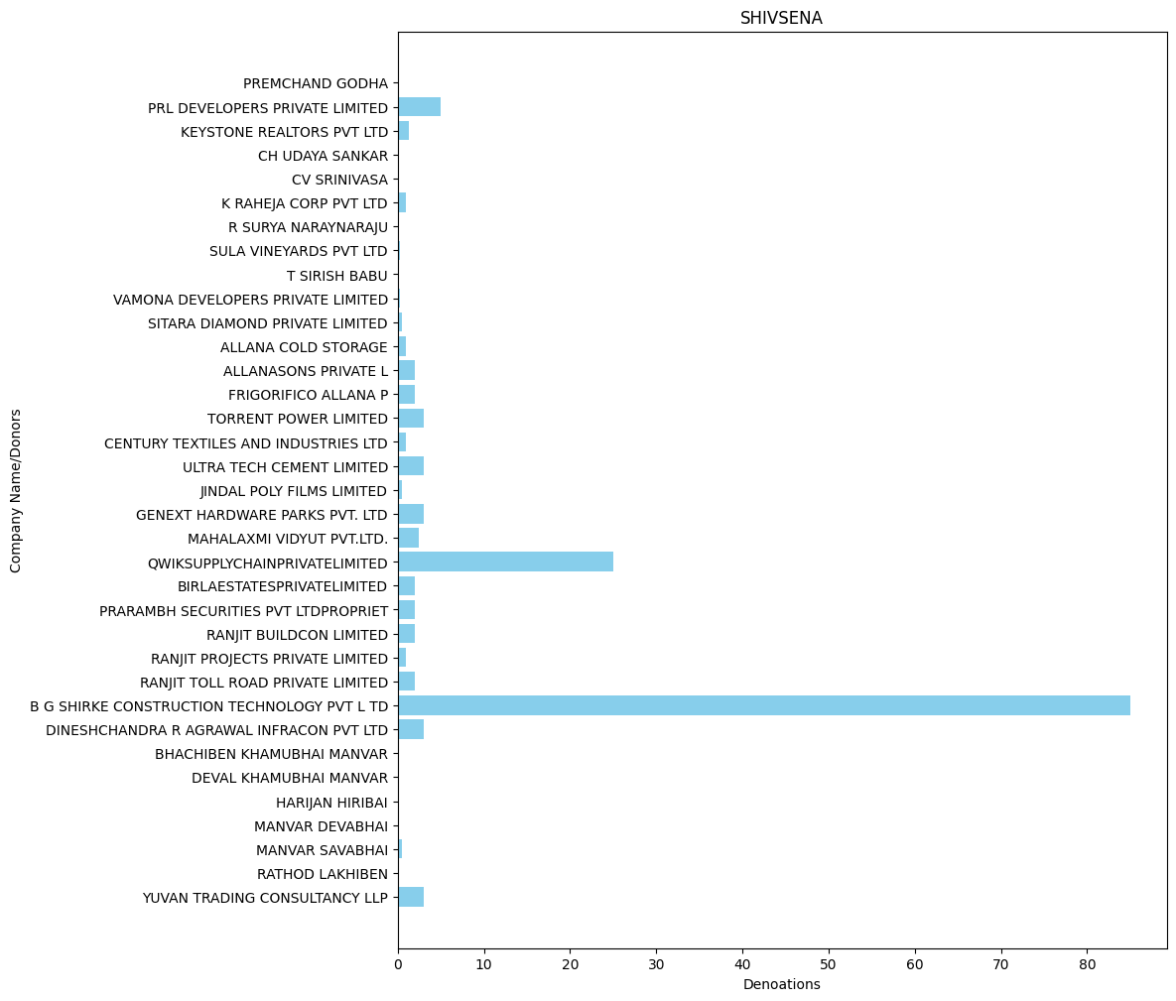

* **SHIROMANI AKALI DAL(in Crore): -**

'VARDHMAN TEXTILES LTD': 0.75,

'BHARTI INFRATEL LIMITED': 1.0,

'FASTWAY TRANSMISSIONS PVT LTD': 5.0,

'SANDEEP KHANNA AND ASSOCIATES': 0.004,

'VIKAS KUMAR GARG': 0.003,

'GOURAV KUMAR': 0.003,

'KEVENTER FOODPARK INFRA LIMITED': 0.5

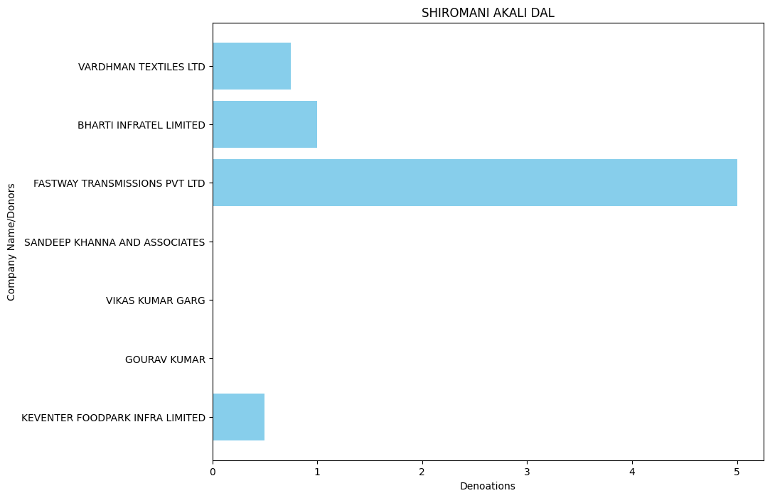

* **DRAVIDA MUNNETRA KAZHAGAM (DMK) (in Crore): -**

'MODERN ROAD MAKERS PVT LTD': 2.0,

'FUTURE GAMING AND HOTEL SERVICES PR': 453.0,

'MEGHA ENGINEERING AND INFRASTRUCTURES LI MITED': 60.0,

'KAL RADIO LIMITED': 3.5,

'SOUTH ASIA FM LIMITED': 3.5,

'SUN DISTRIBUTION SERVICES PVT LTD': 3.0,

'THE INDIA CEMENTS LTD': 4.0,

'THRIVENI EARTH MOVERS PVT LTD': 3.0,

'FUTURE GAMING AND HOTEL SERVICES PRIVATE LIMITED': 50.0,

'MEGHA ENGINEERING & INFRASTRUCTURES LIMITED': 25.0,

'FERTILELAND FOODS PRIVATE LIMITED': 5.0,

'SANDEEP AUTO LINES': 1.0,

'ASKUS LOGISTICS PVT LTD': 7.0,

'HERALD BEVERAGES PRIVATE LIMITED': 4.0,

'WESTWELL GASES PRIVATE LIMITED': 8.0

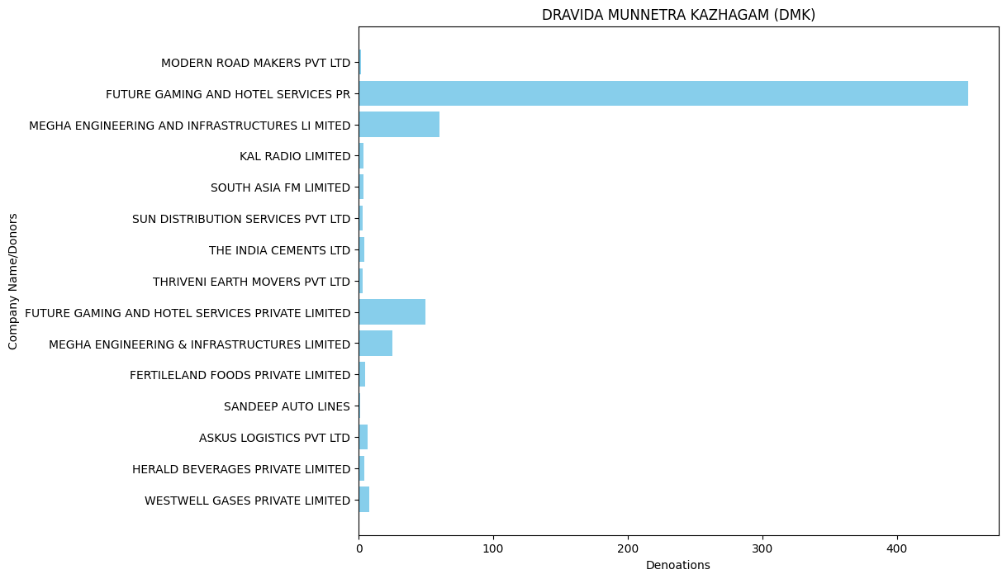

* **RASHTRIYA JANTA DAL(in Crore): -**

'QUALITY MAINTENANCE VENTURE LTD': 0.5,

'BHARTI AIRTEL LIMITEDAIRTEL CURRE NT AC-GCO': 0.1,

'M/SGAURAV INTERNATIONAL': 0.1,

'RICHA & CO': 0.5,

'SARITA HANDA EXPORTS PVT LTD': 0.3,

'SHREE CEMENT LTD': 1.0,

'CASTLE LIQUORS PRIVATE LIMITED': 0.7,

'IFB AGRO INDUSTRIES LIMITED': 35.0,

'M S VARAS INTERNATIONAL PVT LTD': 0.5,

'ASKUS LOGISTICS PRIVATE LIMITED': 9.0,

'PURULIA BOTTLING PVT LTD': 2.5,

'LAXMI INDUSTRIAL BOTTLING PLANT': 2.44,

'PRAKASH DISTILLERY & CHEMICAL CO (P) LT D': 0.8,

'VIKAS PARASRAMPURIA': 1.5,

'HERALD BEVERAGES PRIVATE LIMITED': 2.0,

'MAHABIR BANKA': 1.5,

'RAUNAK GUPTA': 3.5,

'SANDEEP AUTO LINES': 2.0,

'WESTWELL GASES PRIVATE LIMITED': 5.1,

'NORTHERN SPIRITS LTD': 1.2,

'RAHUL CHOUDHARY': 0.04,

'SENGUPTA AND SENGUPTA PVT LTD': 1.0,

'DYNAMIC CS BOTTLING PVT LTD': 0.22,

'MONALISA BOTTLING INDUSTRIES PVT LTD': 1.0

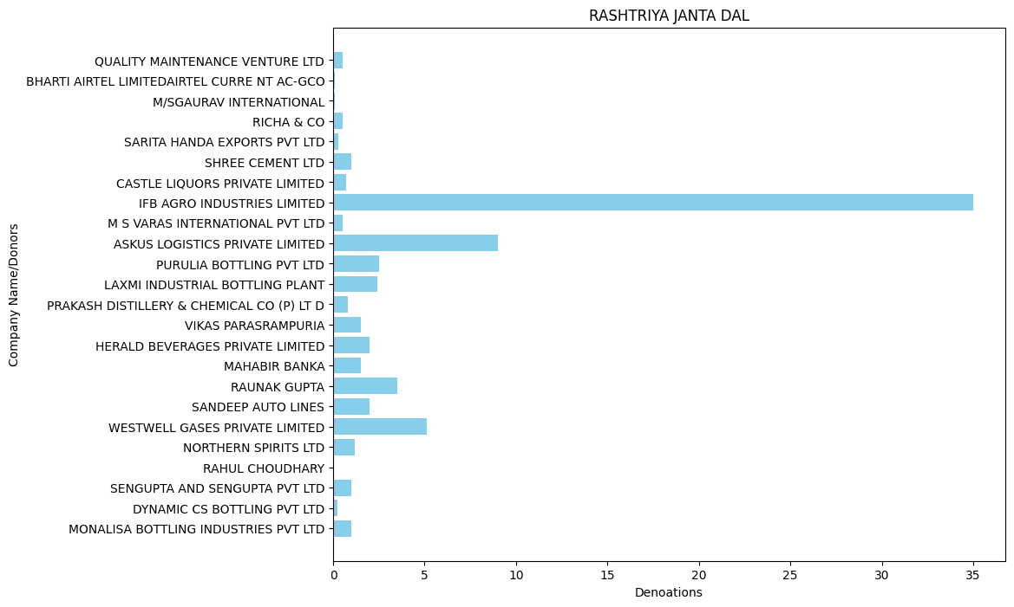

* **JAMMU AND KASHMIR NATIONAL CONFERENCE(in Crore): -**

'BHARTI AIRTEL LIMITEDAIRTEL CURRE NT AC-GCO': 0.5

* **BIHAR PRADESH JANTA DAL(UNITED) (in Crore)**: -

'BHARTI INFRATEL LIMITED': 1.0,

'SHREE CEMENT LTD': 1.0,

'MEGHA ENGINEERING AND INFRASTRUCTURES LTD': 10.0

In above data few of the party transection is hub so we can’t understand the data

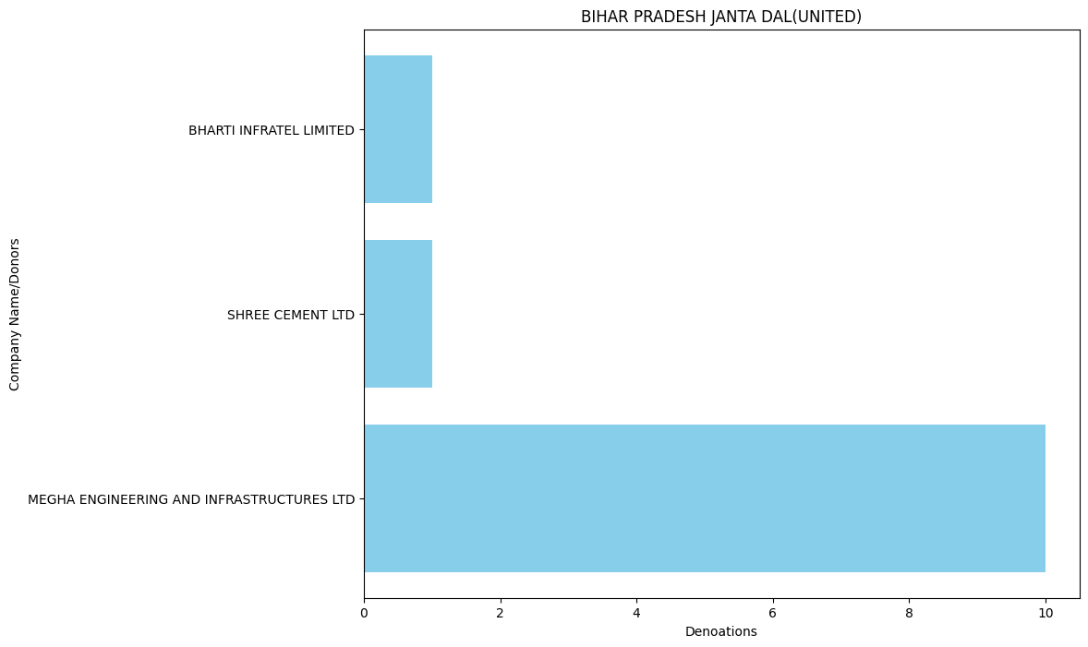

* **NATIONALIST CONGRESS PARTY MAHARASHTRA PRADESH(in Crore): -**

'AMBUJA HOUSING AND URBAN INFRASTRUCTURE CO. LTD.': 1.0,

'TORRENT POWER LIMITED': 3.5,

'AMBUJA REALTY EVENTS MANAGMENT LTD': 0.5,

'CHANDA INVESTMENT TRADING CO. PVT': 0.5,

'CYZACHEM PVT LTD': 0.75,

'MAGARPATTA TOWNSHIP DEV AND CONST C': 3.0,

'NANDED CITY DEVELOPMENT AND CONSTRU': 2.0,

'SEZ BIOTECH SERVICES PVT LTD': 0.75,

'MAHALAXMI VIDYUT PVT.LTD.': 2.5,

'RAHUL BHATIA': 3.8,

'V M SALGAOCAR CORPORATION PVT LTD': 0.1,

'GOA CARBON LTD': 0.1,

'QWIKSUPPLYCHAINPRIVATELIMITED': 10.0

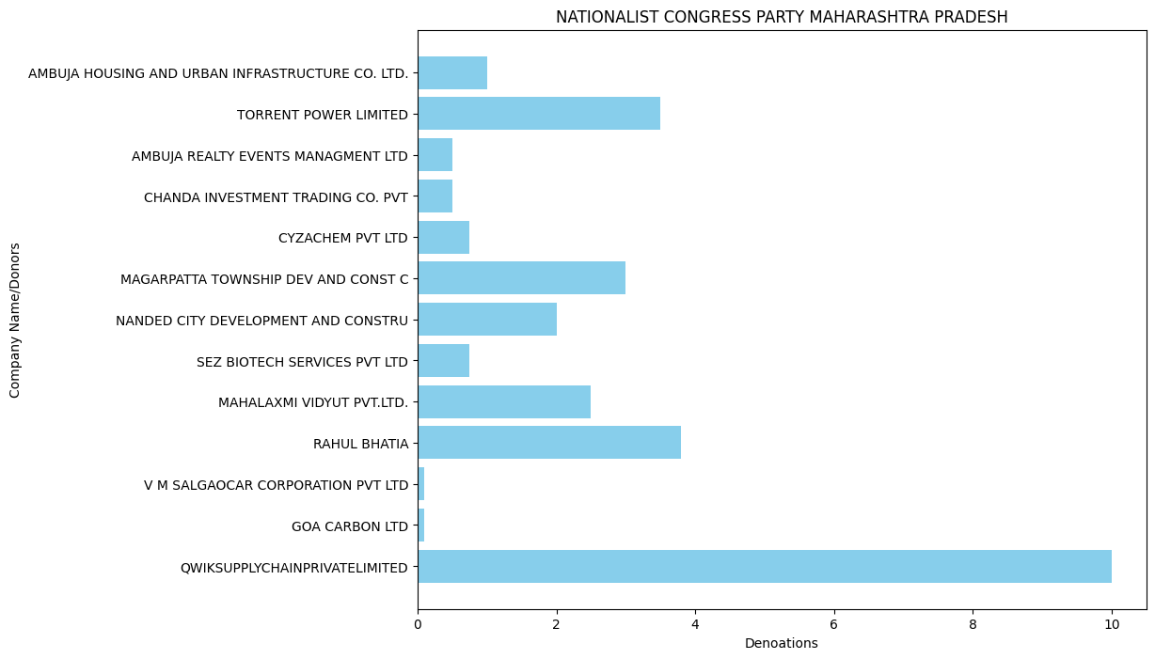

* **ADYAKSHA SAMAJVADI PARTY(in Crore): -**

'KEVENTER FOODPARK INFRA LIMITED': 10.0,

'M S JUGENDRA SINGH AND COMPANY': 0.21,

'TORRENT PHARMACEUTICALS LTD': 3.0

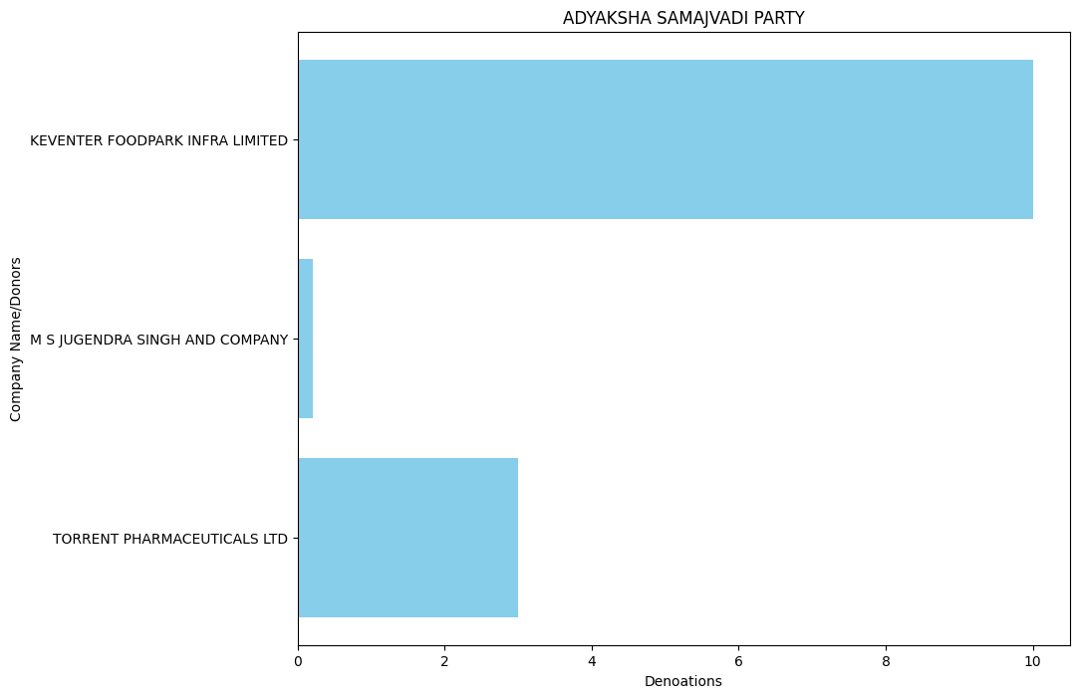

* **AAM AADMI PARTY(in Crore): -**

'TORRENT PHARMACEUTICALS LIMITED': 1.0,

'BG SHIRKE CONSTRUCTION TECHNOLOGY PVT LTD': 1.0,

'LEPTON SOFTWARE EXPORT AND RESEARCH PRIVATE LTD': 0.1,

'KRBL LTD': 0.2,

'BAJAJ AUTO LTD': 8.0,

'TECH MAHINDRA LTD': 1.0,

'SPICEJET LIMITED': 0.65,

'RAMAN SHARMA': 0.2,

'TORRENT POWER LTD': 2.0,

'V M SALGAOCAR CORPORATION PVT LTD': 0.3,

'DIWAKAR NIGAM': 0.25,

'MOTOWN TRADING PVT LTD': 0.15,

'DEMPO IND PVT LTD NAVHIND PAPERSAND PUB': 0.05,

'DEVASHRI NIRMAN LLP': 0.05,

'GOA CARBON LTD': 0.1,

'VARDHMAN TEXTILES LTD': 0.5,

'TRANSWAYS EXIM PRIVATE LIMITED': 7.0,

'ANAND SAKHARAM PIMPARKAR': 0.1,

'DR. MANDEEP SHARMA': 0.1,

'MR ANUJ GOENKA': 0.1,

'MR. BAL KISHAN GOENKA': 0.1,

'MRS. SUSHILA GOENKA': 0.1,

'MS. SHIPRA GOENKA': 0.1,

'S K SUPPLY CHAIN SOLUTIONS': 0.1,

'S K TRADERS': 0.1,

'S K TRADING CO.': 0.1,

'SAN BEVERAGES PVT LTD': 0.3,

'SAN LOGISTICS': 0.3,

'SANJAY KUMAR': 0.15,

'VINAY KUMAR BHATT': 0.15,

'AAYTEE LOGISTICS PRIVATE LIMITED': 0.3,

'ABHISHEK KAUSHIK': 0.1,

'ASHISH AGARWAL': 0.1,

'ASHOK KUMAR': 0.2,

'ASIAN TRADING CORPORATION LIMITED': 5.0,

'BENGAL VIPANAPAN PRIVATE LIMITED': 1.0,

'GPC FOODS PRIVATE LIMITED': 0.1,

'IFB AGRO INDUSTRIES LIMITED': 4.0,

'PRATIBHA AGARWAL': 0.1,

'SANTOSH GOYAL': 0.1,

'SUNKURU SURESH SUBUDHI': 0.23,

'SUNKURU SURESH SUBUDHI JT': 0.02,

'ARCEDGES BUILDING INDIA LLP': 0.5,

'AVON CYCLES LTD': 1.4,

'BESSEGGENINFOTECHLLP': 1.0,

'FORTUNE METALIKS LIMITED': 0.5,

'TORRENT POWER LIMITED': 5.0,

'KULWANT SINGH': 0.3,

'MANJIT KAUR': 0.5,

'PARAMJIT SINGH S O JAGJIT SINGH': 0.2,

'BIRD WORLDWIDE FLIGHT SERVICES INDI': 2.0,

'YASHODA SUPER SPECIALITY HOSPITAL': 1.0,

'AVEES TRADING FINANCE PVT LTD': 10.0,

'VINEET NANDA': 0.1,

'MKJ ENTERPRISES LIMITED': 7.0,

'NIRAV MAROTI': 0.15

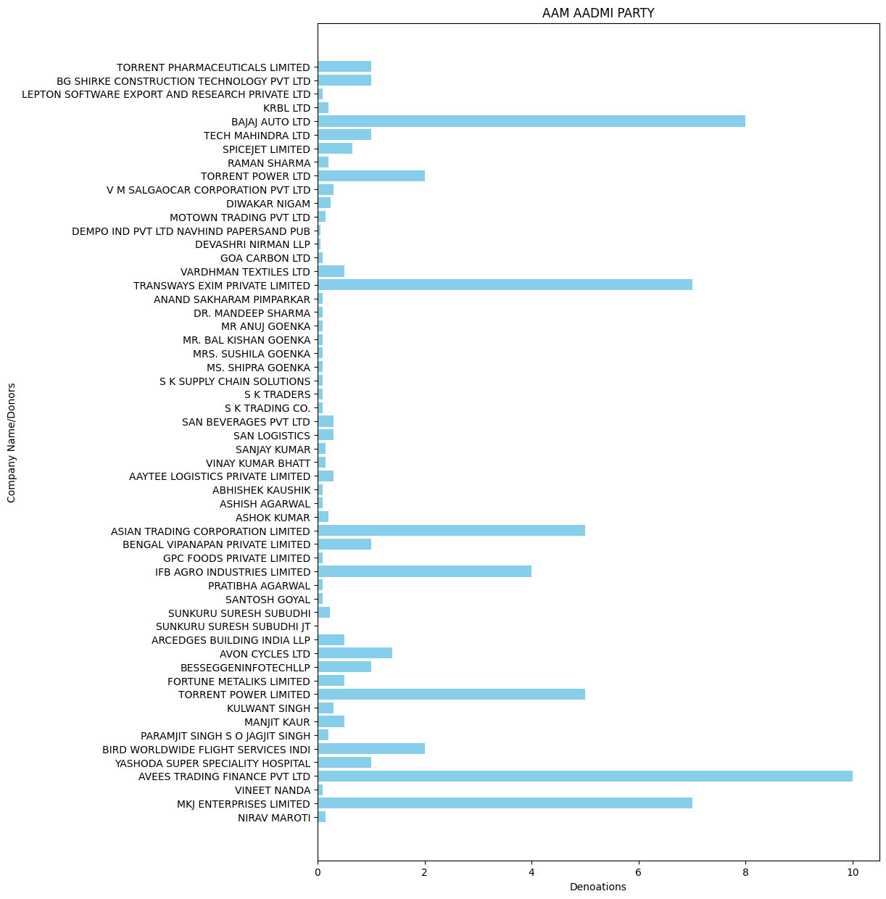

* **BHARAT RASHTRA SAMITHI(in Crore): -**

"DR.REDDY'S LABORATORIES LTD": 32.0,

'ITC LIMITED': 1.6029,

'MYTRAH ENERGY(INDIA) PRIVATE LIMITED': 5.0,

'MEGHA ENGINEERING AND INFRASTRUCTURES LI MITED': 150.0,

'ANBEE CONSTRUCTIONS LLP': 2.0,

'CAPE TRADING LLP': 2.0,

'CAPSTAN TRADING LLP': 2.0,

'CASA MARIA PROPERTIES LLP': 2.0,

'K RAHEJA CORP PVT LTD': 18.0,

'PALM SHELTER ESTATE DEVELOPMENT LL': 2.0,

'RAGHUKOOL ESTATE DEVELOPMENT LLP': 2.0,

'YASHODA SUPER SPECIALITY HOSPITAL': 94.0,

'BIGC MOBILES PVT LTD': 2.5,

'R.S.BROTHERS RETAIL INDIA PRIVATE LIMITE D': 2.5,

'SANDHYA CONSTRUCTIONS & ESTATES PRIVATE LIMITED': 13.0,

'GORUKANTI DEVENDER RAO': 1.0,

'GORUKANTI SURENDER RAO': 1.0,

'LAKSHMI MEDICALS': 2.0,

'RAJAPUSHPA ASSET MANAGEMENT LLP': 5.0,

'RAJAPUSHPA PROPERTIES PVT LTD': 20.0,

'RAVENDER RAO GORUKANTI': 1.0,

'BORAVELLI BHUPAL REDDY': 1.0,

'BORAVELLI RAMULAMMA': 1.0,

'DHEERAJ MEDICALS': 15.0,

'HETERO DRUGS LIMITED': 30.0,

'HETERO LABS LIMITED': 20.0,

'HONOUR LAB LTD': 20.0,

'KOYA AND COMPANY CONSTRUCTION LTD': 20.0,

'MEGHA ENGINEERING & INFRASTRUCTURES LIMITED': 45.0,

'14 REELS PLUS LLP': 1.0,

'AASHMAN ENERGY PVT LTD': 2.0,

'ANANTPURA WIND ENERGIES PVT LTD': 1.0,

'AUROBINDO PHARMA LIMITED': 15.0,

'AXIS CLINICALS LIMITED': 5.0,

'BRICKS INFRATECH LLP': 5.0,

'CHENNAI GREEN WOODS PRIVATE LIMITED': 50.0,

'ELITE DEVELOPERS': 2.0,

'EVEY TRANS PVT LTD': 6.0,

'GANGDARI HYDRO POWER PVT LTD': 1.0,

'GREENKO ASTHA PROJECTS (INDIA) PVT LTD': 1.0,

'GREENKO HIM KAILASH HYDRO POWER PVT LTD': 1.0,

'GREENKO SOLAR POWER (DHARAMAVARAM) LTD': 1.0,

'GREENKO SRI SAI KRISHNA HYDRO ENERGIES PVT LTD': 1.0,

'GREENKO SUMEZ HYDRO ENERGIES PVT LTD': 2.0,

'HES INFRA PVT LTD': 20.0,

'INDUS INDUSTRIAL TEC': 0.195,

'INDUS ORGANICS': 0.195,

'IRA BLOSSOM FIELDS': 3.0,

'KONERU RAVITEJA': 0.199,

'LOKESH KUMAR': 0.199,

'MSN PHARMACHEM PVT LTD': 20.0,

'P TEJAVARDHAN REDDY': 0.5,

'PAVANKUMAR REDDY KUNDURU': 0.5,

'PPR M SAND LLP': 10.0,

'PRATYASH RENEWABLE PRIVATE LIMITED': 2.0,

'R.S.BROTHERS RETIAL INDIA PVT LTD': 1.0,

'RAVINDRANATHA REDDY BANDI': 0.5,

'RAYALA SEEMA WIND ENERGY PVT LTD': 1.0,

'RT RENEWABLE ENERGY PVT LTD': 2.0,

'SAROJA RENEWABLES PRIVATE LIMITED': 2.0,

'SEI BASKARA POWER PVT LTD': 2.0,

'SEI ENERSTAR RENEWABLE ENRGY PVT LTD': 2.0,

'SEI MIHIR ENERGY PVT LTD': 2.0,

'SHREYAS RENEWABLE ENERGY PVT LTD': 2.0,

'SRI YANTRA ASSOCIATES': 0.199,

'SRICHAITANYA STUDENTS FACILITY MANAGEMENT PVT LTD': 10.0,

'TRIREME INFRASTRUCTURRE PVT LTD': 1.0,

'VARSITY EDUCATION MANAGEMENT PVT LIMITED': 2.0,

'VEERA RAVEENDRA': 0.5,

'ZUVAN ENERGY PVT LTD': 2.0,

'GREENKO BUDHIL HYDRO POWER PVT LTD': 3.0,

'GREENKO RAYALA WIND POWER PVT LTD': 3.0,

'SANOLA WIND PROJECT PVT LTD': 2.0,

'SEI VENUS PVT LTD': 2.0,

'SUNBORNE ENERGY ANDHRA PVT LTD': 2.0,

'TANOT WIND POWER VENTURES PVT LTD': 1.0,

'NATCO PHARMA LIMITED': 10.0,

'DASAMI LAB PRIVATE LTD': 2.5,

'HAZELO LAB PRIVATE LTD': 12.5,

'HINDYS LAB PRIVATE LTD': 12.5,

'DANIKA TRADERS PRIVATE LTD': 2.5,

'SELMAR LAB PRIVATE LTD': 10.0,

'AQ SQUARE REALTORS PRIVATE LIMITED': 8.0,

'ACHINTYA SOLAR POWER PRIVATE LIMITED': 4.0,

'GRINIBHRIT SOLAR POWER PVT LTD': 1.0,

'NSL SEZ(HYDERABAD) PRIVATE LIMITED': 19.5,

'PENNAR RENEWABLES PVT LTD( NEW ERA': 1.0,

'PRABHAKARA RAO MANDAVA': 0.5,

'PREMIER PHOTOVOLTAIC MEDAK (P)LTD': 1.0,

'SUVARCHAS SOLAR POWER PRIVATE LIMITED': 1.0,

'VISHVARUPA SOLAR POWER PRIVATE LIMITED': 2.0,

'BUILDOX DEVELOPERS LLP': 0.35,

'MKJ ENTERPRISES LIMITED': 10.0,

'RAJESH MANNALAL AGRAWAL': 5.0,

'SMRITI AGRAWAL': 1.0,

'ASIAN AGRI GENETICS LIMITED': 4.5,

'BISHOPS WEED FOOD CRAFTS PRIVATE LI': 1.0,

'CAMELIA GRIHA NIRMAN PRIVATE LIMITED': 1.0,

'CHAYA REAL ESTATE PVT LIMITED': 1.0,

'CURATED LIVING SOLUTIONS PRIVATE LI': 1.0,

'DIVYASREE HOLDINGS PVT LTD': 1.0,

'DIVYASREE NSL INFRASTRUCTURE PRIVATE LIM ITED': 1.0,

'DIVYASREE SOFTTECH REALTORS PVT LTD': 1.0,

'MIDAS PROJECTS PRIVATE LIMITED': 1.0,

'NSL RENEWABLE POWER PRIVATE LIMITED': 5.0,

'PRABHAKAR RAO ASHA PRIYA PROPERTIES': 3.0,

'PRABHAT HOMES PRIVATE LIMITED': 2.0,

'TOPNOTCH PROJECTS PRIVATE LIMITED': 0.5,

'YOGA BUILDERS PVT LTD': 3.0,

'FORTUNE ESTATE DEVELOPERS PVT LTD': 1.0,

'SOHINI DEVELOPERS LLP': 3.0,

'VAMSIRAM BUILDERS LLP': 3.0,

'VAMSIRAM DEVELOPERS LLP': 3.0,

'VAMSIRAMS JYOTHI LORVEN': 1.0,

'BALAJI REAL ESTATE VENTURES PVT LT': 1.0,

'BHAGYANAGAR INFRA PROJECTS': 1.0,

'BHAGYASREE REALTORS PRIVATE LIMITED': 1.0,

'HONOUR LAB LIMITED': 5.0,

'MYTRAH ENERGY INDIA PRIVATE LIMITED': 1.0,

'NSL SEZ HYDERABAD PRIVATE LIMITED': 5.0,

'MODERN ROAD MAKERS PVT LTD': 5.0,

'SUPER CYBERTECH PARK PRIVATE LIMITE': 10.0,

'IRB MP EXPRESSWAY PRIVATE LIMITED': 25.0,

'VENKAT PRANEETH DEVELOPRS (P) LTD': 1.0,

'DIVI S LABORATORIES LIMITED': 20.0,

'KITEX CHILDRENSWEAR LTD': 9.0,

'KITEX GARMENTS LIMITED': 16.0,

'AALAYA CONSTRUCTIONS': 1.0,

'BHASWINI DEVELOPERS': 1.0,

'DIVIT SECURITY': 0.7,

'MY HOME INFRASTRUCTURES PRIVATE LI': 15.0,

'SRI DEVELOPERS': 1.0,

'SRI KARTHIKEYA DEVELOPERS': 1.0,

'VASUDHA DEVELOPERS': 1.0,

'AQUA SPACE DEVELOPERS PRIVATE LIMIT': 15.0,

'CHANDAKA SANYASI RAO': 0.05,

'DINESH PROJECTS': 0.55,

'ELLISBRIDGE ESTATES PVT LTD': 0.5,

'FOR M/S SRI NIDHI CONSTRUCTIONS': 1.0,

'G CHANDRASHEKHAR': 0.05,

'GAJA ENGINEERING PVT LTD': 5.0,

'LAURELSECURITIESPVTLTD': 2.0,

'MB POWER (MADHYA PRADESH) LTD': 5.0,

'SAGAR CEMENTS LIMITED': 0.5,

'SIDDHARTH DEVELOPERS': 1.0,

'SWARNARETH MINERAL INDUSTRIES': 1.0,

'VERTEX VEGA DEVELOPERS LLP': 4.0,

'AMAR KRISHNA SAJJA': 0.05,

'BESSEGGENINFOTECHLLP': 4.0,

'KAUSTUBH VERMA': 0.5,

'KNR CONSTRUCTIONS LTD': 10.0,

'LPF SYSTEMS PRIVATE LIMITED': 1.0,

'MUPPANA VENKATA RAO': 0.9,

'NVNR POWER INFRA PRIVATE LIMITED': 2.0,

'PRESTIGE GARDEN ESTATES PRIVATE LIM': 5.0,

'PRESTIGE PROJECTS PVT LTD': 5.0,

'PRUDHVI CONSTRUCTIONS PRIVATE LIMIT': 2.5,

'R': 2.5,

'REPALLY ASHOK': 0.05,

'RIGHT AID CONSULTANTS PVT LTD': 1.5,

'SAGI VENKATA RAMAKRISHNA RAJU': 1.0,

'SILVERTONE SECURITIES PRIVATE LIMIT': 0.3,

'TELLAPUR TECHNOCITY PRIVATE LIMI': 20.0,

'V BALAVEERIAH SONS': 0.25,

'BSCPL INFRASTRUCTURE LIMITED': 1.5,

'GURRAM MOUNIKA': 0.2,

'GURRAM RAVI': 0.2,

'MANITHEJ ENTERPRISES': 0.1,

'PASURA AGRI SCIENCES LLP': 0.25,

'PASURA CROP CARE PVT LTD': 0.5,

'PRIMUSGLOBALTECHNOLOGIESPVTLTD': 0.25,

'ABHINANDANSTOCKBROKINGPVTLTD': 1.0,

'ALA RAMANJANEYULU': 0.05,

'BIOLOGICAL E LIMITED': 5.0,

'BOSE CONSTRUCTIONS': 0.5,

'BUTTA HOSPITALITIES PVT LTD': 0.25,

'CYBER HOMES': 1.0,

'DOYEN ENGINEERING SERVICES PRIVATE': 1.0,

'EVEREST ENTERPRISE': 0.2,

'GANGADASU BASIVI REDDY': 0.08,

'GANGES JUTE PRIVATE LTD': 1.0,

'GOWREDDY HARIPRASAD REDDY': 0.05,

'HINDYS LAB PVT. LTD. (PREVIOUSLY HIND LI FE SCIENCES PVT LTD)': 5.0,

'ICONICA PROJECTS': 1.0,

'ISTAMSETTY SONY': 0.12,

'KAMNA CREDITS AND PROMOTORS PVT LTD': 7.0,

'KARTHIKEYA CONSTRUCTIONS': 1.0,

'KARTIKEYA INFRA': 0.09,

'KMK DEVELOPERS PVT LTD ASHISH BHAS': 1.0,

'NVSUBBA RAO': 1.5,

'PCBL LIMITED': 5.0,

'PREMIER PLASTIC INDUSTRIES': 0.09,

'R K V FABTECH INDIA PRIVATE LIMITED': 0.4,

'R N CONSTRUCTIONS': 2.0,

'R V SUBRAHAMANYAM ISTAMSETTY': 0.13,

'RAMESH KRISHNA ENGINEERS PRIVATE LIMITED': 0.2,

'SIAN INFRA AND REALCON LLP': 0.25,

'SR DEVELOPERS': 1.0,

'SRI SAI BIO ORGANICS( OPR BY R V SUBRAHM ANYAM I)': 3.55,

'SRI SIDDARTHA CONSTRUCTIONS': 1.0,

'SRI VIGNEWARA CONSTRUCTIONS': 0.09,

'SRIVAY INDUSTRIES LIMITED': 1.49,

'SRIVILAS HYDROTECH PVT LTD': 1.0,

'SUNIL ENGINEERING AND SYSTEMS': 1.5,

'THE ANGUS COMPANY LIMITED': 2.0,

'THE GANGES MANUFACTURING CO LTD': 1.0,

'TSHARKS INFRA DEVELOPERS PRIVATE LI': 3.5,

'TSHARKS OVERSEAS EDUCATION CONSULTA': 4.0,

'VASAVI AVENUES LLP': 5.0,

'VENKATESH NARAYAN REDDY': 0.2,

'VINAY AGARWAL': 0.08,

'NATCO PHARMA LTD': 10.0,

'BASANT GAJANAND LAKHOTIYA': 0.2,

'GOURAV RAJESH MUNDHRA': 0.05,

'HEMANT LAKHOTIA': 0.07,

'NIKHIL SUNIL MUNDHRA': 0.05,

'RACHIT KAILASH MUNDHRA': 0.05,

'ASHISH KHANDELWAL': 0.06,

'VIVEK BANSAL': 0.07,

'ASHISH JAIN': 0.2,

'DEEPAK': 0.2,

'KAUSHALENDER AGGARWAL': 0.15,

'L7 HITECH PRIVATE LIMITED': 22.0,

'AKSHAT GREENTECH PRIVATE LIMITED': 5.0,

'H S ARAVINDA': 0.25,

'MR. ISHANT GUPTA': 0.05,

'MR. NISHANT K YADAV': 0.1,

'APARNA FARMS AND ESTATES LLP': 15.0,

'JK PAPER LIMITED': 0.5,

'DESAI TRADING CONSULTANTS PVT LTD': 1.0,

'WELSPUN LIVING LIMITED': 5.0,

'YUVAN TRADING CONSULTANCY LLP': 2.0,

'INORBIT MALLS': 5.0

* **BIJU JANATA DAL(in Crore): -**

'KAYPEE ENTERPRISES': 10.0,

'MS S N MOHANTY': 45.0,

'PENGUIN TRADING & AGENCIES LIMITED': 27.5,

'ESSEL MINING AND INDS LTD': 174.5,

'ULTRATECHCEMENTSLTD': 10.0,

'GRASIM INDUSTRIES LTD': 10.0,

'UTKAL ALUMINA INTERNATIONAL LTD': 10.0,

'ARDENT STEEL LIMITED': 4.0,

'RUNGTA SONS P LTD': 50.0,

'SHRI JAGANNATH STEELS & POWER LTD': 14.0,

'ORISSA METALIKS PVT LIMITED': 10.0,

'PROCURE ADVISORY SERVICES PRIVATE LTD': 8.0,

'RASHMI CEMENT LTD': 45.0,

'RASHMI METALIKS LTD': 27.0,

'ROSHNI DEALMARK PRIVATE LTD': 5.0,

'KAMNA CREDITS AND PROMOTORS PVT LTD': 5.0,

'NIRMAL KUMAR BATHWAL': 2.0,

'ORRISA METALIKS PVT LTD': 8.0,

'PENGUIN TRADING AND AGENCIES LTD': 3.0,

'AVEES TRADING AND FINANCE PVT LTD': 3.0,

'JINDAL STAINLESS LTD': 30.0,

'VEDANTA LIMITED': 40.0,

'PRB SECURITIES PVT LTD': 1.5,

'DIVIT SECURITY': 0.5,

'IFB AGRO INDUSTRIES LIMITED': 6.3,

'PROCURE ADVISORY SERVICES PRIVATE L': 1.0,

'ROSHNI DEALMARK PRIVATE LIMITED': 1.0,

'ABHINANDANSTOCKBROKINGPVTLTD': 1.2,

'BENGAL VIPANAPAN PRIVATE LIMITED': 3.0,

'JINDAL STEEL AND POWER LIMITED': 100.0,

'MONALISA BOTTLING INDUSTRIES PVT LTD': 2.0,

'MANU VYAPAR (P) LTD.': 2.0,

'GALAXY C.S. BOTTLING PLANT': 0.5,

'MKJ ENTERPRISES LIMITED': 10.0,

'D S ENGINEERING WORKS LLP': 5.0,

'BALU CEMENT CORPORATION': 1.5,

'BALU IRON AND STEEL COMPANY': 6.0,

'PARESH CHAMPAKLAL SHAH': 1.0,

'SILVERTONE SECURITIES PRIVATE LIMIT': 1.2,

'VIPUL CHAMPAKLAL SHAH': 1.0,

'THE PUNJAB BUSINESS SUPPLY COMPANY': 7.8,

'UTKAL ALUMINA INTERNATIONAL LIMITED': 60.0,

'PRADEEP AGGARWAL': 1.0,

'SHRI SHAMLAJI SALES PRIVATE LIMITED': 10.0,

'VIKAS AGGARWAL': 1.0,

'HH IRON AND STEEL PRIVATE LIMITED': 5.0,

'THRIVENI EARTHMOVERS PVT LTD': 5.0

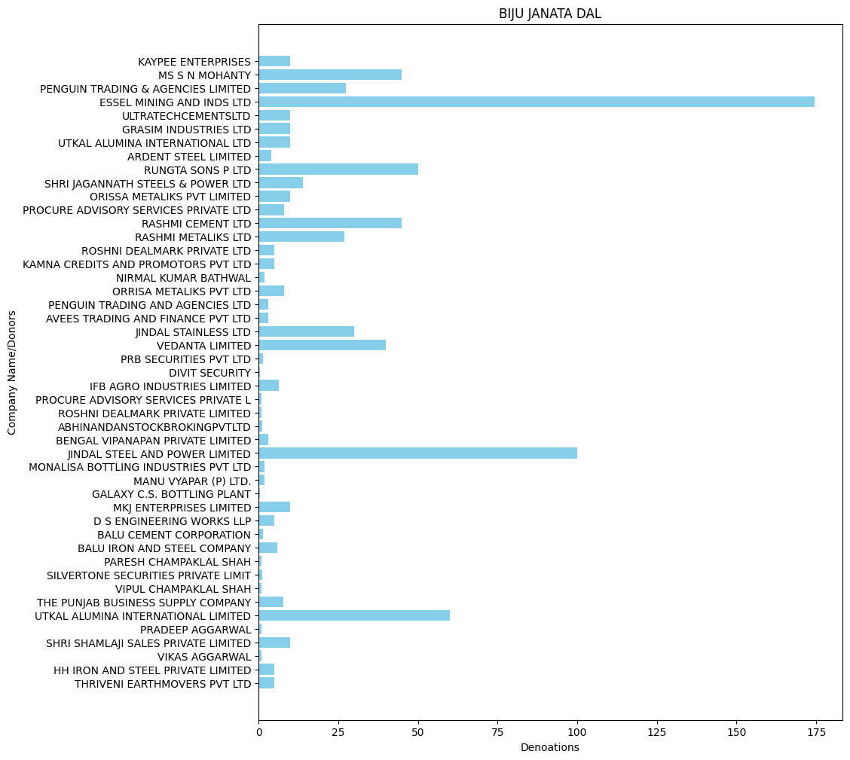

* **YSR(in Crore): -**

'FUTURE GAMING AND HOTEL SERVICES PR': 154.0,

'PRAKASH DISTILLERY & CHEMICAL CO (P) LT D': 0.12,

'RAMESH AGARWAL C S BOTTLING PLANT': 0.72,

'SAROJIT KUMAR DEY': 0.5,

'HIMALAYAN ENDEAVOUR PVT LTD': 1.4,

'LAXMI INDUSTRIAL BOTTLING PLAN': 0.71,

'MONALISA BOTTLING INDUSTRIES PVT LTD': 0.5,

'SENGUPTA AND SENGUPTA PRIVATE LIMIT': 1.4,

'TRANSWAYS EXIM PRIVATE LTD': 0.6,

'VARAS INTERNATIONAL PRIVATE LIMITED': 0.3,

'ACHINTYA SOLAR POWER PVT LTD': 1.0,

'DIVYESH POWER PVT LTD': 2.0,

'ELENA RENEWABLE ENERGY PVT LTD': 2.0,

'SEI DIAMOND PVT LTD': 2.0,

'TANOT WIND POWER VENTURES PVT LTD': 3.0,

'MEGHA ENGINEERING AND INFRASTRUCTURES LI MITED': 37.0,

'JYOTSNA AGGARWAL': 0.25,

'KHUSHBU AGGARWAL': 0.25,

'PREM AGGARWAL': 0.25,

'PREM AGGARWAL AND SONS HUF': 0.25,

'SANDEEP AGGARWAL': 0.25,

'SANDEEP AGGARWAL AND SONS HUF': 0.25,

'USHA AGGARWAL': 0.25,

'VEDANTA ELECTRICALS PRIVATE LIMITED': 1.75,

'VIPIN AGGARWAL': 0.25,

'VIPIN AGGARWAL AND SONS HUF': 0.25,

'THE RAMCO CEMENTS LIMITED': 23.0,

'EVERSHINE INTERIORS CHENNAI PVT LTD': 5.0,

'FUTURISTIC HANDLING SERVICES PVT LTD': 5.0,

'AARISH SOLAR POWER PRIVATE LIMITED': 1.0,

'AASHMAN ENERGY PRIVATE LIMITED': 1.0,

'ANIMALA WIND POWER PRIVATE LIMITED': 2.0,

'AXIS WIND FARMS (MPR DAM) PRIVATE L': 3.0,

'DIVYESH POWER PRIVATE LIMITED': 1.0,

'ELENA RENEWABLE ENERGY PRIVATE LIMITED': 1.0,

'GREENKO ANANTAPUR WIND POWER PRIVATE LIMITED': 5.0,

'GREENKO URAVAKONDA WIND POWER PRIVA': 3.0,

'SEI ARUSHI PVT LTD': 1.0,

'SHREYAS RENEWABLE ENERGY PRIVATE LTD': 1.0,

'SKEIRON RENEWABLE ENERGY AMIDYALA PRIVATE LIMITED': 5.0,

'TADAS WIND ENERGY PVT LTD': 1.0,

'ZUVAN ENERGY PRIVATE LIMITED': 1.0,

'SAGAR CEMENTS LIMITED': 0.5,

'DEVARAHIPPARIGI WIND POWER PVT LTD': 2.0,

'GREENKO RAYALA WIND POWER PRIVATE LIMITE D': 2.0,

'KHANDKE WIND ENERGY PRIVATE LIMITED': 2.0,

'SKEIRON RENEWABLE ENERGY AMIDYALA P': 2.0,

'SNEHA KINETIC POWER PROJECTS PVT LTD': 10.0,

'OSTRO JAISALMER PRIVATE LIMITED': 17.0,

'OSTRO MADHYA WIND PRIVATE LIMITED': 17.0,

'NATCO PHARMA LTD': 3.0

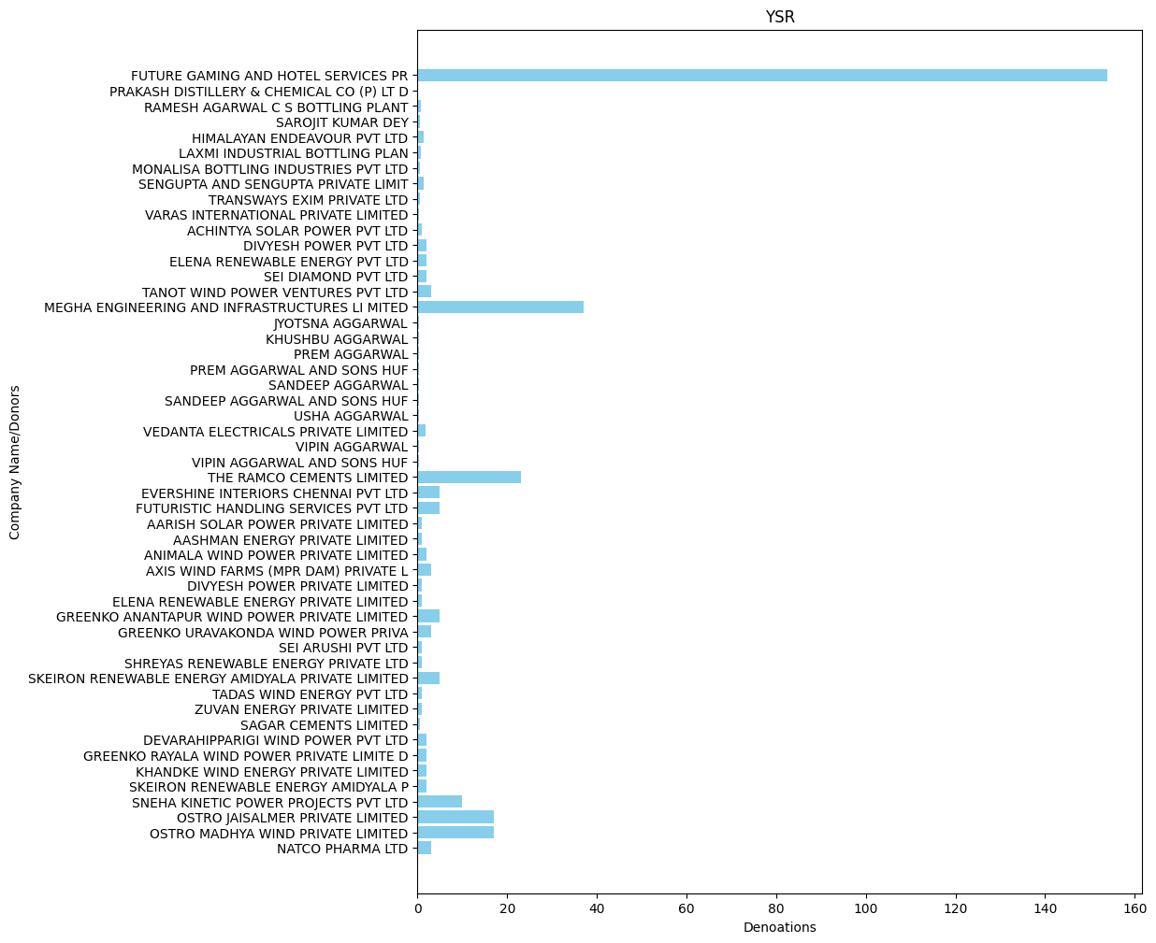

* **TELUGU DESAM PARTY(in Crore): -**

'AUROBINDO PHARMA LIMITED': 2.5,

'NATCO PHARMA LTD': 14.0,

'DR REDDYS LABORATORIES LIMITED': 3.0,

'TRIDENTCHEMPHARLIMITED': 5.0,

'THE RAMCO CEMENTS LIMITED': 5.0,

'AMARAVATI TEKSYSTEMS PRIVATE LIMITE': 2.0,

'TEKREANT INDIA PRIVATE LIMITED': 2.0,

'SLICK SOFTWARE SOLUTIONS PRIVATE LI': 1.0,

'SREE RAYALASEEMA HI STRENGTH HYPO LTD': 1.0,

'EFICENS SOFTWARE SERVICES PVT LTD': 2.0,

'MEGHA ENGINEERING AND INFRASTRUCTURES LI MITED': 28.0,

'RITHWIK PROJECTS PRIVATE LIMITED': 5.0,

'KIRITI VENTURES PRIVATE LIMITED': 2.0,

'C R ASSOCIATES': 5.0,

'MAATHA PROJECTS LLP': 5.0,

'N A R INFRA PRIVATE LIMITED': 5.0,

'SUDHAKAR KANCHARLA': 5.0,

'SAGAR CEMENTS LIMITED': 0.5,

'BYRAPANENI SHIVARJUN RAO': 0.25,

'SLRV HOMES LLP': 2.0,

'R K INFRACORP PRIVATE LIMITED': 0.88,

'PRIMUSGLOBALTECHNOLOGIESPVTLTD': 0.45,

'SRI SIDDHARTH INFRATECH & SERVICES(I) PVT LTD': 0.9,

'SRI SIDDHARTH INFRATECH AND SERVICES I P': 0.1,

'AIC VMR PROJECTS PVT LTD': 2.0,

'SEPC POWER PVT LTD OPERATION RETEN': 5.0,

'SOMASILA SOLAR POWER LIMITED': 2.0,

"DR.REDDY'S LABORATORIES LTD": 10.0,

'BHARAT BIOTECH INTERNATIONAL LIMITED': 10.0,

'CHIRON BEHRING VACCINES PVT LTD': 5.0,

'BIOVET PVT LTD': 5.0,

'RCC NUTRA FILL PRIVATE LIMITED': 5.0,

'GRANULES INDIA LIMITED': 3.0,

'SHIRDI SAI ELECTRICALS LTD': 40.0,

'SRI CHAITANYA STUDENTS FACILITY MANAGEME': 5.0,

'VIHAAN AUTO VENTURES PRIVATE LIMITED': 2.0,

'WESTERN UP POWER TRANSMISSION COMPANY LI MITED': 20.0

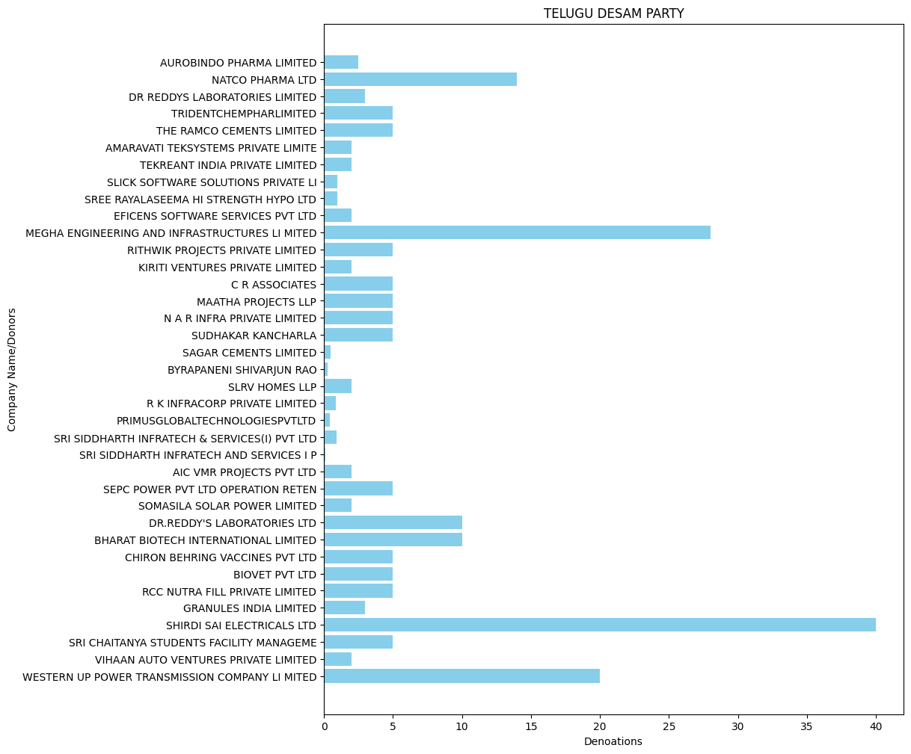

* **GOA FORWARD PARTY(in Crore): -**

'V M SALGAOCAR CORPORATION PVT LTD': 0.15,

'GOA CARBON LTD': 0.2

* **MAHARASHTRAWADI GOMNTAK PARTY(in Crore):-**

'V M SALGAOCAR CORPORATION PVT LTD': 0.35,

'SHRINIVAS VASUDEVA DEMPO': 0.2

* **SIKKIM KRANTIKARI MORCHA (in Crore): -**

'FUTURE GAMING AND HOTEL SERVICES PR': 8.0,

'IPCA LABORATORIES LIMITED': 3.5,

'ZYDUS HEALTHCARE LIMITED': 8.0,

'FUTURE GAMING AND HOTEL SERVICES PVT LTD': 3.0,

'MICRO LABS LIMITED': 7.0,

'TORRENT PHARMACEUTICALS LTD': 7.0

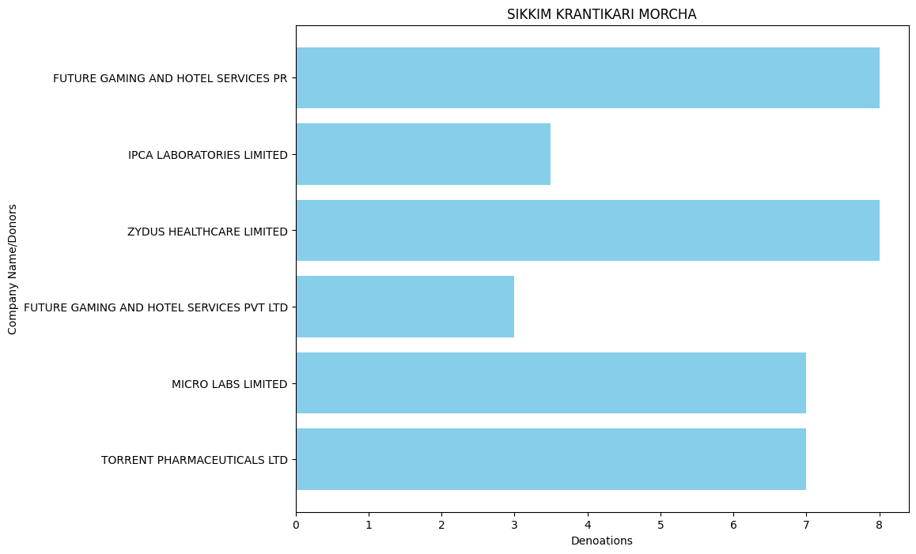

* **JANASENA PARTY (in Crore): -**

'MEGHA ENGINEERING AND INFRASTRUCTURES LI MITED': 4.0,

'NATCO PHARMA LTD': 5.0,

'VALLURUPALLI PRABHU KISHORE': 1.0,

'SRI CHAITANYA STUDENTS FACILITY MANAGEME': 1.0,

'WESTERN UP POWER TRANSMISSION COMPANY LI MITED': 10.0

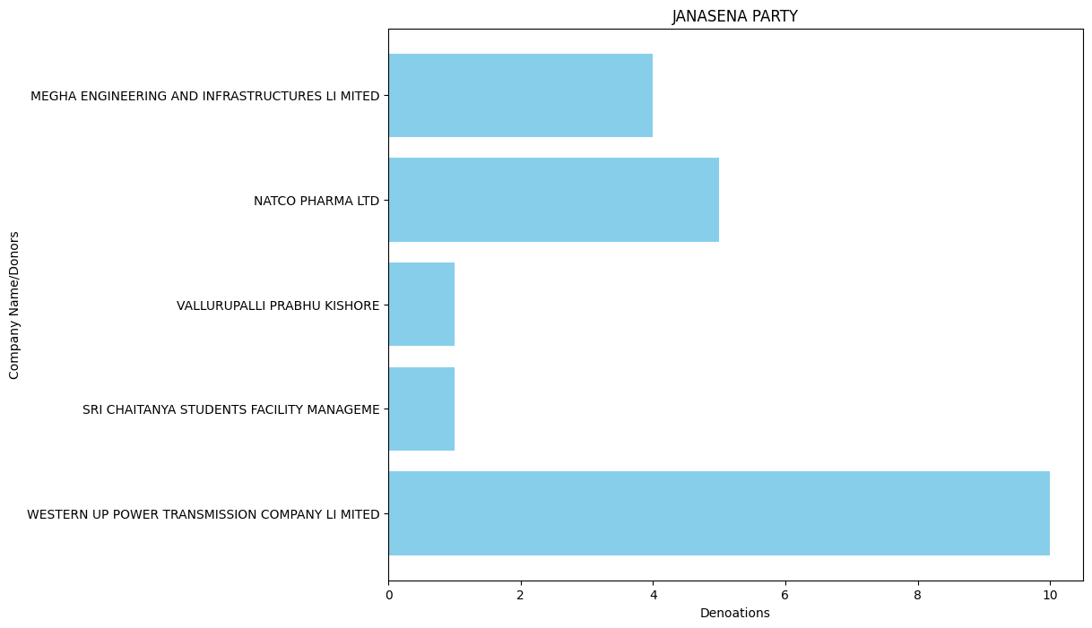

* **YSR CONGRESS PARTY (in Crore): -**

'YASHODA SUPER SPECIALITY HOSPITAL': 1.0,

'THE RAMCO CEMENTS LIMITED': 1.0,

'AARISH SOLAR POWER PRIVATE LIMITED': 1.0

* **JHARKHAND MUKTI MORCHA (in Crore): -**

SHREE CHAND SARAOGI': 0.75,

'RITESH PROJECTS PVT LTD': 0.25,

'MKJ ENTERPRISES LIMITED': 1.0,

'VEDANTA LIMITED': 5.0,

'PUJA COAL PRIVATE LIMITED': 2.0,

'THRIVENI SAINIK MINING PRIVATE LIMI': 3.0,

'DINESHCHANDRA R AGRAWAL INFRACON PVT LTD': 0.5

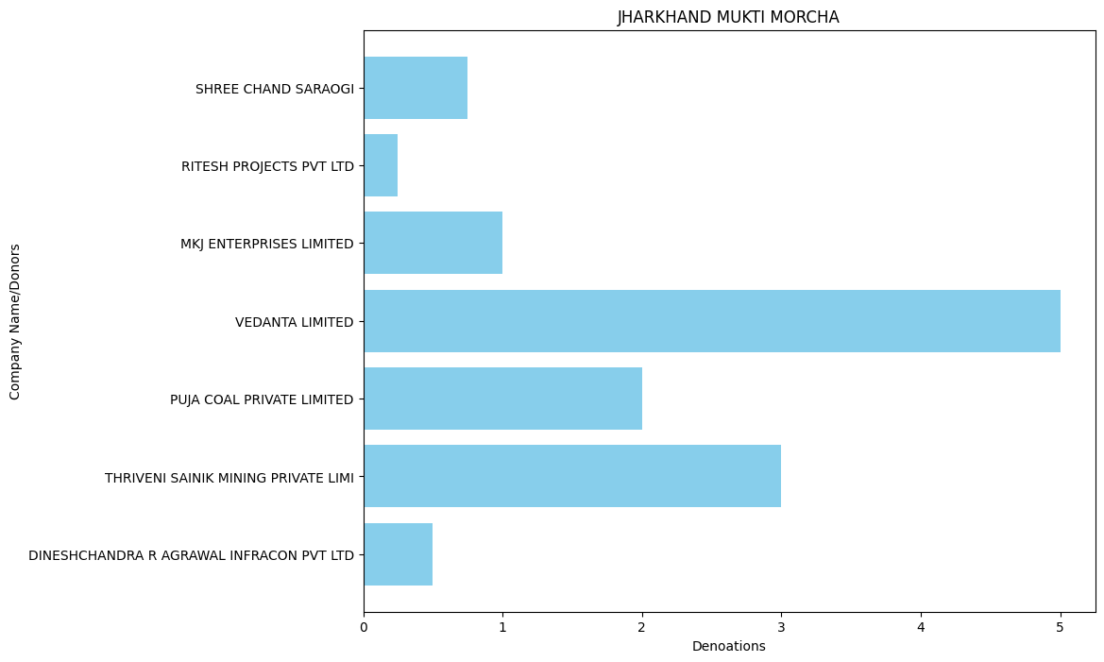

* **JANATA DAL ( SECULAR ) (in Crore): -**

'ILABS HYD TECHNOLOGY CENTRE PVT LTD': 5.0,

'KCR ENTERPRISE LLP': 5.0,

'KIRAN MAZUMDAR SHAW': 1.0,

'MEGHA ENGINEERING AND INFRASTRUCTURES LI MITED': 5.0,

'RITHWIK PROJECTS PRIVATE LIMITED': 10.0,

'NARA CONSTRUCTIONS': 10.0,

'NIMBHA BIOTECH PRIVATE LIMITED': 2.0,

'SIGMA ADVANCED SYSTEMS PRIVATE LIMI': 3.0

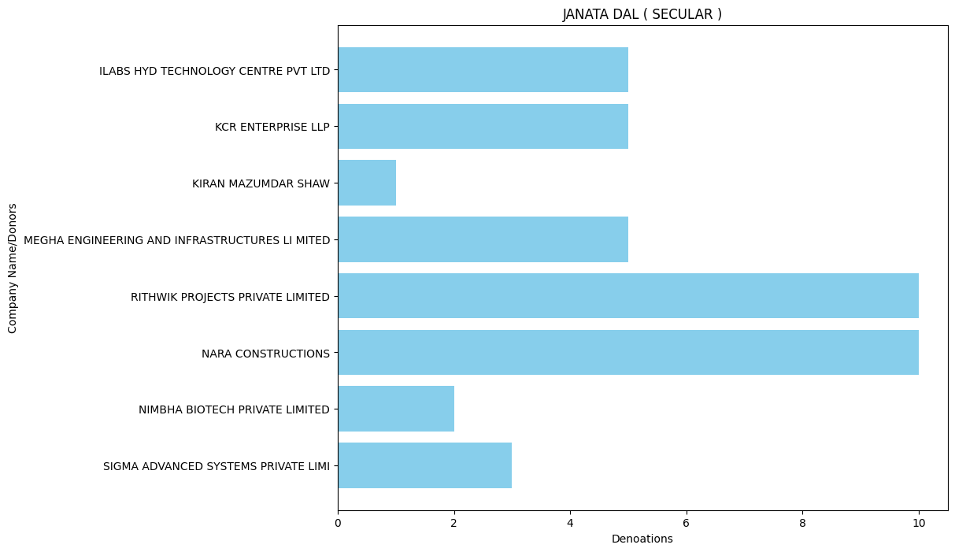

* **SIKKIM DEMOCRATIC FRONT (in Crore): -**

'FUTURE GAMING AND HOTEL SERVICES PR': 5.0,

'TORRENT PHARMACEUTICALS LTD': 0.5

The data above has huge violations in some parties and is difficult to understand, so I break

it down by year bases.

**Further Break the Marged Datasets: -**

**BJP: -**

* BJP 2019 : -

'A B C INDIA LIMITED': 0.4,

'ARIHANT ENTERPRISES': 0.4,

'CHOUDHARY GARMENTS': 0.2,

'ESSEL MINING AND INDS LTD': 50.0,

'GRASIM INDUSTRIES LTD': 23.0,

'HIGHSTREET CRUISES AND ENTERTAINMENT PVT LTD': 0.3,

'KAMLANG SAW & VENEER MILLS PVT LTD': 0.2,

'MEGHA ENGINEERING AND INFRASTRUCTURES LI MITED': 125.0,

'MSPL LTD': 1.0,

'MYRIAD DEVELOPERS': 0.15,

'OMKAR VENTURES PVT LTD': 4.0,

'PATEL HIGHWAY MANAGEMENT PVT LTD': 1.0,

'PHL FINIVEST PVT LTD': 40.0,

'PIRAMAL CAPITAL AND HOUSING FINANCE LTD': 10.0,

'PIRAMAL ENTERPRISES LTD': 10.0,

'RENUKA INVESTMENTS AND FINANCE LTD': 5.0,

'RENUKESHWAR INVESTMENTS PVT LTD': 5.0,

'SHIVAM TRANSCON PRIVATE LIMITED': 0.5,

'SKYWORLD DEVELOPERS LLP': 0.15,

'TEXPORT CREATION': 0.9,

'ALOK NARAYAN PANDEY': 3.4,

'BELLWEY INTERNATIONAL CO': 1.0,

'CHHATTISGARH DISTILLERIES LIMITED': 1.0,

'DEMPO INDUSTRIES PVT LTD': 0.05,

'GUJARAT FLUORO CHEMICALS LIMITED': 10.0,

'MOHINDER': 0.25,

'MR RAJ DEEPAK VARSHNEY': 0.05,

'MS PEARL GLOBAL INDUSTRIES LTD FORM': 1.6,

'OCEAN SPARKLE LTD': 0.1,

'PREMCHAND GODHA': 0.1,

'PRL DEVELOPERS PRIVATE LIMITED': 10.0,

'SHAHAB RIZVI': 0.1,

'SHANKARANARAYANA CONSTRUCTIONS PVT': 5.0,

'SRI KRISHNA INFRAASTRUCTURES': 2.0,

'SUN PHARMA LABORATORIES LIMTED': 20.0,

'SUN PHARMA LABORATORIES LTD': 11.5,

'VASSUDEVA DEMPO FAMILY PRIVATE TRUST': 0.05,

'CAVALIER TRANSPORTERS PRIVATE LIMITED': 0.85,

'JAI SUSPENSION SYSTEMS LLP': 0.5,

'KEVENTER FOODPARK INFRA LIMITED': 144.5,

'KEYSTONE REALTORS PVT LTD': 3.0,

'MUTHOOT FINANCE LTD': 3.0,

'OMKAR REALTORS PROJECTS PVT LTD': 3.0,

'PEGASUS PROPERTIES PVT LTD': 10.0,

'PRIME SALES CORPORATION': 1.25,

'RAIPUR BOTLING COMPANY': 1.0001,

'S R C CHEMICALS PVT LTD': 1.0,

'SANJAY JAIN': 0.1,

'SDS LOGISTICS PRIVATE LIMITED': 0.35,

'SHAURYAVIR CARRIERS PRIVATE LIMITED': 1.0,

'SNS CLOTHING PVT LTD': 2.0,

'ST PATRICKS REALTY PVT LTD': 3.0,

'SWETA ESTATES PVT LTD': 2.0,

'THE SUPREME INDUSTRIES LTD': 1.5,

'UM CABLES LIMITED': 4.0,

'VEDANTA LIMITED': 52.65,

'ACE COMERCIAL COMPANY PRIVATE LIMITED': 0.25,

'DEVEN CHAND JAIN': 0.7,

'RAJEEV KUMAR JAIN': 0.2,

'AISHWARYA BUSINESS CORPORATION PVT, LTD': 5.0,

'B2C CONSULTING LLP': 1.0,

'BAJAJ AUTO LTD': 10.0,

'BAJAJ FINANCE LTD': 20.0,

'BAJAJ HOLDINGS & INVESTMENT LIMITED': 10.0,

'BHARTI AIRTEL LIMITEDAIRTEL CURRE NT AC-GCO': 14.4,

'BHARTI INFRATEL LIMITED': 2.0,

'FINOLEX CABLES LTD': 18.0,

'GRAUER AMP': 0.01,

'HUB POWER COMPANY': 0.95,

'INOX AIR PRODUCTS LTD': 4.0,

'INOX LEISURE LTD': 1.0,

'LAKSHMI NIWAS MITTAL': 35.0,

'LALIT GULATI': 0.5,

'M/SGAURAV INTERNATIONAL': 0.4,

'MEHERFOUNDATIONSANDCIVILENGPVT': 0.5,

'MOTOWN TRADING PVT LTD': 0.05,

'MR. VIJAY KUMAR GOYAL': 0.1,

'NAVAYUGA ENGINEERING COMPANY LIMITED': 45.0,

'ORIENT FASHION EXP (I) PVT LTD': 0.6,

'RICHA GLOBAL EXPORTS PRIVATE LIMITED': 1.0,

'SAMMAN LAL SHER SINGH PAPERS PVT LT': 0.25,

'SARD INDIA PRIVATE L': 0.6,

'SAURABH GUPTA': 10.0,

'SHAHIEXP': 3.0,

'VM SALGAOCAR CORPORATION PVT LTD': 0.2,

'ADIT BUILD WELL PVT LTD': 1.0,

'GANNON DUNKERLEY AND CO LIMITED': 1.5,

'K RAHEJA CORP PVT LTD': 2.0,

'LOTUS TEXPARK LIMITED FORMERLY LOTUS INT EGRATED TEXPARK LTD': 4.5,

'M/SKJS AHLUWALIA': 14.0,

'MEENU CREATION LLP': 0.6,

'MR SAURABH BAKLIWAL': 0.2,

'OM METALS DEVELOPERS (P) LTD.': 1.5,

'RADICO KHAITAN LIMITED': 5.0,

'S D CORPORATION PVT LTD': 17.0,

'SHIVALIK PRINTS LIMITED': 0.35,

'SPPL PROPERTY MANAGEMENT PVT LTD': 3.0,

'STAR CEMENT MEGHALAYA LIMITED': 0.5,

'UNNIKRISHNAN K': 1.1,

'AIS DISTRIBUTION': 2.5,

'FORCE MOTORS LTD': 0.75,

'INDUSTRIAL TECHNO MAN POWER SUPPLY AND SERVICES PVT LTD': 9.0,

'ISHAN TECHNICAL PLANT SERVICES PVT LTD': 16.0,

'JAI BHARAT TECHNICAL SERVICES PVT LTD': 10.5,

'JAI SUSPENSION SYSTEMS L L P': 0.4,

'MADHYA PRADESH WASTE MANAGEMENT PR': 0.25,

'REAL TECHNICAL SOLUTIONS PVT LTD': 11.0,

'TALENTO TECHNICAL PLANT SERVICES PVT LTD': 12.0,

'VARDHMAN TEXTILES LTD': 1.0,

'COMFORT TRIMS PRIVATE LIMITED': 2.5,

'GHCL LTD': 0.5,

'GUWAHATI CARBON LIMITED': 2.0,

'HALDIA ENERGY LIMITED': 16.0,

'INDIA GLYCOLS LTD': 2.0,

'JINDAL POLY FILMS LIMITED': 3.0,

'QUALITY MAINTENANCE VENTURE LTD': 1.0,

'REGENT ELECTRO MECH PRIVATE LIMITED': 1.0,

'TORRENT POWER LIMITED': 12.5,

'TORRENT PHARMACEUTICALS LIMITED': 11.5,

'ZENSAR TECHNOLOGIES LTD': 3.0,

'BISHAN M AGARWAL': 0.1,

'BRIGHT STAR INVESTMENTS PVT.LTD': 10.0,

'CEAT LTD': 6.0,

'DERIVE INVESTMENTS': 5.0,

'DERIVE TRADING AND RESORTS PRIVATE LIMIT': 5.0,

'IVL DHUNSERI PETROCHEM INDUSTRIES PRIVAT E LIMITED': 1.0,

'KISHAN M AGARWAL': 0.1,

'M R F LIMITED': 0.15,

'MADANLAL LTD.': 175.5,

'SARITA MIRANIA AGARWAL': 0.1,

'SEEMA MIRANIA AGARWAL': 0.1,

'SHANKARRESOURCESPVTLTD': 5.0,

'SWAL CORPORATION LIMITED': 5.0,

'HIND TERMINALS PVT LTD': 1.0,

'INFOTELACCESSENTERPRISESPL00108': 5.0,

'INFOTELBUSINESSSOLUTIONSLTDBR': 15.0,

'INFOTELTECHNOLOGIESPRIVATELIMITE': 10.0,

'KAYPEE ENTERPRISES': 9.0,

'KEC INTERNATIONAL LIMITED': 11.0,

'LUMAX INDUSTRIES LIMITED': 2.0,

'NEXG DEVICES PVT LTD': 20.0,

'S.S.EARTHMOVERS AND LOGISTICS': 10.0,

'ASHUTOSH JYOTIPRASAD TAPARIA': 0.5,

'ATHENA INFRASTRUCTURE LIMITED': 10.0,

'BG SHIRKE CONSTRUCTION TECHNOLOGY PVT LTD': 0.5,

'ENAM HOLDINGS PRIVATE LIMITED': 10.0,

'ESTEE TRANSWAYS PRIVATE LIMITE': 0.5,

'FAMY ENERGY PRIVATE LIMITED': 5.0,

'FAMY STERI PVT LIMITED': 0.5,

'INDRANI PATNAIK': 5.0,

'INTERGLOBE AIR TRANSPORT LIMITED': 11.0,

'INTERGLOBE REAL ESTATE VENTURES PVT LTD': 20.0,

'JBM INDUSTRIES LIMITED': 1.25,

'JMC PROJECTS': 2.0,

'JMC PROJECTS INDIA LTD': 1.0,

'K K RESOURCES PRIVATE LIMITED': 2.5,

'LUCINA LAND DEVELOPMENT LIMITED': 20.0,

'M/S VISION SECURITY SERVICES, PROP-MAJOR DEVENDRA NATH DAS': 2.0,

'MAKARAND PLANTATIONS PVT LIMITED': 0.5,

'NARBHERAM VISHRAM': 4.0,

'S.P. SINGLA CONSTRUCTIONS PRIVATE LTD.': 0.75,

'SAROSH ALIZAH MINING': 2.5,

'SELENE CONSTRUCTIONS LIMITED': 10.0,

'SMR AUTOMOTIVE SYSTEMS INDIA LTD': 3.0,

'SYLVANUS PROPERTIES LIMITED': 10.0,

'THAKUR PRASAD SAO & SONS PVT LT': 5.0,

'URMILA DEVI TAPARIA': 0.5,

'TAQUITO LEASE OPERATORS PVT. LTD': 4.0,

'CIPLA LTD': 7.0,

'CIPLA LIMITED': 8.0,

'PUSHKARA COMMOSALES PRIVATE LIMITED': 0.75,

'ROOPREKHA VYAPAAR PRIVATE LIMITED': 0.5,

'CHAKRADHARI TRADELINK PRIVATE LIMIT': 0.9,

'MANKIND TRACOM PRIVATE LIMITED': 0.6,

'MKJ ENTERPRISES LTD': 14.42,

'NATRAJ GOODS PRIVATE LIMITED': 0.5,

'ULTRA TECH CEMENT LIMITED': 2.0,

'PRESTIGE HABITAT VENTURES': 5.0,

'PRESTIGE NOTTING HILL INVESTMENTS': 5.0,

'PRESTIGE SOUTHCITY HOLDINGS': 5.0,

'JNS INSTRUMENTS LTD': 1.0,

'ABHISHEK RATHI': 0.04,

'ALLANASONS PRIVATE L': 1.0,

'AMRITA AGARWAL': 0.01,

'ANIL CHANDAK': 0.09,

'ANSHUL GADIA': 0.03,

'ANUBHAV CHANDAK': 0.08,

'BAPPADITYA ROY': 0.02,

'BHAWNA AGARWAL': 0.05,

'BHAWNA KASAT': 0.005,

'DLF COMMERCIAL DEVELOPERS LIMITED': 15.0,

'DLF LUXURY HOMES LIMITED': 10.0,

'HARI PRASAD AGARWAL': 0.05,

'HIMANSHU RAJNIKANT SHAH': 0.02,

'JASWANT KUMAR SETHIA': 0.05,

'JAY USHIN LTD': 0.33,

'JAYANTA KUMAR DAS': 0.01,

'JOSYULA VENKATESH': 0.02,

'MANISH AGARWAL': 0.02,

'MINDA KYORAKU LTD': 0.5,

'MINDARIKA PRIVATE LTD': 1.0,

'NAVARUN SEN': 0.02,

'NCC LIMITED': 20.0,

'NEERAJ GANDHI': 0.03,

'PANKAJ PERIWAL': 0.09,

'PRAHLAD SHARMA': 0.02,

'PRAMOD BAJORIA': 0.03,

'RAHUL TULSIAN': 0.04,

'RAJESH JAIN': 0.01,

'RAJESH KUMAR AGARWAL': 0.08,

'RAJESH SHARMA': 0.1,

'RAJIV KUMAR JHA': 0.01,

'RAMAWATAR SHARMA': 0.02,

'RAMESH TAPARIA': 0.02,

'RAVI KUMAR SHARMA': 0.03,

'ROHIT AGARWAL': 0.015,

'SHIRISH BAJAJ': 0.01,

'SOHAN SARAF': 0.01,

'SUBHASH CHANDRA GUPTA': 0.01,

'SUKHBIR SINGH': 0.03,

'SUMITRA DEVI AGARWAL': 0.05,

'SUNDEEP JHUNJHUNWALA': 0.05,

'UPL LIMITED': 10.0,

'VAIBHAV BHUTANI': 0.02,

'VIKASH JHUNJHUNWALA': 0.05,

'VIKRAM KUMAR KHAITAN': 0.05,

'VINAY AGARWAL': 0.01,

'VINAY KUMAR GANERIWAL': 0.02,

'YOGESH GARODIA': 0.01,

'GENEXT HARDWARE PARKS PVT. LTD': 2.0,

'INFINA FINANCE PRIVATE LIMITED': 25.0,

'KANHA VINCOM PRIVATE LIMITED': 1.0,

'ORIENTAL SOUTH DELHI HOTELS PVT LTD': 5.0,

'PURI CONSTRUCTION PVT LTD': 1.0,

'RAJIV S SOMANI': 0.1

* BJP 2020: -

'RAJU KUMAR SHARMA': 10.0,

'APCO INFRATECH PVT LTD FORMERLY AP': 10.0,

'DLF COMMERCIAL DEVELOPERS LIMITED': 15.0,

'INFINA FINANCE PRIVATE LIMITED': 10.0,

'JINDAL SAW LIMITED': 9.0,

'RATNAMANI METALS AND TUBES LTD': 2.5,

'FRIGERIO CONSERVA AL': 1.0,

'WELSPUN CORP LTD': 9.0,

'HARINAGAR SUGAR MILLS LTD': 0.4,

'G R INFRAPROJECTS L': 5.0,

'INDIA GLYCOLS LTD': 1.99

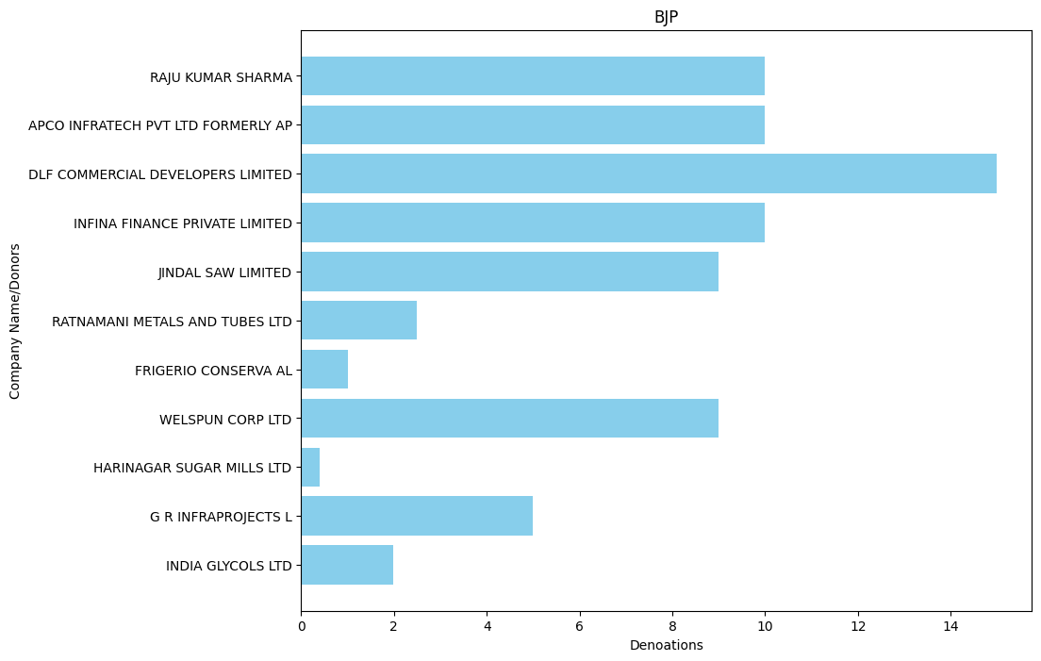

* BJP 2021: -

'RAMESH AGARWAL C S BOTTLING PLANT': 0.03,

'GEOJIT INVESTMENT SERVICES LTD': 0.025,

'HIMALAYAN ENDEAVOUR PVT LTD': 0.1,

'L S DAVAR AND CO': 1.0,

'LAXMI INDUSTRIAL BOTTLING PLAN': 0.14,

'SENGUPTA AND SENGUPTA PRIVATE LIMIT': 0.1,

'TRANSWAYS EXIM PRIVATE LTD': 0.1,

'BHARTI AIRTEL LIMITED': 5.0,

'BHARTI TELEMEDIA LIMITED': 30.0,

'HH IRON AND STEEL PRIVATE LIMITED': 5.0,

'MKK METAL SECTIONS P LTD': 3.0,

'PHILLIPS CARBON BLACK LIMITED': 20.0,

'SHYAM STEEL MANUFACTURING LTD. (FLY SOVA ISPAT LTD.)': 3.0,

'BALU CEMENT CORPORATION': 2.5,

'BALU IRON AND STEEL COMPANY': 5.0,

'CRESCENT POWER LTD': 1.0,

'HALDIA ENERGY LIMITED': 35.0,

'JINDAL HOUSE': 5.0,

'MEGHA ENGINEERING AND INFRASTRUCTURES LI MITED': 33.0,

'MOHAN STEEL CORPORATION': 5.0,

'SILVERTOSS SECURITIES PVT LTD': 2.5,

'AJAY GUPTA': 2.0,

'DLF COMMERCIAL DEVELOPERS LIMITED': 10.0,

'DLF LUXURY HOMES LIMITED': 5.0,

'INFINA FINANCE PRIVATE LIMITED': 25.0,

'K AMISH KUMAR TRADING PVT LTD': 5.0,

'PURSHOTTAM LAL GUPTA': 3.0,

'TORRENT POWER LIMITED': 7.5,

'TORRENT PHARMACEUTICALS LIMITED': 2.5,

'CHANDER COMMERCIALS PVT LTD': 20.0,

'CHANDRAJYOTI ESTATE DEVELOPERS PVT.': 10.0,

'HARDESH ORES PVT LTD': 6.0,

'HONEYWELL PROPERTIES PVT LTD': 30.0,

'RAY CONSTRUCTIONS LTD': 6.5,

'D S ENGINEERING WORKSHOP LLP': 5.0,

'GOODLUCK INDIA LTD': 2.0,

'MYTRAH ENERGY INDIA PRIVATE LIMITED': 10.0,

'J.K.CEMENT LTD.': 10.0,

'FUTURE GAMING AND HOTEL SERVICES PR': 50.0,

'TAVINDER SINGH KOHLI': 5.0,

'YASHODA SUPER SPECIALITY HOSPITAL': 2.0

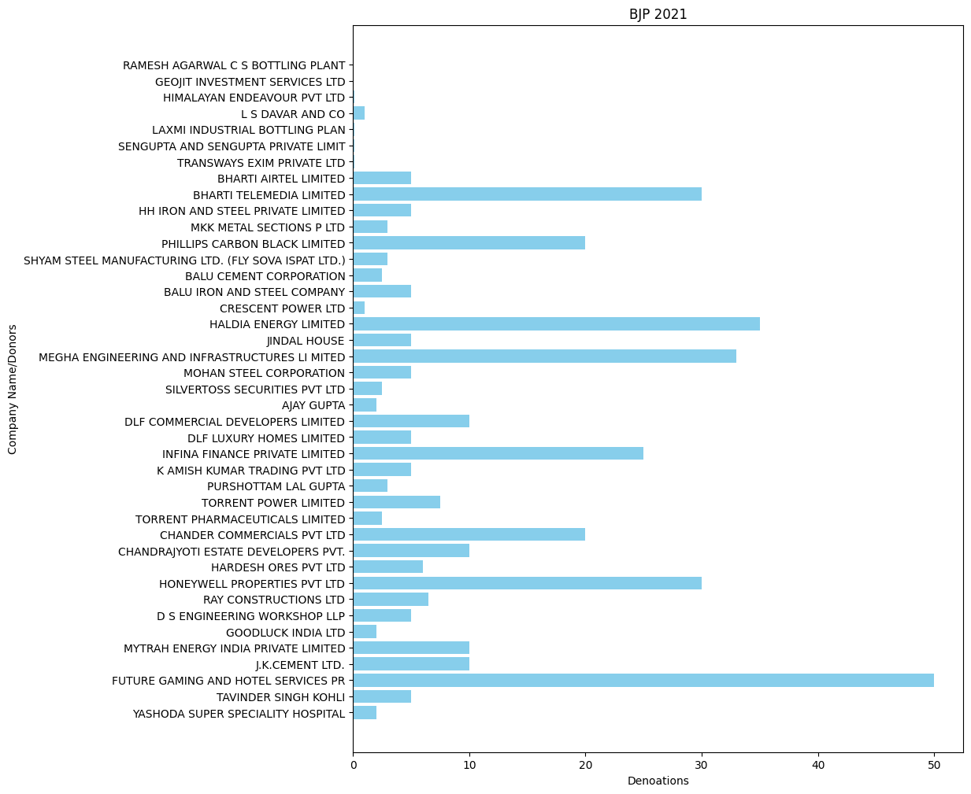

* BJP 2022: -

'DALMIA BHARAT SUGAR AND INDUSTRIES LTD': 2.0,

'GANDHI SECURITIES INVESTMENT': 0.5,

'PRATIKSHA DOSHI': 0.75,

'TORRENT POWER LTD': 18.0,

'LALITPUR POWER GENERATION COMPANY LIMITED': 5.0,

'AUROBINDO PHARMA LTD': 3.0,

'CHOWGLE AND COMPANY PVT LTD': 1.2,

'FUTURE GAMING AND HOTEL SERVICES PR': 50.0,

'MODERN ROAD MAKERS PVT. LTD.': 40.0,

'QWIKSUPPLYCHAINPRIVATELIMITED': 325.0,

'GOODLUCK INDIA LTD': 3.0,

'V M SALGAOCAR BROTHER PVT LTD': 0.9,

'V M SALGAOCAR CORPORATION PVT LTD': 2.2,

'BALRAMPUR CHINI MILLS LTD': 2.0,

'HEENA STEEL LLP': 2.5,

'HINDUSTAN TEXTILES': 5.0,

'KAMAL TRADING CORPORATION': 2.0,

'MEGHA ENGINEERING AND INFRASTRUCTURES LTD': 60.0,

'MKK METAL SECTIONS PVT LTD': 2.5,

'MOHAN STEEL CORPORATION': 3.0,

'SATISHCHANDRA SHANTILAL DOSHI HUF': 0.75,

'TORRENT PHARMACEUTICALS LTD': 7.0,

'VACMETINDIALIMITED': 9.0,

'VARDHMAN TEXTILES LTD': 16.0,

'ADITYA KUMAR GARG': 1.0,

'AJAY METALLOYS PVT LTD': 5.0,

'APCO INFRATECH PRIVATE LIMITED': 10.0,

'BALU CEMENT CORPORATION': 2.0,

'BALU IRON & STEEL COMPANY': 4.0,

'BHARTI AIRTEL LIMITED': 35.0,

'DEMPO IND PVT LTD NAVHIND PAPERSAND PUB': 0.1,

'DEVASHRI NIRMAN LLP': 0.3,

'DLF COMMERCIAL DEVELOPERS LIMITED': 90.0,

'HARDESH ORES PVT LTD': 3.0,

'HARMESH RAHUL JOSHI': 5.0,

'INFRASTRUCTURE LOGISTICS PVT LTD': 4.0,

'KRISHNA SHEET PROCESSORS PVT LTD': 3.0,

'LULU INDIA SHOPPING MALL PRIVATE LI': 2.0,

'NAVAL KISHORE AGARWAL': 4.0,

'RAHUL JAGANNATH JOSHI': 5.0,

'RAY CONSTRUCTIONS LTD': 10.0,

'REENA GARG': 1.0,

'SHRI JAGANNATH STEELS & POWER LTD': 0.5,

'SHRINIVAS VASUDEVA DEMPO': 0.5,

'SWAL CORPORATION LIMITED': 30.0,

'ULTRATECHCEMENTSLTD': 10.0,

'VEDANTA LIMITED': 173.0,

'VEDANTA LTD': 3.5,

'HALDIA ENERGY LIMITED': 10.0,

'AUTHUM INVESTMENT AND INFRASTRUCTURE LTD': 10.0,

'MEGHA ENGINEERING & INFRASTRUCTURES LIMITED': 5.0,

'PIRAMAL ENTERPRISES LIMITED': 25.0,

'RAJESH MANNALAL AGRAWAL': 5.0,

'WELSPUN CORP LIMITED': 13.0,

'CHOWGULE AND COMPANY PVT LTD': 0.5,

'DR REDDYS LABORATORIES LIMITED': 1.0,

'NATCO PHARMA LIMITED': 2.0,

'AUROBINDO PHARMA LIMITED': 6.5,

'GREENKO ENERGY PROJECTS PRIVATE LTD': 8.0,

'NCC LIMITED': 40.0,

"DR.REDDY'S LABORATORIES LTD": 14.0,

'HERO MOTOCORP LIMITED': 20.0,

'MOHIT MINERALS LIMITED': 7.0,

'SWAMI FUELS PRIVATE LIMITED': 5.0,

'AJANTA PHARMA LTD': 3.0,

'GANDHAR COALS AND MINES PVT LTD': 3.0,

'GENUS POWER INFRASTRUCTURES LIMITED': 0.5,

'INTAS PHARMACEUTICALS LIMITED': 20.0,

'MEGHA ENGINEERING AND INFRASTRUCTURES LI MITED': 64.0,

'MICHIGAN ENGINEERS PVT LTD': 3.0,

'MICRO LABS LTD': 6.0,

'NAVAYUGA ENGINEERING CO LTD': 10.0,

'PRARAMBH SECURITIES PVT LTDPROPRIET': 33.0,

'TORRENT POWER LIMITED': 13.0,

'TORRENT PHARMACEUTICALS LIMITED': 15.0,

'ZYDUS HEALTHCARE LIMITED': 18.0,

'MARUTI SUZUKI INDIA LTD': 20.0,

'ARVIND LIMITED': 9.0,

'ARVINDBEAUTYBRANDSRETAILPVTLTD': 3.0,

'ARVINDINFRACONLLP': 4.0,

'CIPLA LIMITED': 22.0,

'IPCA LABORATORIES LIMITED': 10.0,

'MAATHA PROJECTS LLP': 15.0,

'NATCO PHARMA LTD': 3.0,

'SOMASILA SOLAR POWER LIMITED': 5.0,

'SRI SIDDHARTH INFRATECH AND SERVICES I P': 30.0,

'THE ANUP ENGINEERING': 2.0,

'ARIZONAGLOBALSERVICESPVTLTDBR': 5.0,

'GLENMARK PHARMACEUTICALS LTD': 9.75,

'MANKIND PHARMA LIMITED': 24.0,

'MNMEDIAVENTURESPVTL108': 5.0,

'NEXG DEVICES PVT LTD': 15.0,

'WELSPUN ENTERPRISES LTD': 10.0,

'ALEMBICPHARMACEUTICALSLINCLRTGS': 6.2,

'ALKEM LABORATORIES LIMITED': 15.0,

'FIOTEX COTSPIN PRIVATE LIMITED': 0.38,

'NIRMA LIMITED': 3.0,

'PANACEA BIOTEC PHARMA LTD PHARMACEU': 1.0,

'PIRAMAL PHARMA LIMITED': 3.0,

'RMC SWITCHGEARS LTD': 0.5,

'WELSPUN INDIA LIMITED': 10.0,

'ANGEL FIBERS LIMITED': 0.29,

'BEST AGROLIFE LIMITED': 10.0,

'DHRUV COTTON PROCESSING PVT LTD': 0.1915,

'DLF GARDEN CITY INDORE PVT LTD': 15.0,

'DLF LUXURY HOMES LIMITED': 10.0,

'M M YARNS PVT LTD': 0.383,

'RAGHAV COTSPIN PRIVATE LIMITED': 0.1504,

'RAMKRISHNA COTSPIN PVT LTD': 0.1915,

'SANVI SPINNING MILLS PVT LTD': 0.2833,

'SHINE COTSPIN PVT LTD': 0.1368,

'SNB MINERALS PRIVATE LIMITED': 1.0,

'SUN OILNATURAL GAS DIV SUN PETRO P.': 4.0,

'SUSTAINABLE SPINNING AND COMMODITIES PVT LTD': 0.145,

'TRIBHUVAN SPINTEX PRIVATE LIMITED': 0.2484,

'UNITED PHOSPHORUS INDIA LLP': 50.0,

'USV PRIVATE LTD ( FORMERLY USV LTD)': 10.0,

'DCM SHRIRAM LTD': 5.0,

'PATEL ENGINEERING LTD.': 2.0,

'ABNLINVESTMENTLIMITED': 10.0,

'BIRLACARBONINDIAPRIVATELIMITED': 55.0,

'UTKAL ALUMINA INTERNATIONAL LIMITED': 35.0

* BJP 2023: -

'DHARIWAL INFRASTRUCTURE LIMITED': 25.0,

'HALDIA ENERGY LIMITED': 20.0,

'MR. KAUKUNTLA VENU GOPAL': 0.1,

'AUTHUM INVESTMENT AND INFRASTRUCTURE LTD': 15.0,

'RANJIT BUILDCON LIMITED': 7.0,

'RANJIT PROJECTS PRIVATE LIMITED': 1.5,

'RANJIT TOLL ROAD PRIVATE LIMITED': 1.5,

'ALEMBICPHARMACEUTICALSLINCLRTGS': 4.0,

'B G SHIRKE CONSTRUCTION TECHNOLOGY PVT L TD': 30.0,

'LUPIN LIMITED': 18.0,

'MICHIGAN ENGINEERS PVT LTD': 6.0,

'RAKESH PRAVINCHANDRA SHAH': 1.86,

'BIOXGREEN TECHNOLOGY PRIVATE LIMITE': 10.0,

'KAYPEE ENTERPRISES': 5.0,

'MAHINDRA & MAHINDRA LTD': 25.0,

'MEGHA ENGINEERING AND INFRASTRUCTURES LI MITED': 297.0,

'MOHIT MINERALS LTD': 5.0,

'MR KONARK RAJENDRA SHAH': 2.0,

'PRAGATI ENTERPRISES': 3.5,

'SOPANRAO BALKRISHNA DHASAL AGRO PRODUCTS LIMITED': 0.2,

'KONARK RAJENDRA SHAH': 4.5,

'MARAL OVERSEAS LTD.': 3.0,

'TARLA RAJENDRA SHAH': 1.5,

'AVEES TRADING FINANCE PVT LTD': 1.0,

'CAPACITE INFRAPROJECTS LTD': 7.0,

'DIPAN': 0.85,

'HEENA STEEL LLP': 2.0,

'INDER': 14.0,

'JAINENDRA': 0.62,

'JAINENDRA P SHAH': 0.01,

'JINDAL HOUSE': 4.0,

'LAXMI CIVIL ENGINEERING SERVICES PR': 40.0,

'MOHAN STEEL CORPORATION': 6.0,

'SPECO INFRASTRUCTURES': 2.5,

'UNIPRO TECHNO INFRASTRUCTURE PVT LTD': 8.0,

'WPIL LIMITED': 15.0,

'ANTIQUE INDIA PRIVATE LIMITED': 1.0,

'DESCENT BUILDWELL LLP': 1.0,

'KALPATARU PROJECTS INTERNATIONAL LIMITED': 25.5,

'CHENNAMANAGATHIHALLI SOLAR POWER PROJECT': 0.015,

'CHIKKAHALLI SOLAR POWER PROJECT LLP': 0.2,

'COMFORT TRIMS PRIVATE LIMITED DIVIS': 8.0,

'GREENKO MP01 IREP PRIVATE LIMITED': 5.0,

'HANSVAHINI AUTO INTERIOR PVT LTD': 4.0,

'HH IRON AND STEEL PRIVATE LIMITED': 10.0,

'HIREHALLI SOLAR POWER PROJECT LLP': 0.2,

'HUNSANKODILLI SOLAR POWER PROJECT LLP': 0.2,

'KIRAN MAZUMDAR SHAW': 4.0,

'MADAMAGERI SOLAR POWER PROJECT LLP': 0.2,

'RSLH AUTO SEAT TRIMS PVT LTD': 3.0,

'AUGMONT ENTERPRISES PRIVATE LIMITED': 5.0,

'BAPUNA ALCOBREW PRIVATE LIMITED': 0.25,

'BUILDOX DEVELOPERS LLP': 0.6,

'JWIL INFRA LTD. (FORM. JITF WATER': 10.4,

'LCCPROJECTSPRIVATELIMITED': 31.5,

'MR SAURABH BAKLIWAL': 0.1,

'PRESTIGE ESTATES PROJECTS LTD PREST': 5.0,

'R R KABEL LIMITED': 0.02,

'SATEC ENVIR ENGINEERING (I) PVT LTD': 12.0,

'THE RAMCO CEMENTS LIMITED': 25.0,

'VILLAGE DE NANDI PVT LTD RERA DESIG': 5.0,

'AKSENTT TECH SERVICES LIMITED (UNITY TEL ECOM INFRASTRUCTURE)': 15.0,

'DILIP RAMANLAL THACKER': 3.0,

'DINESHCHANDRA R AGRAWAL INFRACON PVT LTD': 15.0,

'TEJAS': 0.87,

'SAGAR CEMENTS LIMITED': 0.5,

'ARAVIND S': 0.0001,

'CREATIVE LLP': 0.96,

'VIDITVA CONSTRUCTIONS': 0.48,

'ASHOKA MUDHOL NIPANI ROADS LIMITED': 5.0,

'INDIA EXPOSITION MART LTD': 0.1,

'VIVA HIGHWAYS LTD': 5.0,

'AMD ENGINEERING CONSULTANTS': 0.75,

'EAGLE INFRA INDIA LTD': 4.0,

'MOUNT EVEREST BREWERIES LIMITED': 1.99,

'NIRANJAN LAL AND SONS HUF': 0.75,

'SOM DISTILERIES PRIVATE LTD': 1.0,

'KAMNA CREDITS AND PROMOTORS PVT LTD': 1.0,

'GVPR ENGINEERS LTD': 5.0,

'MKJ ENTERPRISES LIMITED': 12.5,

'BAIN GLOBAL RESOURCES LLP': 5.0,

'INDURU SUDHAKARA REDDY': 5.0,

'J B ENTERPRISE': 1.0,

'PATEL ENGINEERING LTD.': 4.0,

'ASHOKA BAGEWADI SAUNDATTI ROAD LIMITED': 4.0,

'ASSOCIATED ALCOHOLS': 2.0,

'GENUS POWER INFRASTRUCTURES LIMITED': 10.0,

'INTERNATIONAL TRADING CORPORATION': 1.5,

'SOM DISTILLERIES BREWERIES LIMITED': 1.0,

'SOM DISTILLERIES PVT LTD': 1.0,

'VARDHMAN TEXTILES LIMITED': 3.0,

'ABHIJIT INTERNATIONAL': 2.0,

'ASHOKA HUNGUND TALIKOT ROAD LTD': 4.5,

'BALU IRON AND STEEL COMPANY': 5.0,

'BHACHIBEN KHAMUBHAI MANVAR': 1.0,

'DEVAL KHAMUBHAI MANVAR': 1.0,

'DIVI S LABORATORIES LIMITED': 30.0,

'FORCE MOTORS LTD': 5.6,

'GOODLUCK INDIA LIMITED': 7.5,

'HARIJAN HIRIBAI': 1.0,

'MANVAR DEVABHAI': 1.0,

'MANVAR SAVABHAI': 5.0,

'RATHOD LAKHIBEN': 1.0,

'SI AIR SPRINGS PRIVATE LTD': 1.5,

'THE ASSOCIATED AUTO PARTS PRIVATE LIMITED': 1.0,

'TVS MOBILITY PRIVATE LIMITED': 16.0,

'VIJAYKUMARMISHRACONSTRUCTIONPVT': 5.0,

'ADITYA KUMAR GARG': 0.75,

'ANITA HEMANT SHAH': 8.2,

'APCO INFRATECH PRIVATE LTD': 10.0,

'BLUESTONE COMMODITIES LLP': 2.0,

'GANDHAR COALS AND MINES PVT LTD': 3.0,

'HETERO BIOPHARMA LIMITED': 5.0,

'HETERO LABS LIMITED': 5.0,

'JINDAL SAW LIMITED': 18.0,

'REENA GARG': 0.75,

'SELMAR LAB': 5.0,

'SUNDRAM INDUSTRIES PVT LTD': 0.5,

'VS TOWERS': 0.5,

'J K CEMENT LIMITED': 5.0,

'UNILIGHT REINSURANCE BROKERS PVT LTD': 0.5,

'WONDER CEMENT LTD': 10.0,

'CYIENT LIMITED': 10.0,

'NATCO PHARMA LTD': 10.0,

'APL HEALTHCARE LIMITED': 10.0,

'AUROBINDO PHARMA LIMITED': 25.0,

'EUGIA PHARMA SPECIALITIES LIMITED': 15.0,

'BHARTI AIRTEL LIMITED': 93.0,

'BHARTI TELEMEDIA LIMITED': 7.0,

'MR. MAYANK SINGHAL': 0.75,

'PRAKASH BALWANT MENGANE': 3.0,

'PRATHMESH CONSTRUCTION': 25.0,

'SARDA ENERGY AND MINERALS LTD': 5.0,

'VEDANTA LIMITED': 1.0,

'DAAWAT FOODS LTD': 1.0,

'MAHENDRA SPONGE AND POWER LIMITED': 0.25,

'WESTERN UP POWER TRANSMISSION COMPANY LI MITED': 80.0,

'JINDAL STEEL AND POWER LIMITED': 3.0,

'WARORA CHANDRAPUR BALLARPUR TOLLRO': 0.001,

'MAITHRI LABORATORIES (PVT) LTD': 2.0,

'MSN LABORATORIES PVT LTD': 10.0,

'MSN ORGANICS PVT LTD': 2.0,

'MSN PHARMACHEM PVT LTD': 6.0,

'MY HOME INFRASTRUCTURES PVT LTD MY': 5.0,

'SAFAL GOYAL REALTY LLP': 35.0,

'SASMAL INFRASTRUCTURE PRIVATE LIMITED': 5.0,

'TERACON BUILDTECH LLP': 15.0,

'ACE URBAN DEVELOPERS PVT LTD': 10.0,

'DCM SHRIRAM LIMITED': 5.0,

"DR.REDDY'S LABORATORIES LTD": 10.0,

'K R RAJA JT': 25.0,

'LAXMIDAS VALLABHDAS ASMITA MERCHA': 25.0,

'MAATHA PROJECTS LLP': 5.0,

'PRASAD AND COMPANY PRIVATE LIMITED': 3.0,

'QWIKSUPPLYCHAINPRIVATELIMITED': 50.0,

'SRI SIDDHARTH INFRATECH AND SERVICES I P': 20.0,

'SUNDARAM INDUSTRIES PVT LIMITED': 1.0,

'ABIS AGROTECH PVT LTD': 0.5,

'G S ISPAT': 4.0,

'MKK METAL SECTIONS P LTD': 2.0,

'AJAY GUPTA': 2.0,

'BIRLACARBONINDIAPRIVATELIMITED': 50.0,

'HARMESH RAHUL JOSHI': 5.0,

'JAI GANESH ISPAT AND FERRO ALLOYS PVT LTD': 4.0,

'M/S T S WIND POWER DEVELOPERS': 1.3,

'RAHUL JAGANNATH JOSHI': 5.0,

'SEPC POWER PVT LTD OPERATION RETEN': 5.0,

'ULTRA TECH CEMENT LIMITED': 10.0,

'UTKAL ALUMINA INTERNATIONAL LIMITED': 40.0,

'WARORA CHANDRAPUR BALLARPUR TOLLROA': 7.0

* BJP 2024: -

'SPECO INFRASTRUCTURE': 1.5,

'ENVIRO CONTROL PRIVATE LIMITED FORM': 10.0,

'DIPAN': 0.6,

'GENUS POWER INFRASTRUCTURES LIMITED': 15.0,

'JAINENDRA': 0.9,

'TORRENT POWER LIMITED': 25.0,

'TORRENT PHARMACEUTICALS LTD': 25.0,

'BHARTI AIRTEL LIMITED': 50.0,

'GK ENERGY MARKETERS PRIVATE LIMITED': 6.0,

'TVS MOTOR COMPANY LIMITED': 10.0,

'ASHOKA DEVELOPERS': 1.0,

'INDERDEEP CONSTRUCTION CO': 6.0,

'M/S T S WIND POWER DEVELOPERS': 1.0,

'RUNGTA SONS P LTD': 50.0

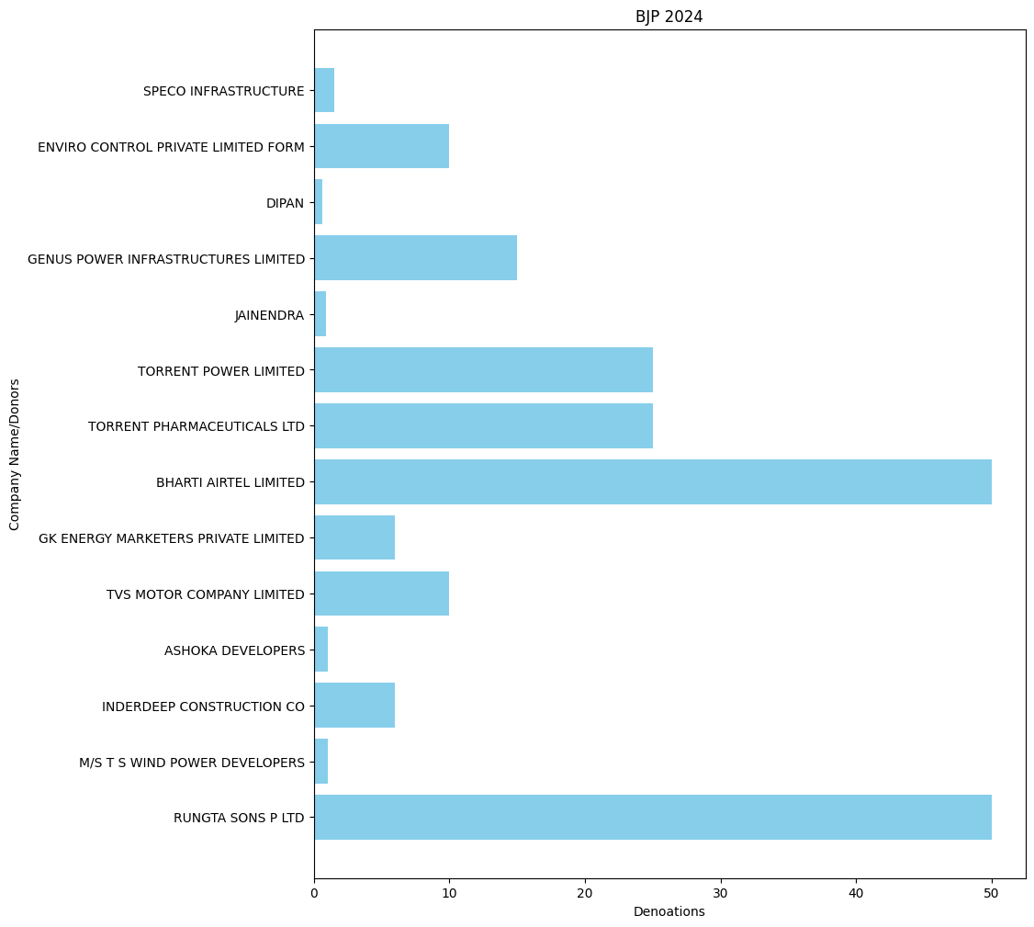

**ALL INDIA TRINAMOOL CONGRESS: -**

* ALL INDIA TRINAMOOL CONGRESS 2019 : -

'ACROPOLIS MAINTENANCE SERVICES PRIVATE LIMITED': 0.25,

'INNOCENT MERCHANDISE PVT LTD': 0.25,

'MERLIN RECREATION PVT LTD': 0.25,

'AMBUJA REALTY EVENTS MANAGMENT LTD': 1.0,

'HITECH SYSTEMS & SERVICES LTD': 1.0,

'KEVENTER FOODPARK INFRA LIMITED': 20.0,

'PHILIPS CARBON BLACK LTD': 5.0,

'ITC LIMITED': 4.9546,

'BAGDOGRA REALTORS PVT LTD': 1.0,

'OM CREDIT PVT LTD': 1.0,

'ALMIGHTY FINANCE AND INVESTMENT P': 0.3,

'G M HOLDINGS PVT LTD': 0.4,

'OM METALS DEVELOPERS (P) LTD.': 5.5,

'SUNSHINE FINTRADE PVT LTD': 0.4,

'FAIRPLAN VINTRADE PRIVATE LIMITED': 0.7,

'CHAKRADHARI TRADELINK PRIVATE LIMIT': 0.3,

'CHITRAKUT HOLDINGS LTD': 1.0,

'DAFFODIL GOODS PRIVATE LIMITED': 0.2,

'LILAC MERCHANDISE PRIVATE LIMITED': 0.2,

'MAHAVIRA VINCOM PRIVATE LIMITED': 0.3,

'AVEES TRADING & FINANCE PVT LTD': 24.0,

'NIRMALDEEP RESOURCES LTD': 0.4,

'CONFIDENT FINANCIAL CONSULTANCY PRI': 0.25,

'PERFECT INVESTMENT CONSULTANCY PRIV': 0.18,

'SIDHANT INVESTMENT ADVISORY PRIVATE': 0.25,

'SKP MERCHANTS LLP': 1.0

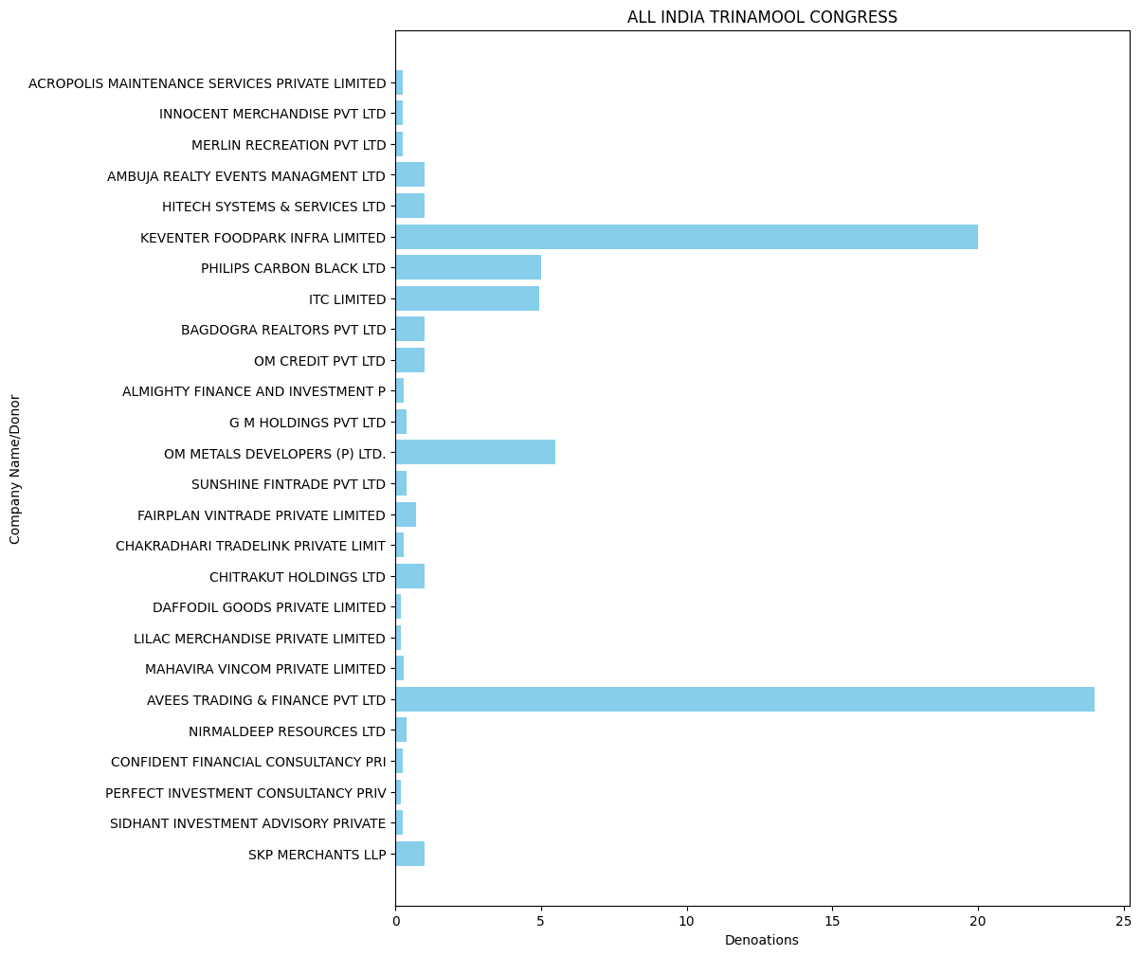

* ALL INDIA TRINAMOOL CONGRESS 2020: -

KEJRIWAL MIINIING PRIVATE LIMITED': 4.0,

'BHARAT AJMERA': 0.03,

'CRESCENT POWER LTD': 2.0,

'HALDIA ENERGY LIMITED': 21.0,

'KIRTAN AJMERA': 0.06,

'MUKESH AJMERA': 0.03,

'POORVI DUGAR AJMERA': 0.02,

'RONAK AJMERA': 0.2,

'TILAK AJMERA': 0.03,

'HARINAGAR SUGAR MILLS LTD': 0.4,

'FUTURE GAMING AND HOTEL SERVICES PR': 1.0,

'UTKARSH SFATIK LIMITED': 1.0

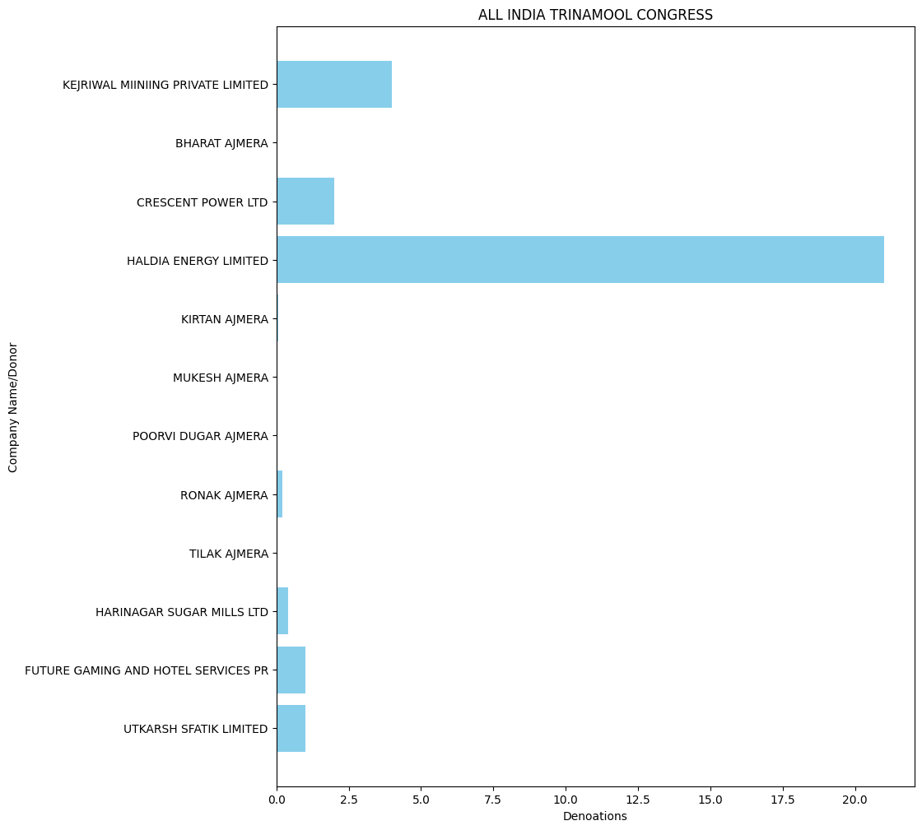

* ALL INDIA TRINAMOOL CONGRESS 2021: -

'CRESCENT POWER LTD': 11.0,

'HALDIA ENERGY LIMITED': 55.0,

'QUALITY MAINTENANCE VENTURE LTD': 0.5,

'S E BUILDERS AND REALTORS LTD': 0.5,

'PHILLIPS CARBON BLACK LIMITED': 10.0,

'MISRILALL MINES PVT LTD': 14.0,

'OM CREDIT PVT LTD': 2.0,

'CRYSTAL TEA INDIA PVT LTD': 1.25,

'NANGALIA ASSOCIATES': 0.5,

'RAHUL BHATIA': 16.2,

'SILVER LINE INVESTMENT COMPANY': 0.4,

'AUSTIN PLYWOOD PRIVATE LIMITED FORMERLY B S PROGRESSIVE PVT': 1.3,

'BHARAT AJMERA': 0.03,

'ISHANI BHAVIK AJMERA': 0.05,

'JMS MINING PRIVATE LIMITED': 2.5,

'KIRTAN AJMERA': 0.05,

'MUKESH AJMERA': 0.03,

'PARESH AJMERA': 0.02,

'POORVI DUGAR AJMERA': 0.03,

'TILAK AJMERA': 0.03,

'UTSAV ENCLAVE LLP': 0.1,

'ABHIJIT INTERNATIONAL': 0.5,

'DESCENT BUILDWELL LLP': 1.0,

'GOLDSTONE CEMENTS LTD': 2.0,

'INDIAN VALVE': 0.2,

'NORTH EAST INFRA NET WORK': 1.65,

'RONAK AJMERA': 0.05,

'SURENDRA STEELS PRIVATE LIMITED': 1.0,

'SHIV SHANKAR SECURITIES PVT LTD': 0.85,

'MKJ ENTERPRISES LTD': 27.4,

'TRANSWAYS EXIM PRIVATE LTD': 1.8,

'MONALISA BOTTLING INDUSTRIES PVT LTD': 2.5,

'PURULIA BOTTLING PVT LTD': 0.75,

'ABHINANDANSTOCKBROKINGPVTLTD': 2.0,

'M/S. K.D. LIQUOR FERTILIZER PRIVATE L': 3.5,

'M/S. RAMESH AGARWAL C S BOTTLING PL': 2.1,

'PLUTO FINANCE PRIVATE LTD': 0.24,

'PRAKASH DISTILLERY & CHEMICAL CO (P) LT D': 0.358,

'RITESH REAL ESTATES PVT LTD': 0.34,

'RITESH VANIJYA PRIVATE LIMITED': 0.3,

'SAROJIT KUMAR DEY': 0.91,

'VPL OIL MARKETING PVT LTD': 0.4,

'DEEPAK KUMAR AGARWAL': 0.06,

'DHARIWAL INFRASTRUCTURE LIMITED': 10.0,

'FUTURE GAMING AND HOTEL SERVICES PR': 76.0,

'HIMADRI KHAN COUNTRY SPIRIT BOTTLING PLA NT CUM WARE HOUSE': 0.7,

'PRARAMBH SECURITIES PVT LTDOWN A/C': 0.75,

'RITESH NIRMAN PVT LTD': 0.4,

'RITESH PROJECTS PVT LTD': 3.1,

'SENGUPTA AND SENGUPTA PRIVATE LIMIT': 2.0,

'SHREE SALASAR PROPERTIES & FINANCE PVT LTD': 1.0,

'SPEED BUSINESS PVT LTD': 0.4,

'SSALASAR FINANCIAL ADVISORY SERVICE PVT LTD': 1.0,

'SUMAN AGARWAL': 0.04,

'SWARNAPUSHPA VANIJYA PRIVATE LIMITE': 1.25,

'VARAS INTERNATIONAL PRIVATE LIMITED': 0.35,

'HIMALAYAN ENDEAVOUR PVT LTD': 3.0,

'LAXMI INDUSTRIAL BOTTLING PLAN': 1.555,

'MIRANIA BUILDERS LLP': 0.45,

'RIPLEY & CO STEVDORING & HANDLING PVT LT D': 1.0,

'SUDSAR BUILDSPACE LLP': 0.2,

'B M A MERCHANDISE LLP': 0.1,

'COALSALE COMPANY LTD': 0.95,

'GLOWING FERN HIGHRISE LLP': 0.1,

'KISHAN M AGARWAL HUF': 0.2,

'OM VINCOM PVT LTD': 0.6,

'SKP MERCHANTS LLP': 2.0,

'TIVOLI PARK APARTMENTS PVT LTD': 7.0,

'ARCHANA PROPERTIES P LTD': 0.9,

'CHAITANYA ESTATES PRIVATE LIMITED': 0.6,

'DHARMENDRA JAYANTILAL VORA': 0.1,

'GOURAB ROY': 0.3,

'AVEES TRADING FINANCE PVT LTD': 15.0,

'CHARISMA COMBINES PVTLTD': 0.2,

'M S VARAS INTERNATIONAL PVT LTD': 0.6,

'OM ENCLAVE PVT LTD': 0.3,

'PRB SECURITIES PVT LTD': 0.5,

'RANISATI MERCANTILES PVT LTD': 0.3,

'RITESH ENCLAVE PVT LTD': 0.5,

'RUPA H SHAH': 0.1,

'SALASAR SAREES PVT LTD': 0.15,

'SALASAR STOCK BROKING LTD-PROPRIETARY': 5.0,

'TRANSWAYS EXIM PRIVATE LIMITED': 2.5,

'VENUS FINANCIAL CONSULTANTS PVT LTD': 0.7,

'ARUN KUMAR GANERIWALA': 0.02,

'ASHOK DALMIA': 0.01,

'ASISH RAHA': 0.03,

'DEEPAK GURUM': 0.01,

'GALAXY C.S. BOTTLING PLANT': 0.9,

'HITESH D SHAH': 0.3,

'JOSYULA VENKATESH': 0.05,

'LAURELSECURITIESPVTLTD': 2.5,

'LIFELINE MARKETING PRIVATE LIMITED': 1.0,

'NARAYAN PODDAR': 0.03,

'NEERAJ GANDHI': 0.03,

'PRAMOD BAJORIA': 0.05,

'RAJESH KUMAR AGARWAL': 0.07,

'RAJESH SHARMA': 0.07,

'SAGUN TULSYAN': 0.1,

'SANJAY KUMAR SINHA': 0.01,

'VIKASH GUPTA': 0.02,

'VIKASH NAHATA': 0.07,

'VINEET GUPTA': 0.04,

'VIVEK AGARWAL': 0.02,

'YOGESH MANPURIA': 0.07,

'CROCHET TRADE AND INVESTMENT PVT L': 2.0,

'IFB AGRO INDUSTRIES LIMITED': 12.0,

'MIRANIA COMPLEX LLP': 0.1,

'NATURAL RESIDENCY LLP': 0.2,

'RIGHT AID CONSULTANTS PVT LTD': 1.5,

'SILVERTONE SECURITIES PVT LTD': 2.0,

'SUMAN ESTATES PRIVATE LIMITED': 0.35,

'TULIP RESIDENCY LLP': 0.1

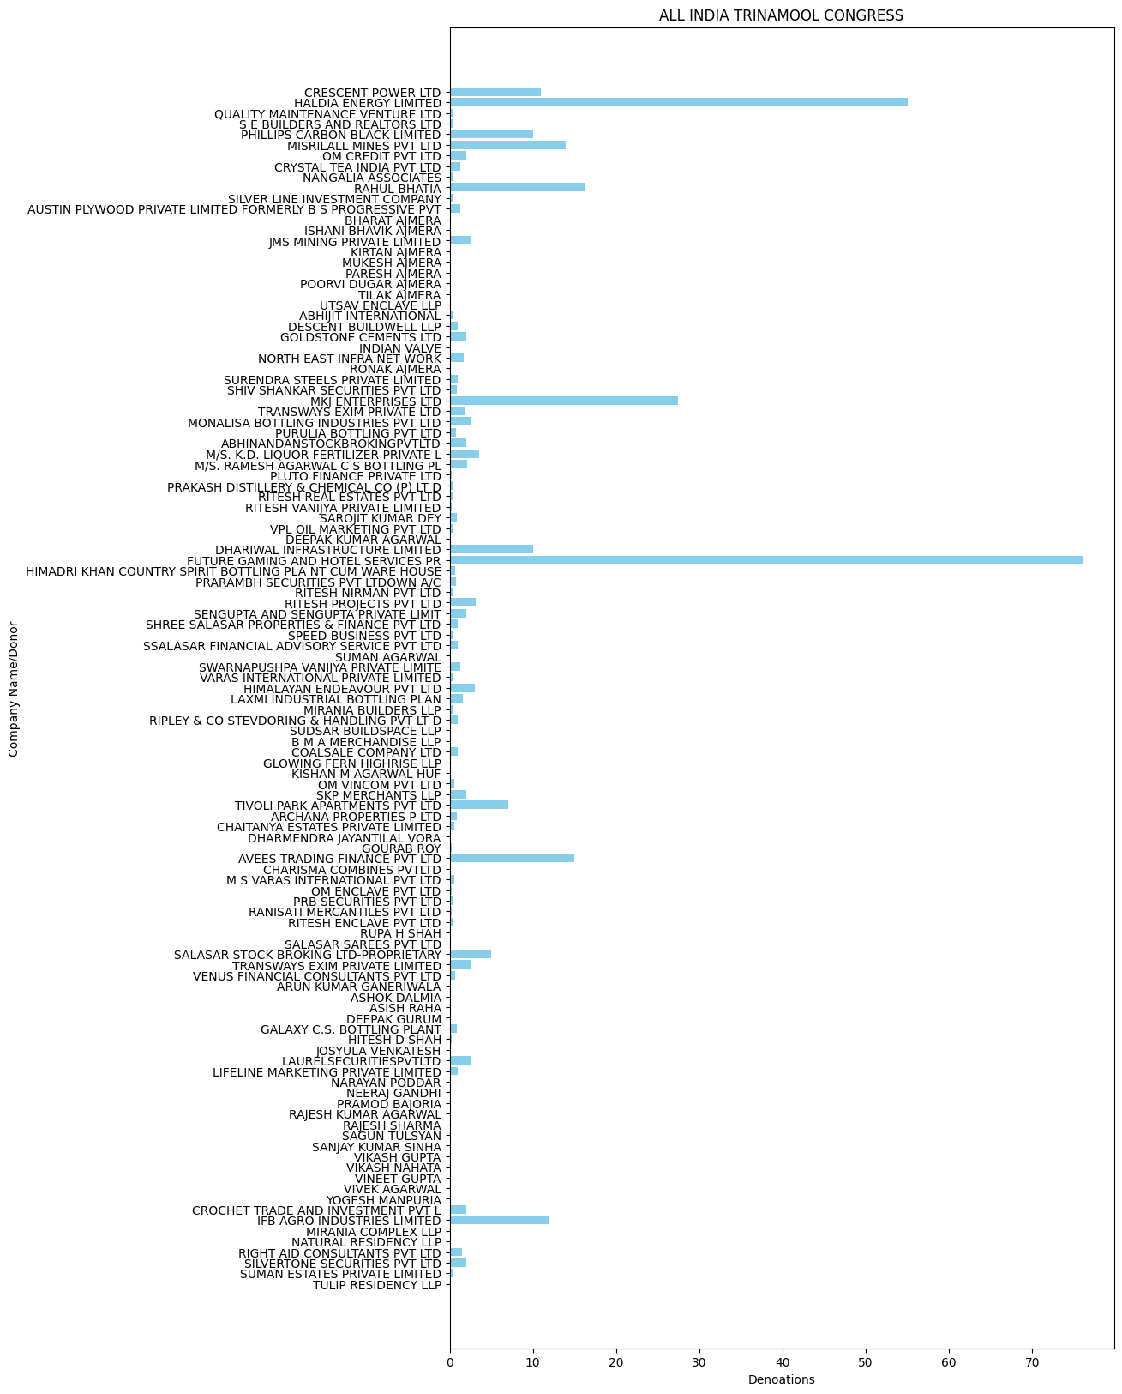

* ALL INDIA TRINAMOOL CONGRESS 2022: -

'PRARAMBH SECURITIES PVT LTDPROPRIET': 38.0,

'CHENNAI GREEN WOODS PRIVATE LIMITED': 40.0,

'DHARIWAL INFRASTRUCTURE LIMITED': 35.0,

'GALAXY C.S. BOTTLING PLANT': 1.2,

'HALDIA ENERGY LIMITED': 75.0,

'IFB AGRO INDUSTRIES LIMITED': 13.0,

'KVR BASELINE RESOURCES PRIVATE LIMI': 4.0,

'LAXMI INDUSTRIAL BOTTLING PLAN': 1.15,

'MADHYA PRADESH WASTE MANAGEMENT PRI': 6.0,

'TRANSWAYS EXIM PRIVATE LIMITED': 5.5,

'VARAS INTERNATIONAL PVT LTD': 0.5,

'FUTURE GAMING AND HOTEL SERVICES PR': 140.0,

'FUTURE GAMING AND HOTEL SERVICES PRIVATE LIMITED': 45.0,

'HIMALAYAN ENDEAVOUR PVT LTD': 2.3,

'MONALISA BOTTLING INDUSTRIES PVT LTD': 1.5,

'SENGUPTA AND SENGUPTA PRIVATE LIMIT': 1.5,

'V M SALGAOCAR BROTHER PVT LTD': 0.3,

'M/S. RAMESH AGARWAL C S BOTTLING PL': 0.9,

'MOTOWN TRADING PVT LTD': 0.1,

'PURULIA BOTTLING PVT LTD': 0.75,

'GOA CARBON LTD': 0.1,

'NETINCON MARKETING PVT LTD': 3.0,

'SHRINIVAS VASUDEVA DEMPO': 0.05,

'V M SALGAOCAR CORPORATION PVT LTD': 0.15,

'VEDANTA LTD': 0.2,

'RIPLEY AND CO. STEVEDORING & HANDLING PVT LTD': 3.0,

'PCBL LIMITED': 10.0,

'WESTWELL GASES PRIVATE LIMITED': 5.0,

'GREAT EASTERN STORES PVT LTD': 2.0,

'RIPLEY & CO STEVDORING & HANDLING PVT LT D': 3.0,

'CRESCENT POWER LTD': 15.0,

'ARUNANGSHU MUKHERJEE': 0.6,

'BENGAL VIPANAPAN PRIVATE LIMITED': 2.0,

'RASHMI CEMENT LTD': 8.0,

'ARROW PROJECTS PVT LTD': 1.0,

'BESSEGGENINFOTECHLLP': 1.0,

'MKJ ENTERPRISES LIMITED': 2.0,

'RAJDHANI DEALERS PRIVATE LIMITED': 1.0

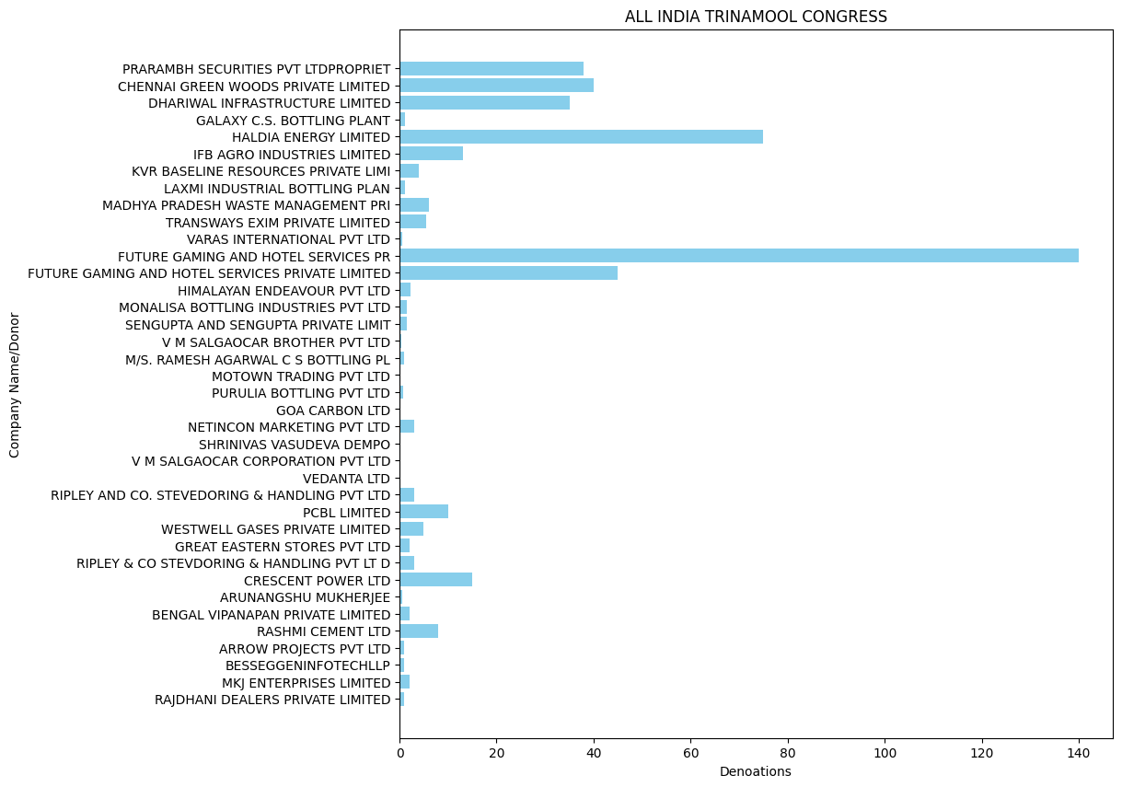

* ALL INDIA TRINAMOOL CONGRESS 2023: -

'CRESCENT POWER LTD': 5.0,

'HALDIA ENERGY LIMITED': 95.0,

'IFB AGRO INDUSTRIES LIMITED': 17.0,

'RIPLEY & CO STEVDORING & HANDLING PVT LT D': 4.5,

'ARROW PROJECTS PVT LTD': 3.5,

'FUTURE GAMING AND HOTEL SERVICES PR': 158.0,

'MANU VYAPAR (P) LTD.': 1.0,

'ARUNANGSHU MUKHERJEE': 0.5,

'RASHMI CEMENT LTD': 10.5,

'SAROJIT KUMAR DEY': 1.45,

'BINOD KUMAR MAROTI': 0.2,

'DHARIWAL INFRASTRUCTURE LIMITED': 45.0,

'M/S. RAMESH AGARWAL C S BOTTLING PL': 3.0,

'MKJ ENTERPRISES LIMITED': 16.5,

'PCBL LIMITED': 30.0,

'TRANSWAYS EXIM PRIVATE LIMITED': 9.8,

'M S VARAS INTERNATIONAL PVT LTD': 1.9,

'MAHABIR BANKA': 1.5,

'RAUNAK GUPTA': 1.5,

'SALASAR FINANCIAL ADVISORY SERVICES': 0.5,

'VIKAS PARASRAMPURIA': 1.5,

'WPIL LIMITED': 7.0,

'ANAND SAKHARAM PIMPARKAR': 0.1,

'BANSAL UDYOG PRIVATE': 0.5,

'CANDY SPIRITS PVT LTD': 1.0,

'DINESH KUMAR LAKHANPAL': 0.05,

'DR. MANDEEP SHARMA': 0.2,

'GUPTA VARUN': 0.05,

'HIMADRI KHAN': 1.3,

'MARDI GRAS LIQUOR DIV OF MARDI GRAS': 2.3,

'SANJAY KUMAR': 0.2,

'SENGUPTA AND SENGUPTA PRIVATE LIMIT': 4.2,

'VIJAY KUMAR GOYAL': 0.1,

'VINAY KUMAR BHATT': 0.15,

'BESSEGGENINFOTECHLLP': 1.5,

'HERALD BEVERAGES PRIVATE LIMITED': 5.5,

'HIMALAYAN ENDEAVOUR PVT LTD': 5.3,

'JWIL INFRA LTD. (FORM. JITF WATER': 0.1,

'K D LIQUOR AND FERTILIZER PVT LTD': 0.5,

'MONALISA BOTTLING INDUSTRIES PVT LTD': 2.65,

'MR SAURABH BAKLIWAL': 0.4,

'VIPIN GUPTA': 0.5,

'ASKUS LOGISTICS PRIV': 6.0,

'CASTLE LIQUORS PRIVATE LIMITED': 4.8,

'CHANDAN AGARWAL': 0.015,

'MADHUMITA SAH': 0.02,

'MR SACHIN BAKLIWAL': 0.3,

'PRAKASH DISTILLERY & CHEMICAL CO (P) LT': 0.5,

'RAJDHANI DEALERS PRIVATE LIMITED': 2.0,

'RUMA GHATAK': 0.01,

'SANDEEP AUTO LINES': 5.5,

'SANJIB CHAKRABORTY': 0.01,

'WESTWELL GASES PRIVATE LIMITED': 10.4,

'MANOTOSH DAS': 1.2,

'RAMESH AGARWAL C S BOTTLING PL': 1.5,

'CROCHET TRADE AND INVESTMENT PVT LT': 1.5,

'RPSG VENTURES LIMITED': 3.0,

'FUTURE GAMING AND HOTEL SERVICES PVT LTD': 62.0,

'KAMNA CREDITS AND PROMOTORS PVT LTD': 6.0,

'ABHRAJIT MITRA': 1.05,

'HIMANGA MERCANTILES PVT LTD': 0.15,

'RAUNAK PROPERTIES PVT. LTD': 0.3,

'B.DAS AND ASSOCIATES PVT. LTD.': 1.0,

'GALAXY C.S. BOTTLING PLANT': 0.3,

'LAXMI INDUSTRIAL BOTTLING PLANT': 0.71,

'AVEES TRADING FINANCE PVT LTD': 6.5,

'RAHUL CHOUDHARY': 0.01,

'PRASHANT KUMAR JAISWAL': 1.5,

'SHREE CHAND SARAOGI': 0.75,

'KISHAN F.L. BOND HOUSE': 1.7,

'SOURABH': 0.2688,

'DYNAMIC CS BOTTLING PVT LTD': 0.03,

'TEGA INDUSTRIES LIMI': 1.0,

'VAIBHAV LAXMI CAPITAL MARKET PRIVATE LIM': 1.0

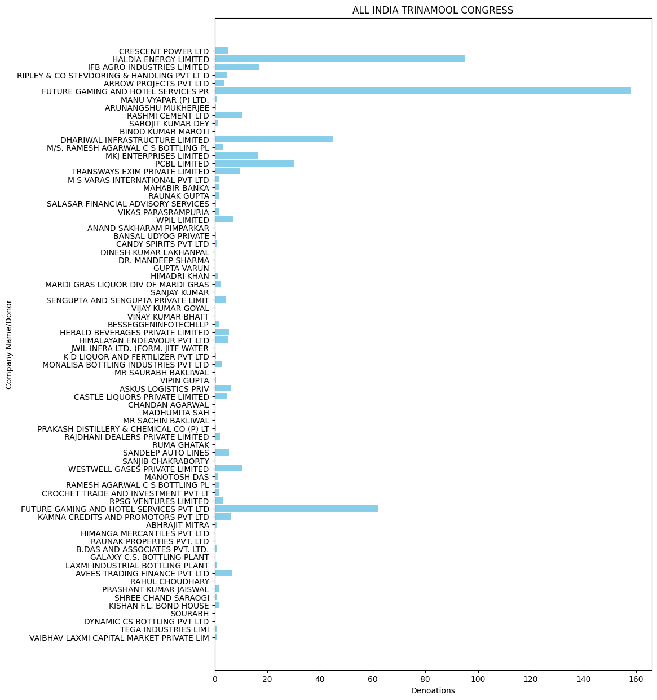

* ALL INDIA TRINAMOOL CONGRESS 2024: -

'KALPTARU INVESTMENTS PVT.LTD. PROP': 2.5,

'KUSUM MAROTI': 0.15,

'NIRAV MAROTI': 0.2,

'PREETI MAROTI': 0.15,

'ASISH FINANCE PRIVATE LIMITED': 5.0,

'PLUTO FINANCE PRIVATE LTD.': 0.75,

'HALDIA ENERGY LIMITED': 35.0,

'TRANSWAYS EXIM PRIVATE LIMITED': 1.5,

'RANISATI MERCANTILES PVT. LTD.': 0.75,

'CASTLE LIQUORS PRIVATE LIMITED': 2.0,

'HIMALAYAN ENDEAVOUR PVT LTD': 0.6,

'LAXMI INDUSTRIAL BOTTLING PLANT': 0.5,

'PRAKASH DISTILLERY & CHEMICAL CO (P) LT': 0.8,

'SAROJIT KUMAR DEY': 0.5,

'DYNAMIC CS BOTTLING PVT LTD': 0.25,

'FUTURE GAMING AND HOTEL SERVICES PR': 60.0,

'GALAXY C.S. BOTTLING PLANT': 0.7,

'KISHAN F.L. BOND HOUSE': 0.8,

'M S VARAS INTERNATIONAL PVT LTD': 0.8,

'M/S. RAMESH AGARWAL C S BOTTLING PL': 1.5,

'MAHABIR BANKA': 2.0,

'PURULIA BOTTLING PVT LTD': 1.0,

'R B DEALERS PVT LTD': 0.5,

'SANDEEP AUTO LINES': 1.5,

'SENGUPTA AND SENGUPTA PVT LTD': 0.5,

'SUMAN ESTATES PRIVATE LIMITED': 0.5,

'VIKAS PARASRAMPURIA': 2.0,

'ABHINANDANSTOCKBROKINGPVTLTD': 2.0,

'AMAN JAISWAL': 0.1,

'MRPANKAJKUMARGUPTA': 0.1,

'PRASHANT KUMAR JAISWAL': 2.8,

'SYNERGY DEALCOM PVT LTD-SELF A/C': 3.0

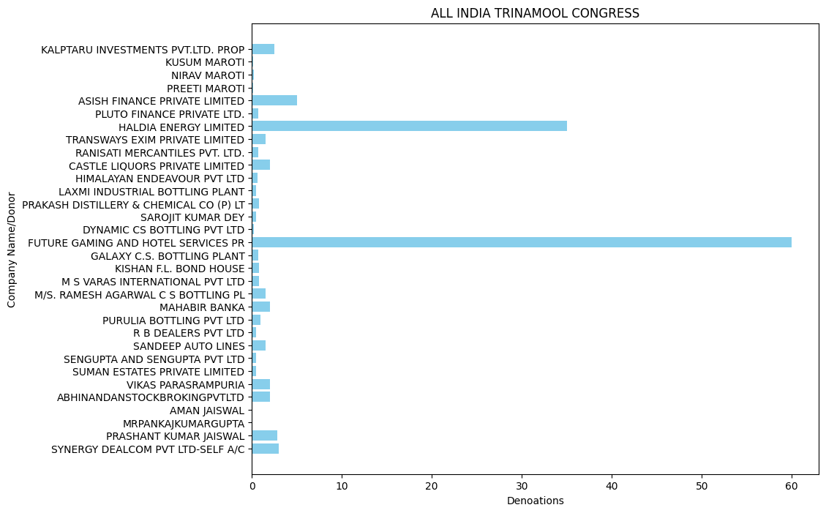

**PRESIDENT, ALL INDIA CONGRESS COMMITTEE**

* Congress 2019: -

PONUGOTI HEMENDAR RAO': 0.03,

'KOTESWAR RAO GULLAPALLY': 0.05,

'MANDADI RAMULU': 0.04,

'PAPPI REDDY': 0.05,

'PEDDIREDDY RAMANJANEYA REDDY': 0.05,

'PREMCHAND GODHA': 0.05,

'PRL DEVELOPERS PRIVATE LIMITED': 5.0,

'RAVINDER AGARWAL': 0.08,

'SANGIREDDY THIRUPATHI REDDY': 0.05,

'SWAPNA CHENNAVARAM': 0.05,

'VINAY AGARWAL': 0.09,

'IDEAL REAL ESTATES PRIVATE LIMITED': 1.0,

'JUBILANT LIFE SCIENCES LIMITED': 1.0,

'KEVENTER FOODPARK INFRA LIMITED': 20.0,

'KEYSTONE REALTORS PVT LTD': 0.6,

'MODERN ROAD MAKERS PVT LTD': 6.0,

'OMKAR REALTORS PROJECTS PVT LTD': 1.5,

'P SHIVA SHANKAR REDDY': 0.04,

'POLINA GANESWARARAO': 0.04,

'SK INFRA': 0.04,

'SREE KRUTHI': 0.08,

'THE SUPREME INDUSTRIES LTD': 1.25,

'ANJANI ROADLINES': 0.5,

'APOLLO TYRES LIMITED': 3.0,

'BHARTI INFRATEL LIMITED': 8.0,

'CHHATTISGARH DISTILLERIES LIMITED': 2.0,

'FINOLEX CABLES LTD': 2.0,

'UTKAL ALUMINA INTERNATIONAL LIMITED': 0.1,

'VM SALGAOCAR CORPORATION PVT LTD': 0.1,

'WELSPUN ENTERPRISES LTD': 3.0,

'DERIVE TRADING AND RESORTS PRIVATE LIMIT': 1.5,

'DERIVE TRADING AND RESORTS PRIVATE LIMITED': 1.0,

'KAYPEE ENTERPRISES': 3.0,

'OM METALS DEVELOPERS (P) LTD.': 2.0,

'SHIVALIK PRINTS LIMITED': 1.0,

'STAR CEMENT MEGHALAYA LIMITED': 4.5,

'EDELWEISS HOUSING FINANCE LTD.': 1.0,

'PVR LTD': 2.0,

'ROSHINI DEVELOPERS PRIVATE LTD': 0.5,

'MEGHA ENGINEERING AND INFRASTRUCTURES LI MITED': 5.0,

'UM CABLES LIMITED': 0.5,

'GUJARAT FLUORO CHEMICALS LIMITED': 2.0,

'MADANLAL LTD.': 10.0,

'SHREE CEMENT LIMITED': 1.5,

'WELSPUN CORP LTD': 5.0,

'JMC PROJECTS': 2.0,

'NATCO PHARMA LTD': 0.25,

'MAHALAXMI VIDYUT PVT.LTD.': 1.0

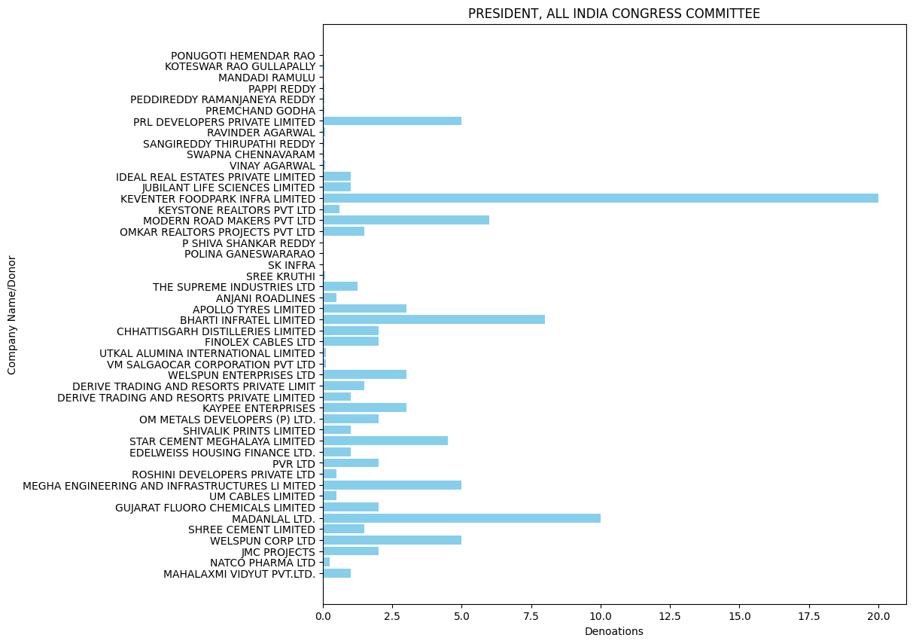

* Congress 2020: -

'CASTAMET WORKS PRIVATE LIMITED': 0.65,

'BANGUR SHREE': 0.4,

'JANAM ENTERPRISES': 0.35,

'SHREE CEMENT LTD': 4.0,

'TANUSHREE LOGISTICS PRIVATE LIMITED': 0.6,

'GENUS POWER INFRASTRUCTURES LTD': 3.0

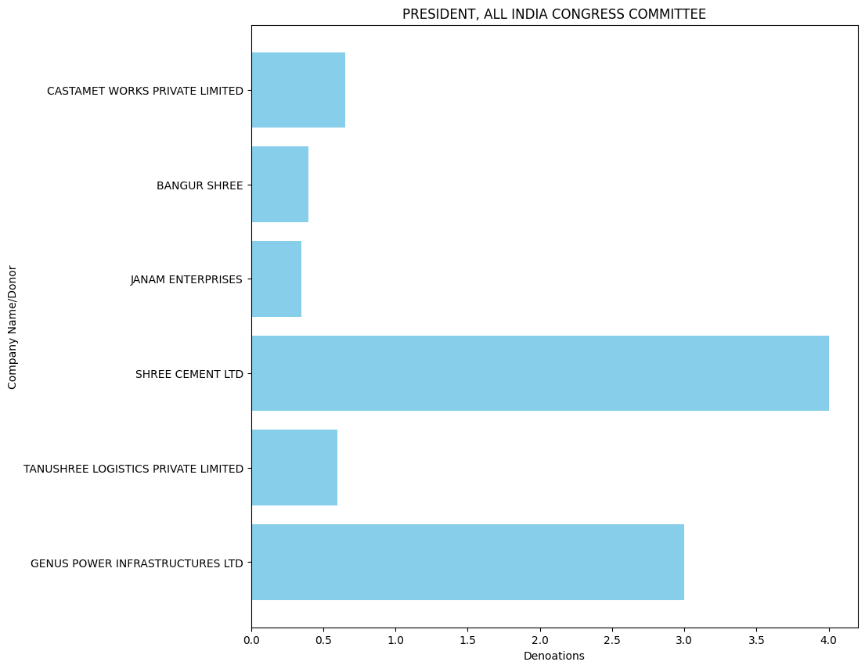

* Congress 2021: -

'CASTAMET WORKS': 2.0,

'GEOJIT INVESTMENT SERVICES LTD': 0.075,

'TANUSHREE LOGISTICS PRIVATE LIMITED': 5.0,

'MEGHA ENGINEERING AND INFRASTRUCTURES LI MITED': 5.0,

'MISRILALL MINES PVT LTD': 1.0,

'RAVLON PROPERTIES PVT LTD.': 0.1,

'TORRENT PHARMACEUTICALS LIMITED': 5.0,

'D R INTERNATIONAL PRIVATE LIMITED': 3.0,

'D R POLYMERS PVT LTD': 3.0,

'GENUS POWER': 5.0,

'VEDANTA LIMITED': 25.0,

'ABHINANDANSTOCKBROKINGPVTLTD': 3.5,

'AGARWAL M BISHAN': 0.3,

'BESSEGGEN INFOTECH LLP': 4.0,

'BM DEALERS LLP': 0.2,

'DR. MANDEEP SHARMA': 0.25,

'FRESHBYTE BUILDTECH PVT LTD': 0.2,

'JK LAKSHMI CEMENT LIMITED': 6.0,

'K B DEALERS PRIVATE LIMITED': 0.2,

'K M A COMMODITIES LLP': 0.4,

'K M DEALERS LLP': 0.2,

'KB DEALERS LLP': 0.2,

'KISHAN MIRANIA AGARWAL': 0.3,

'KM DEALERS LLP': 0.2,

'LEVOC FINANCE PVT LTD': 0.4,

'MR SAURABH BAKLIWAL': 0.4,

'SARITA MIRANIA AGARWAL': 0.2,

'SEEMA MIRANIA AGARWAL': 0.2,

'BHUDUTT JANGID': 0.05,

'VIKRAM SINGH': 0.05,

'ABHAY SHUKLA': 0.2,

'AUSTIN PLYWOOD PRIVATE LIMITED FORMERLY B S PROGRESSIVE PVT': 0.4,

'HALDIA ENERGY LIMITED': 15.0,

'NAMIT PURI': 0.3,

'RITESH PROJECTS PVT LTD': 2.0,

'SANJAY KUMAR': 0.1,

'RAJESH M AGRAWAL': 2.0,

'SREENATH FINVEST PRIVATE LIMITED': 0.1,

'MKJ ENTERPRISES LTD': 8.0,

'DHARMENDRA JAYANTILAL VORA': 0.062,

'SPML OM METALS JV': 5.0,

'YASHODA SUPER SPECIALITY HOSPITAL': 10.0,

'RAJEEV KUMAR SHARMA': 0.1,

'RUPA H SHAH': 0.01,

'ANAND PIMPARKAR': 0.08,

'DEEPAK KUMAR GADDHYAN': 0.5,

'RAKESH KUMAR SHARMA': 0.25,

'ACHINT MAHESHWARI': 0.05,

'ANIL KUMAR KEDIA': 0.05,

'ANUJ KUMAR JAIN': 0.06,

'ASHOK DALMIA': 0.02,

'ATUL KUMAR SINGH': 0.07,

'HITESH D SHAH': 0.2,

'LIFELINE MARKETING PRIVATE LIMITED': 1.0,

'MONIKA': 0.05,

'NARAYAN PODDAR': 0.02,

'NITIN BANSAL': 0.05,

'PRB SECURITIES PVT LTD': 2.0,

'RAHUL GUPTA': 0.04,

'SKP MERCHANTS LLP': 3.0,

'VIKASH GUPTA': 0.02,

'VIVEK AGARWAL': 0.03,

'AMIT AGARWAL': 0.01,

'ANAND AGARWAL': 0.0075,

'ANIL KUMAR MALAWAT': 0.05,

'ANKIT AGARWAL': 0.01,

'ARUN KUMAR JOSHI': 0.03,

'BIMALA PRASANNA SINGH ROY': 0.04,

'BINOD KUMAR AGARWAL': 0.1,

'MANISH KUMAR KHAKHOLIA': 0.04,

'MANOJ KUMAR AGARWAL': 0.02,

'NARESH HIRALAL BHANSALI': 0.25,

'NITESH KUMAR GUPTA': 0.25,

'NLB SERVICES PRIVATE LIMITED': 0.32,

'PAYEL AGARWAL': 0.03,

'PRADIP KUMAR DAS': 0.015,

'RAHUL AGARWAL': 0.01,

'RAHUL BHUWANIA': 0.03,

'RAJENDRA AGARWAL': 0.2,

'SANDEEP JHUNJHUNWALA': 0.125,

'SANJAY JHUNJHUNWALA': 0.03,

'SURBHI AGARWAL': 0.1,

'SUSHIL KUMAR KOTHARI': 0.045,

'UTTAM KUMAR GHOSH': 0.025

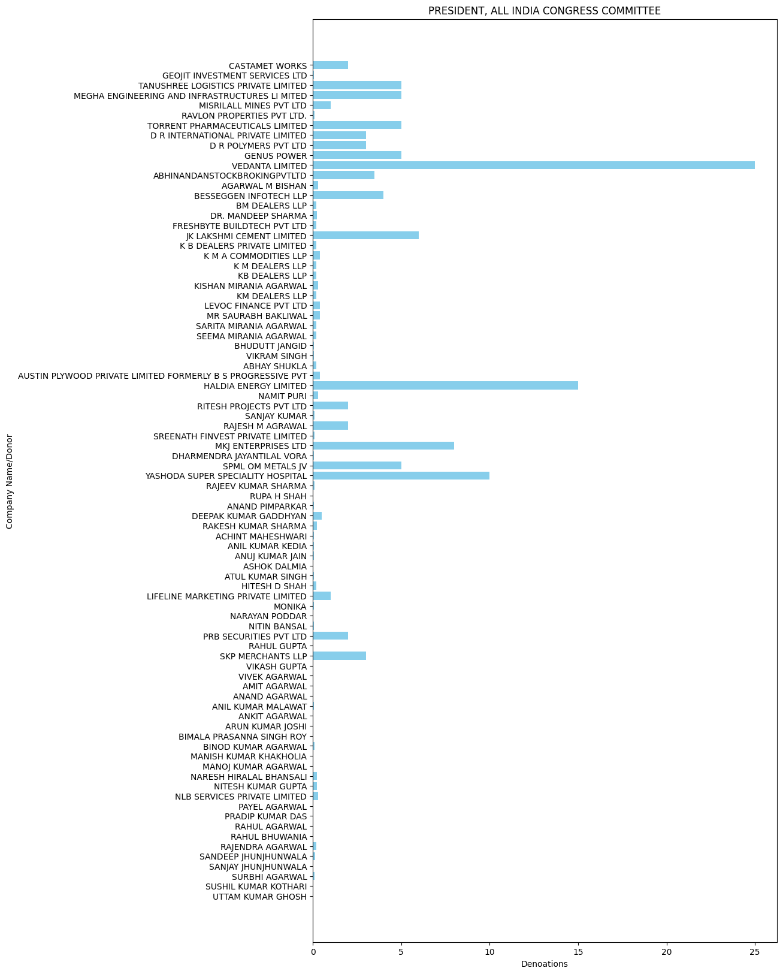

* Congress 2022: -

'BANSAL BUSINESS PRIVATE LIMITED': 0.5,

'BANSHIDHAR VYAPAAR PVT LTD': 0.72,

'BENGAL COKE COMPANY LIMITED': 11.321,

'BMW INFOTECH PRIVATE LIMITED': 0.09,

'BMW INFRASTRUCTURE LLP': 2.6,

'CLIX SECURITIES PRIVATE LIMITED': 0.35,

'DEEP IRON AND STEEL PVT LTD': 0.3,

'JIT INDUSTRIAL PARK LLP': 0.999,

'RAJESH MANNALAL AGRAWAL': 2.0,

'RAMOLI DEALERS PVT LTD': 0.25,

'VAIBHAW TIE UP PRIVATE LIMITED': 0.85,

'CHOWGLE AND COMPANY PVT LTD': 0.3,

'SCAFFOLD PROPERTIES PVT LTD': 7.0,

'ALOK KUMAR SOMANI': 0.15,

'AMIT SOMANI': 0.15,

'DEEPAK KHEMKA': 0.03,

'HIMALAYAN ENDEAVOUR PVT LTD': 0.2,

'MANJU SHREE SOMANI': 0.2,

'NIDHI SOMANI': 0.05,

'PARIKSHIT SOMANI': 0.15,

'RISHABH KHEMKA / ISHWAR CHAND KHEMK': 0.09,

'TANUSHREE SOMANI': 0.05,

'V M SALGAOCAR BROTHER PVT LTD': 0.3,

'V M SALGAOCAR CORPORATION PVT LTD': 0.8,

'VEDANTA LTD': 21.0,

'ANBEE CONSTRUCTIONS LLP': 2.5,

'APOLLO VINTRADE PVT LTD': 1.0,

'BKC PROPERTIES PVT LTD': 10.0,

'BLUEBERRY TRADING COMPANY PRIVATE L': 5.0,

'CAPE TRADING LLP': 2.5,

'CAPSTAN TRADING LLP': 3.25,

'CASA MARIA PROPERTIES LLP': 3.0,

'KAMNA COMMERCIAL PRIVATE LIMITED': 0.05,

'LOUISIANA INVESTMENT FINANCE PVT': 3.0,

'MEGA EQUITAS PRIVATE LIMITED': 1.8,

'MKJ ENTERPRISES LTD': 14.25,

'PALM SHELTER ESTATE DEVELOPMENT LLP': 3.25,

'R B DEALERS PVT LTD': 0.75,

'RAGHUKOOL ESTATE DEVELOPMENT LLP': 2.5,

'SREENATH FINVEST PRIVATE LIMITED': 0.2,

'TARGET VINCOM PVT LTD': 1.0,

'YOGA BUILDERS PVT LTD': 5.5,

'AAKANKSHA BAHETY': 0.1,

'ABHISHEK TIBREWAL': 0.1,

'ANANT UDYOG LLP': 2.0,

'ANKIT BAHETY': 0.1,

'AVIGHNA MEDITECH SOLUTIONS PVT LTD': 0.1,

'AVIGHNA SOLUTIONS': 0.1,

'BIJAY RATAN BAHETY': 0.1,

'BRIJESH BINANI': 0.2,

'CAMELIA GRIHA NIRMAN PRIVATE LIMITED': 5.5,

'DR HEALTHTECH': 0.8,

'GAURAV BAHETY': 0.1,

'HEALTHTECH SOLUTION': 0.2,

'JYOTI LADHA': 0.15,

'MUKUND BINANI': 0.15,

'NEHA BAHETY': 0.1,

'PRAVEEN BAHETY': 0.1,

'PREETI BINANI': 0.15,

'PREM RATAN BAHETY': 0.1,

'SHADOWFAX TRADERS': 1.5,

'SHREE RATAN BAHETY': 0.1,

'SHRINIVAS VASUDEVA DEMPO': 0.5,

'SHYAM SUNDAR BAHETY': 0.2,

'SKP MERCHANTS LLP': 2.0,

'SRINIVASH BINANI': 0.2,

'SUKRITI GUPTA BAHETY': 0.05,

'GOURAB ROY': 0.2,

'SRABANI ROY': 0.05,

'SUMAN ESTATES PRIVATE LIMITED': 0.5,

'TRANSWAYS EXIM PRIVATE LIMITED': 7.0,

'MKJ ENTERPRISES LIMITED': 15.25,

'TRANSWAYS EXIM PVT LTD': 3.0,

'INORBIT MALLS': 10.0,

'MR. DEEPAK': 0.05,

'NUVOCO VISTAS CORPORATION LTD': 7.0,

'VEDANTA LIMITED': 30.0,

'ASHOK PATNI': 2.0,

'SURESH PATNI': 2.0,

'SUSHILA PATNI': 1.0,

'VINEET PATNI': 2.0,

'KANWAR': 2.0,

'RISHABH PATNI': 2.0,

'VIKAS PATNI': 2.0,

'VIVEK PATNI': 2.0,

'GANDHI BROTHERS': 0.2,

'J K CEMENT LTD.': 5.0,

'JK LAKSHMI CEMENT LIMITED': 3.0,

'NIRMA LIMITED': 10.0,

'OM CREDIT PVT LTD': 1.0,

'TORRENT POWER LIMITED': 5.0,

'CIPLA LIMITED': 2.2,

"DR.REDDY'S LABORATORIES LTD": 3.0,

'SAN LOGISTICS': 0.4,

'ARAVALI TECHNICAL SERVICES PVT LTD': 3.0,

'ABHINAV JAIN': 0.02,

'AJANTA PHARMA LTD': 1.0,

'AMIT GUPTA': 0.02,

'GENUS POWER INFRASTRUCTURES LIMITED': 2.0,

'HARSHIT CHHABRA': 0.02,

'NAHAR BUILDERS AND DEVELOPERS LTD': 0.5,

'SAURABH JAIN': 0.05,

'ZYDUS HEALTHCARE LIMITED': 3.0,

'ASHOK CHOUDHARY': 0.1,

'IFB AGRO INDUSTRIES LIMITED': 5.0,

'J S K HOTELS P LTD': 0.75,

'MICRO LABS LTD': 3.0,

'S G AGARWAL & CO': 0.1,

'SERVEALL LAND DEVELOPERS PVT LTD': 2.25,

'SUN OILNATURAL GAS DIV SUN PETRO P.': 4.0,

'YASHODA SUPER SPECIALITY HOSPITAL': 7.0,

'INORBIT MALLS INDIA PRIVATE LIMITED': 10.0,

'DHEERAJ MEDICALS': 2.0,

'LAKSHMI MEDICALS': 3.0

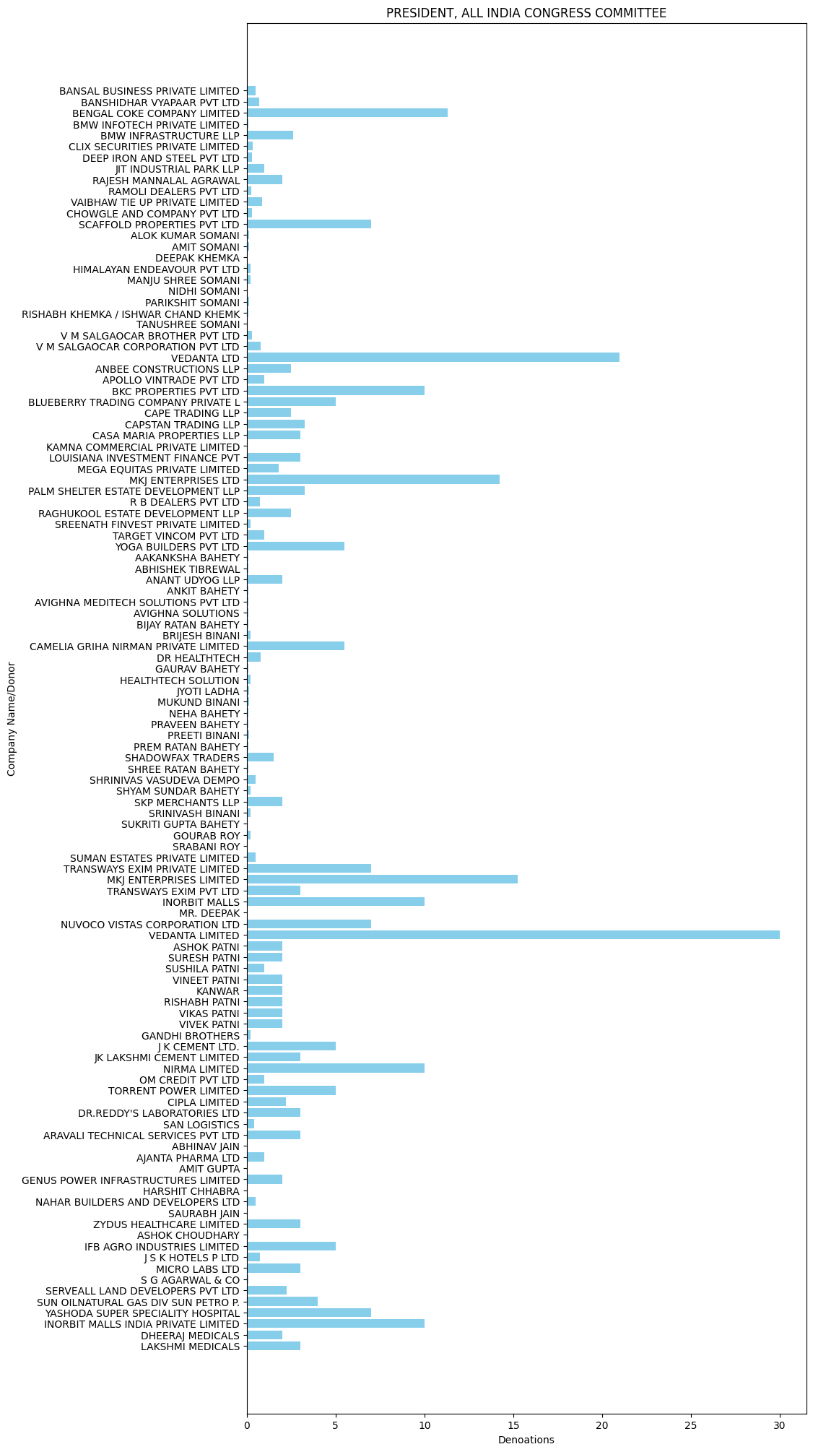

* Congress 2023: -

'DINESH KUMAR AGARWALLA': 0.03,

'MR. DEEPAK KHEMKA': 0.04,

'RISHABH KHEMKA / ISHWAR CHAND KHEMK': 0.04,

'KAMAL MANOHAR': 0.3,

'MAHESH NARAYAN KHADE': 0.5,

'BINOD KUMAR MAROTI': 0.05,

'FUTURE GAMING AND HOTEL SERVICES PR': 50.0,

'MKJ ENTERPRISES LIMITED': 54.1,

'TRANSWAYS EXIM PRIVATE LIMITED': 7.2,

'AVEES TRADING FINANCE PVT LTD': 53.0,

'GENUS POWER INFRASTRUCTURES LIMITED': 3.0,

'HEENA STEEL LLP': 0.5,

'YASHODA SUPER SPECIALITY HOSPITAL': 47.0,

'ABHIJIT INTERNATIONAL': 0.5,

'DESCENT BUILDWELL LLP': 0.5,

'AJAY METALLOYS PVT LTD': 2.5,

'ARS COATED STEEL': 1.0,

'GOODLUCK INDIA LIMITED': 2.5,

'GORJA STEEL PROCESSORS': 3.0,

'KAMAL TRADING CORPORATION': 1.5,

'KIRAN MAZUMDAR SHAW': 1.0,

'M/S KAMAL ISPAT': 0.5,

'MKK METAL SECTIONS P LTD': 5.0,

'MTC ISPAT PVT LTD': 2.5,

'PURSHOTTAM LAL GUPTA': 2.0,

'MEGHA ENGINEERING AND INFRASTRUCTURES LI MITED': 8.0,

'MOHAN STEEL CORPORATION': 2.0,

'PRESTIGE GARDEN ESTATES PRIVATE LIM': 5.0,

'PRESTIGE PROJECTS PVT LTD': 5.0,

'PRESTIGE PROPERTY MANAGEMENT AND SE': 5.0,

'RITHWIK PROJECTS PRIVATE LIMITED': 30.0,

'JINDAL HOUSE': 1.0,

'MSPL LTD': 3.0,

'MYTRAH ENERGY INDIA PRIVATE LIMITED': 3.0,

'NANGALIA ASSOCIATES': 1.0,

'RAMGAD MINERALS AND MINING LTD': 2.0,

'SAGAR CEMENTS LIMITED': 0.5,

'VEDANTA LIMITED': 49.0,

'IDEAL ROAD BUILDERS PVT.LTD.': 6.0,

'INTERGLOBE AVIATION LIMITED': 5.0,

'JINDAL STEEL AND POWER LIMITED': 20.0,

'PRARAMBH SECURITIES PVT LTDPROPRIET': 5.0,

'SIDDHI TRADING': 22.0,

'DHARMENDRA VORA': 0.15,

'HITESH D SHAH': 0.25,

'HITESH D SHAH HUF': 0.25,

'KAMNA CREDITS AND PROMOTORS PVT LTD': 11.5,

'RUPA H SHAH': 0.15,

'SRI KUMARASWAMY MINERAL EXPORTS PR': 8.33,

'TRIDENT LIMITED {FORMERLY ABHISHEK INDUS TRIES LIMITED}': 2.0,

'VEERABHADRAPPA SANGAPPA AND CO': 5.5,

'RAJESH MANNALAL AGRAWAL': 1.0,

'SMRITI AGRAWAL': 1.0,

'THE SANDUR MANGANESE &AMP;AMP; IRON ORES LI': 5.6,

'TRIDENT LIMITED': 5.0,

'WESTERN UP POWER TRANSMISSION COMPANY LI MITED': 110.0,

'ABHRAJIT MITRA': 3.2,

'AJAY SARAF': 0.5,

'NATCO PHARMA LTD': 12.0,

'ABHINANDANSTOCKBROKINGPVTLTD': 2.0,

'STOCKPATHADVISORSLLP': 5.2,

'TORRENT POWER LIMITED': 12.0,

'NANDI ENTERPRISES': 6.18,

'RAY CONSTRUCTIONS LTD': 1.0,

'VARDHMAN TEXTILES LIMITED': 1.0,

'BKC PROPERTIES PVT LTD': 10.0,

'DIVI S LABORATORIES LIMITED': 5.0,

'NUVOCO VISTAS CORP. LTD': 3.0,

'VIJAYKUMARMISHRACONSTRUCTIONPVT': 1.0,

'YOGESH MANPURIA': 0.1,

'B G SHIRKE CONSTRUCTION TECHNOLOGY PVT L TD': 2.0,

'CHENNAI GREEN WOODS PRIVATE LIMITED': 15.0,

'DASAMI LAB PRIVATE LIMITED (FORMERLY HEL IUS LAB PVT LTD)': 5.0,

'HORIZON MEDICAL SUPPLIES': 4.0,

'JINDAL SAW LIMITED': 2.0,

'JK LAKSHMI CEMENT LIMITED': 5.0,

'NARESH HIRALAL BHANSALI': 0.3,

'NEERAJ GANDHI': 0.025,

'NISHANT SARAFF': 0.025,

'RAJESH KUMAR AGARWAL': 0.2,

'SAGUN TULSYAN': 0.2,

'SANDEEP KUMAR SULTANIA (JT1)': 0.1,

'UTKARSH JAIN': 0.05,

'VISHAL KOTHARI': 0.01,

'YOGESH MANNALAL AGRAWAL': 0.5,

'AJIT KUMAR JAIN': 0.02,

'AMRITA AGARWAL': 0.03,

'ANIL KUMAR MALAWAT': 0.08,

'ARUN KUMAR JOSHI': 0.04,

'AYUSH JAIN': 0.03,

'BASUDEV AGARWAL': 0.015,

'HARSHIT KOTHARI': 0.01,

'MANOJ KUMAR AGARWAL': 0.025,

'MRS LILA DEVI SULTANIA': 0.05,

'NIRMA LIMITED': 3.0,

'PARIBARTAN ELECTORAL TRUST': 1.0,

'PRAMOD BAJORIA': 0.1,

'SANJAY AGARWAL': 0.1,

'SANJAY KUMAR SINHA': 0.03,

'SUSHIL KUMAR KOTHARI': 0.04,

'VIKASH GUPTA': 0.06,

'VINAY AGARWAL': 0.03,

'VINIT GUPTA': 0.06,

'VIVEK AGARWAL': 0.07,

'ASHOK': 3.0,

'AVINASH MODI': 3.0,

'SASMAL INFRASTRUCTURE PRIVATE LIMITED': 30.0,

'SECURE METERS LTD': 0.25,

'WOLKEM INDIA LTD': 0.25,

'WONDER CEMENT LTD': 10.0,

'WONDER MINERALS PVT LTD.': 3.0,

'WONDER MARMOSTONES PVT LTD': 2.0,

'HAPPYTAT VILLAS PRIVATE LIMITED': 1.0,

'CYGNUS POWER INFRA SERVICES PRIVATE': 5.5,

'MY HOME INFRASTRUCTURES PVT LTD MY': 4.5,

"DR.REDDY'S LABORATORIES LTD": 11.0,

'SEPC POWER PVT LTD OPERATION RETEN': 30.0,

'SRI SIDDHARTH INFRATECH AND SERVICES I P': 10.0,

'APARNA FARMS AND ESTATES LLP': 15.0,

'HES INFRA PVT LTD': 2.0

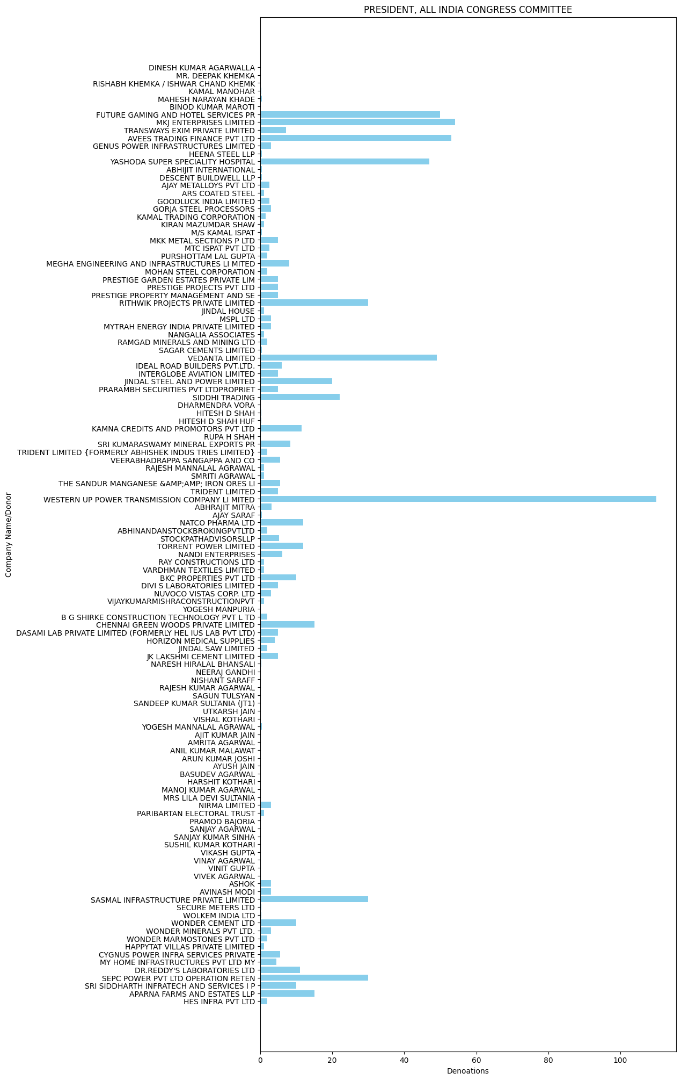

* Congress 2024: -

'ASISH FINANCE PRIVATE LIMITED': 2.0,

'TRANSWAYS EXIM PRIVATE LIMITED': 1.0,

'AMAR SECURITIES PVT LTD': 2.5,

'GANDHI BROTHERS': 0.2,

'MVM SECURITIES PVT LTD-SELF A/C': 3.0,

'RAJ KAMAL DRUGS': 0.05,

'TPK PARTNERS': 1.0,

'ABHINANDANSTOCKBROKINGPVTLTD': 3.0,

'GVPR ENGINEERS LTD': 5.0,

'DYNERE ENGINEERING PRIVATE LIMITED': 1.0,

'MANU VYAPAR (P) LTD.': 2.0,

'SASMAL INFRASTRUCTURE PRIVATE LIMITED': 9.0,

'SIDDHARTH MATHUR': 0.15,

'SIDHARTH AGARWAL': 0.5,

'VEDIKA VANIJYA PVT LTD-SELF A/C': 5.0,

'VIDUR GUPTA': 0.5

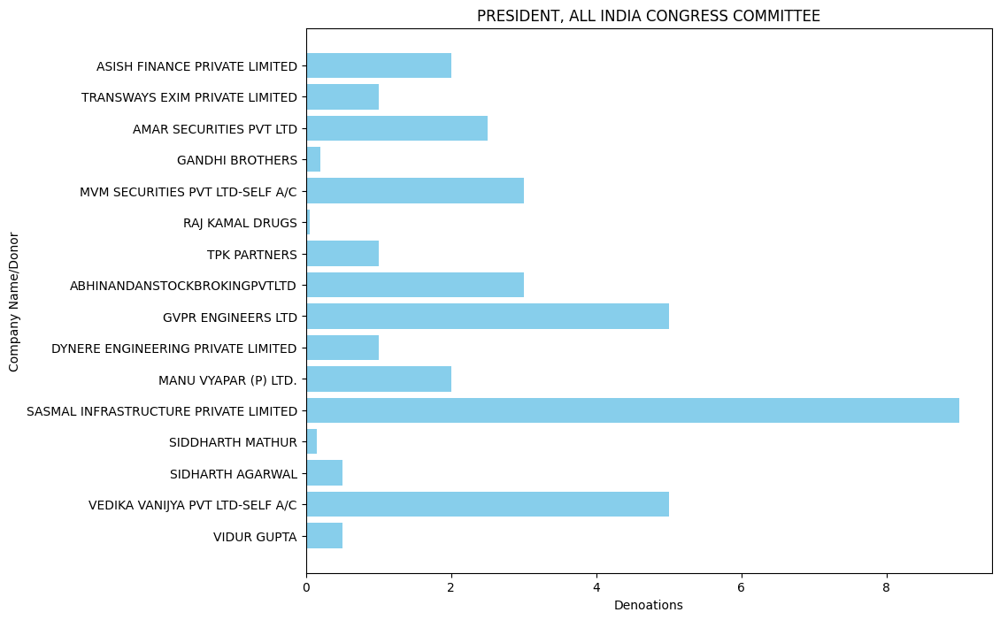

**BHARAT RASHTRA SAMITHI**

* BRS 2020:

FUTURE GAMING AND HOTEL SERVICES PR': 89.0

* BRS 2021: -

'PRAKASH DISTILLERY & CHEMICAL CO (P) LT D': 0.12,

'RAMESH AGARWAL C S BOTTLING PLANT': 0.72,

'SAROJIT KUMAR DEY': 0.5,

'HIMALAYAN ENDEAVOUR PVT LTD': 1.4,

'LAXMI INDUSTRIAL BOTTLING PLAN': 0.71,

'MONALISA BOTTLING INDUSTRIES PVT LTD': 0.5,

'SENGUPTA AND SENGUPTA PRIVATE LIMIT': 1.4,

'TRANSWAYS EXIM PRIVATE LTD': 0.6,

'VARAS INTERNATIONAL PRIVATE LIMITED': 0.3,

'FUTURE GAMING AND HOTEL SERVICES PR': 60.0

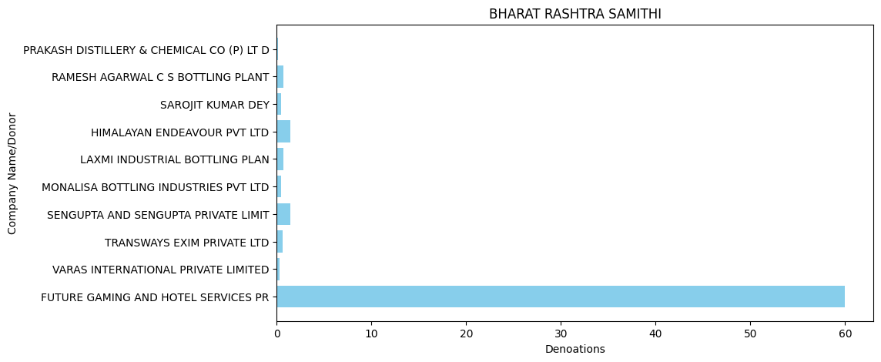

* BRS 2022: -

'ACHINTYA SOLAR POWER PVT LTD': 1.0,

'DIVYESH POWER PVT LTD': 2.0,

'ELENA RENEWABLE ENERGY PVT LTD': 2.0,

'SEI DIAMOND PVT LTD': 2.0,

'TANOT WIND POWER VENTURES PVT LTD': 3.0,

'FUTURE GAMING AND HOTEL SERVICES PR': 5.0,

'MEGHA ENGINEERING AND INFRASTRUCTURES LI MITED': 12.0,

'JYOTSNA AGGARWAL': 0.25,

'KHUSHBU AGGARWAL': 0.25,

'PREM AGGARWAL': 0.25,

'PREM AGGARWAL AND SONS HUF': 0.25,

'SANDEEP AGGARWAL': 0.25,

'SANDEEP AGGARWAL AND SONS HUF': 0.25,

'USHA AGGARWAL': 0.25,

'VEDANTA ELECTRICALS PRIVATE LIMITED': 1.75,

'VIPIN AGGARWAL': 0.25,

'VIPIN AGGARWAL AND SONS HUF': 0.25,

'THE RAMCO CEMENTS LIMITED': 15.0,

'EVERSHINE INTERIORS CHENNAI PVT LTD': 5.0

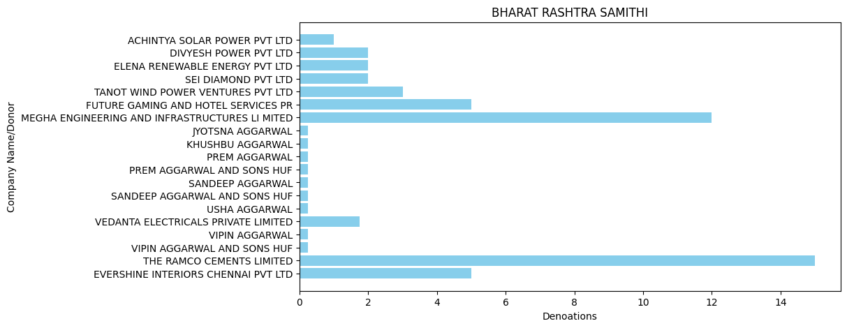

* BRS 2023: -

'THE RAMCO CEMENTS LIMITED': 8.0,

'FUTURISTIC HANDLING SERVICES PVT LTD': 5.0,

'AARISH SOLAR POWER PRIVATE LIMITED': 1.0,

'AASHMAN ENERGY PRIVATE LIMITED': 1.0,

'ANIMALA WIND POWER PRIVATE LIMITED': 2.0,

'AXIS WIND FARMS (MPR DAM) PRIVATE L': 3.0,

'DIVYESH POWER PRIVATE LIMITED': 1.0,

'ELENA RENEWABLE ENERGY PRIVATE LIMITED': 1.0,

'GREENKO ANANTAPUR WIND POWER PRIVATE LIMITED': 5.0,

'GREENKO URAVAKONDA WIND POWER PRIVA': 3.0,

'SEI ARUSHI PVT LTD': 1.0,

'SHREYAS RENEWABLE ENERGY PRIVATE LTD': 1.0,

'SKEIRON RENEWABLE ENERGY AMIDYALA PRIVATE LIMITED': 5.0,

'TADAS WIND ENERGY PVT LTD': 1.0,

'ZUVAN ENERGY PRIVATE LIMITED': 1.0,

'SAGAR CEMENTS LIMITED': 0.5,

'MEGHA ENGINEERING AND INFRASTRUCTURES LI MITED': 25.0,

'DEVARAHIPPARIGI WIND POWER PVT LTD': 2.0,

'GREENKO RAYALA WIND POWER PRIVATE LIMITE D': 2.0,

'KHANDKE WIND ENERGY PRIVATE LIMITED': 2.0,

'SKEIRON RENEWABLE ENERGY AMIDYALA P': 2.0,

'SNEHA KINETIC POWER PROJECTS PVT LTD': 10.0,

'OSTRO JAISALMER PRIVATE LIMITED': 17.0,

'OSTRO MADHYA WIND PRIVATE LIMITED': 17.0

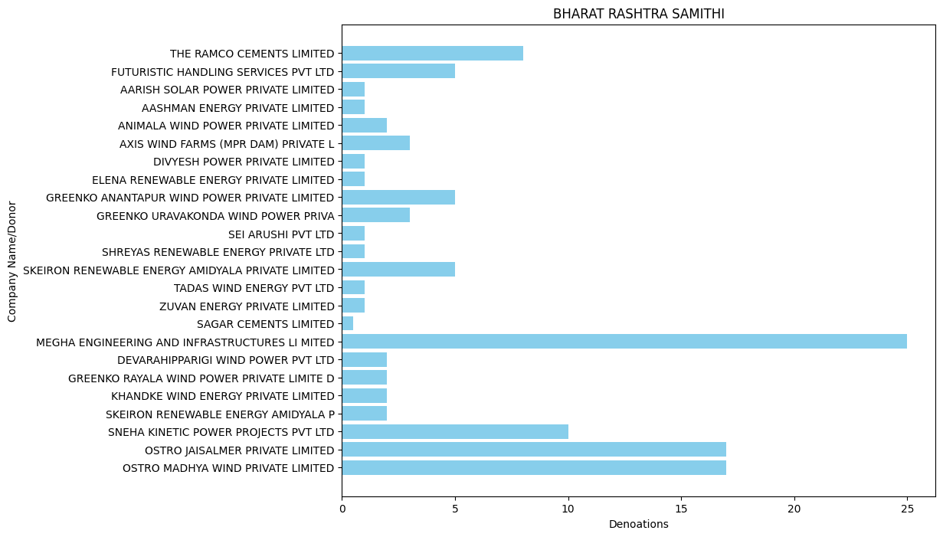

* BRS 2024: -

'NATCO PHARMA LTD': 3.0

Some party datasets become very big after breaking it down on yearly basis so we can't chart it to understand it better and we also can't break it down

further because if we break it on monthly basis the repetition increases and it

also becomes complicated to understand.

Note: - There may be some changes in data loss. I can't add if the dataset

doesn't meet the conditions.

[LinkedIn](http://www.linkedin.com/in/shyam-ranasara-702b6125a) Created By: - Shyam Ranaasara [Instagram](https://www.instagram.com/shyam_ranasara?igsh=bnVydTdzbnRwdzNl)  Student of: -Devi Ahilya Vishwavidyalaya, Indore